|  |  |
| --- | --- |
|  | **MINISTRY OF EDUCATION AND TRAINING** |

|  |  |
| --- | --- |
| **FPT UNIVERSITY** | |
| CAPSTONE PROJECT DOCUMENT | |
| **HANGING PRODUCT STORE** | |
| **SE07.B – GROUP 8** | |
| **Group Members** | |  |  |  | | --- | --- | --- | | Quản Tiến Dân | Team Leader | DanQTSE61144 | | Trần Quang Phúc | Team Member | Dropped out | | Nguyễn Huy Hoàng | Team Member | HoangNHSE61007 | | Huỳnh Công Đức | Team Member | DucHCSE61024 | |
| **Supervisor** | Kiều Trọng Khánh |
| **Ext.Supervisor** | N/A |
| **Capstone Project code** | HPS |

- Ho Chi Minh City, May/2015 -

*This page is intentionally left blank*

Table of Contents

List of Tables 6

List of figures 7

Definition, Acronyms, and Abbreviations 10

A. Report No.1 Introduction 11

1. Project Information 11

2. Introduction 11

3. Current Situation 11

4. Problem Definition 11

5. Proposed Solution 12

5.1 Feature functions 12

5.2 Advantages and disadvantages 12

6. Functional Requirements 13

7. Role and Responsibility 13

B. Report No.2 Software Project Management Plan 14

1. Problem Definition 14

1.1 Name of this Capstone Project 14

1.2 Problem abstract 14

1.3 Project Overview 14

2. Project Organization 16

2.1 Software Process Model 16

2.2 Roles and responsibilities 18

2.3 Tools and Techniques 19

3. Project Management Plan 20

3.1 Software development life cycle 20

3.2 Phase Detail 23

3.3 All Meeting Minute 25

4. Coding Convention 25

C. Report No.3 Software Requirement Specification 26

1. User Requirement Specification 26

1.1 Guest Requirement 26

1.2 Customer Requirement 26

1.3 Store Owner Requirement 26

1.4 Admin Requirement 26

2. User Requirement Specification 27

2.1 External Interface Requirement 27

2.2 System Overview Use Case 28

2.3 List of Use Case 28

3. Software System Attribute 96

3.1 Usability 96

3.2 Reliability 96

3.3 Availability 96

3.4 Security 96

3.5 Maintainability 96

3.6 Portability 96

3.7 Performance 96

4. Conceptual Diagram 97

4.1 Conceptual Diagram 97

D. Report No. 4 Software Design Description 99

1. Design Overview 99

2. System Architectural Design 99

4.1 Web Application Architecture Description 99

4.2 Mobile Application Architecture Description 100

3. Component Diagram 101

4. Detailed Description 103

4.1 Class Diagram 103

4.2 Class Diagram Explanation 103

4.3 Interaction Diagram 108

5. User Interface Design 124

5.1 Guest/Customer Interface Design 124

5.2 Store Owner Interface Design 138

5.3 Admin Interface Design 161

6. Database Design 163

6.1 Entity Relationship Diagram 163

6.2 Entity Dictionary 163

7. Algorithms 164

7.1 Price Suggestion 164

7.2 Consignment State 166

E. Report No. 5 System Implement & Test Description 168

1. Introduction 168

1.1 Overview 168

1.2 Test Approach 168

2. Database Relationship Diagram 168

2.1 Physical Diagram 168

2.2 Data Dictionary 168

3. Performance Measurement 175

4. Test Plan 175

4.1 Features to be tested 175

4.2 Features not to be tested 175

5. System Testing Test Case 175

5.1 StoreOwner Core Flow 176

5.2 Guest Core Flow 180

F. Report No. 6 Software User’s Manual 184

1. Installation Guide 184

1.1 Setting up the environment at server side 184

1.2 Deployment at server side 184

1.3 Setting up the environment at client side 185

2. User Guide 186

2.1 Computer Guide 186

2.2 Mobile Guide 197

G. Appendix 199

# List of Tables

Table 1: Definitions, Acronyms, and Abbreviations 10

Table 2: Roles And Responsibilities 13

Table 3: Hardware Requirement For Mobile 15

Table 4: Hardware Requirement for Server 15

Table 5: Software Process Guideline Question Decision 18

Table 6: Project Roles and Responsibilities 19

Table 7: Software Development Lifecycle Detail 22

Table 8: Phase 1: Requirement Analysis 23

Table 9: Phase 2: System and Software Design 23

Table 10: Phase 3: Implementation and Unit Testing 25

Table 11: Phase 4: Integration and System Testing 25

Table 12: Phase 5: Operation and Maintenance 25

# List of figures

Figure 1: The Waterfall Model (Sommerville, Software Engineering, 2011) 18

Figure 2: System Overview Use Case 29

Figure 3: <Guest> Overview Use Case 30

Figure 4: <Guest> Consign product 30

Figure 5: <Guest> Track product status 39

Figure 6: <Guest> Cancel consigned product 41

Figure 7: <Guest> Search product 43

Figure 9: <Guest> Order product 45

Figure 10: <Customer> Overview User Case 47

Figure 11: <Store Owner> Overview Use Case 48

Figure 12: <Store Owner> Manage new request 49

Figure 13: <Store Owner> Accept request 51

Figure 14: <Store Owner> Refuse request 53

Figure 15: <Store Owner> Manage accepted request 55

Figure 16: <Store Owner> Update request 58

Figure 17: <Store Owner> Receive product 60

Figure 18: <Store Owner> Refuse product 62

Figure 19: <Store Owner> View refused request 64

Figure 20: <Store Owner> View cancelled request 66

Figure 21: <Store Owner> View available product 68

Figure 22: <Store Owner> Publish on web 69

Figure 23: <Store Owner> View sold product 73

Figure 24: <Store Owner> Pay consignor 74

Figure 25: <Store Owner> Process payment 77

Figure 26: <Store Owner> View canceled product 79

Figure 27: <Store Owner> Agree return product 81

Figure 28: <Store Owner> Disagree return product 83

Figure 29: <Store Owner> Complete return product 85

Figure 30: <Store Owner> View ordered product 87

Figure 31: <Store Owner> Send product price to customer 89

Figure 32: <Store Owner> Cancel orders 91

Figure 33: <Store Owner> Sell product 93

Figure 34: <Store Owner> View expired product 96

Figure 35: <Store Owner> Return expired product 98

Figure 36: <Store Owner> Extend consignment period 100

Figure 37: <Store Owner> View on web product 102

Figure 38: <Store Owner> Update product 104

Figure 39: <Store Owner> Cancel Product On Web 107

Figure 40: <Store Owner> View Consignment Statistic 110

Figure 41: < Admin > Create user 114

Figure 42: < Admin > Edit user 116

Figure 43: < Admin > Active/Deactive user 118

Figure 44: <System> Search product online 119

Figure 45: Conceptual Diagram 122

Figure 46: HPS System Architectural 124

Figure 47: Component Diagram 126

Figure 48: Class Diagram 128

Figure 49: <Guest> Consign product 133

Figure 50: <Guest> Search product 134

Figure 52: <Guest> Order product 135

Figure 53: <Store Owner> Publish on web 136

Figure 54: <Store Owner> Pay Consignor 136

Figure 55: <Store Owner> Process payment 137

Figure 56: <Store Owner> Agree return product 137

Figure 57: <Store Owner> Disagree return product 138

Figure 58: <Store Owner> Sell product 138

Figure 59: <Store Owner> Send product price to customer 139

Figure 60: <Store Owner> Cancel orders 139

Figure 61: <Store Owner> Extend consignment period 140

Figure 62: <Store Owner> Update product 140

Figure 63: <Store Owner> View available product 141

Figure 64: <Store Owner> View consignment statistic 141

Figure 65: <Store Owner> Refuse request 142

Figure 66: <Store Owner> Receive Product 142

Figure 67: <Store Owner> Refuse product 143

Figure 68: <Store Owner> Update request 143

Figure 69: <System> Search product online 144

Figure 70. <Store Owner> Login 145

Figure 71. <Store Owner> Receive notification 146

Figure 72. <Store Owner> View task 147

Figure 73. <Store Owner> Auto synchronize 148

Figure 74. <Store Owner> Accept product 149

Figure 75. <Store Owner> Cancel product 150

Figure 76. <Store Owner> View history 151

Figure 77: Login 152

Figure 78: View Home Page 153

Figure 79: Search Product 154

Figure 80: View Detail 155

Figure 81: Order Product 156

Figure 82: Mobile Login 166

Figure 83: Mobile View Task 167

Figure 84: Mobile View Product List 169

Figure 85: Mobile Search Product 170

Figure 86: Mobile View Navigation Drawler 171

Figure 87: Web View Available Product 174

Figure 88: Publish Product 176

Figure 89: Sell Product 178

Figure 90: Pay Consignor 179

Figure 91: Cancel Product 181

Figure 92: Extend Consignment Period 183

Figure 93: Manage Request 185

Figure 94: View Request Detail 186

Figure 95: Accepted Request Details 188

Figure 96: Entity Relationship Diagram 192

Figure 97: Search Product By Product Name Flow Chart 194

Figure 98: Search Product By Serial Flow Chart 194

Figure 99: Physical Diagram 195

Figure 100: StoreOwner Core Flow 203

Figure 101: Guest Core Flow 207

Figure 102: Database Server Login 212

Figure 103: Order Screen 1 217

Figure 104: Order Screen 2 217

Figure 105: Publish Product On Web 220

Figure 106: Sell Product 221

Figure 107: Pay Consignor 222

Figure 108: Create User Screen 223

Figure 109: Login Mobile Screen 224

Figure 110: Receive Product Mobile Screen 225

Figure 111: Cancel Product Mobike Screen 226

# Definition, Acronyms, and Abbreviations

|  |  |
| --- | --- |
| **Name** | **Definition** |
| HPS | Hanging Product Store |
| App | Application |
| OS | Operating System |

Table : Definitions, Acronyms, and Abbreviations

# Report No.1 Introduction

## Project Information

* **Project Name:** Hanging Product Store
* **Project Code:** HPS
* **Product Type:** Website and Android Application
* **Start Date:** May 11, 2015
* **End Date:** September 3, 2015

## Introduction

Nowadays, because of the shopping hobby, many people are willing to buy product even they just use it once. Therefore, they probably have items hanging in their closet that they never use again. Hence, consignment sales service appears.

Currently, in Viet Nam consignment services becomes more popular. There are some consignment sales services but they require consignor brings items to the store and some use manually process in management (give receipts to consignor for tracking).

From above mentioned reasons, this project is going to build an online system for consignment sales service.

## Current Situation

This kind of business is now becoming more popular in daily life, with variety genres of product, no capital. In other country likes US, TheRealReal is very successful. In Viet Nam, there are some consignment sales services such as LALA-Save&Share, khohanghoa.com… They are running their business and expanding their business very well.

## Problem Definition

Here is their advantages and disadvantages:

* LALA-Save&Share:
* Advantages:
* Provide online shopping method.
* Online support available.
* Support consigned-items tracking.
* Disadvantages:
* Doesn’t support online payment for consignor when consigned items are sold.
* Consignor has to bring theirs item to the store to consign.
* Support only fashion product.
* KhoHangHoa.com:
* Advantages:
* Support many types of product.
* Provide online shopping method.
* Support online payment for consignor when consigned-items are sold.
* Online support available.
* Disadvantages:
* Consignor has to bring theirs item to the store to consign.
* Consignor cannot track their consigned-items status immediately.
* TheRealReal.com:
* Advantages:
* Online support available.
* Provide online shopping method, online payment for both consignment and purchase.
* Support product recommendation by season or fashion trend and wish list.
* Support consigned-items tracking.
* Disadvantages:
* Support only fashion product.
* Consignor has to bring theirs item to the store to consign.

## Proposed Solution

Our system include:

* A web app allow multiple store register to receive consignment request, sell consigned product and manage consigned product. Guest and customer can make consignment request and tracking consigned product status.
* An android app helps store owner to receive product.

In more detail, our system has the following functions:

### Feature functions

* Web Application:
* Admin can create account and manage account.
* Guest can make product consignment request, search product and order product. The system support Guest tracking their product status, receive notification about their product status, payment online method and price suggestion.
* Customer can edit profile, search and review their transaction history.
* Every Store owner can manage their consignment request, raise their products on website and manage order product. The system support Store owner tracking consigned product status, payment online method, price suggestion.
* Mobile Application:
* StoreOwner can use their Android phone to receive or cancel product.

### Advantages and disadvantages

* Advantages:
* Support price suggestion.
* Support online payment method.
* Support notification about consigned product status.
* Support tracking product status.
* Support mobile app to receive or cancel product.
* Disadvantages:
* Support only fashion product.
* Internet connection is required.
* Price suggestion only support for original products.

## Functional Requirements

Function requirements of the system are listed as below:

* Consignment request management
* Receive or refuse product
* Raise products on website
* Order management
* Price suggestion
* Online payment method
* Product status notification
* Product status tracking
* Account management

## Role and Responsibility

|  |  |  |  |  |
| --- | --- | --- | --- | --- |
| **No** | **Full Name** | **Role** | **Position** | **Contact** |
| **1** | Kiều Trọng Khánh | Senior Manager | Instructor | [KhanhKT@fpt.edu.vn](mailto:KhanhKT@fpt.edu.vn) |
| **2** | Quản Tiến Dân | Developer | Leader | [DanQTSE61144@fpt.edu.vn](mailto:DanQTSE61144@fpt.edu.vn) |
| **3** | Trần Quang Phúc | Developer | Member | [PhucTQSE60993@fpt.edu.vn](mailto:PhucTQSE60993@fpt.edu.vn) |
| **4** | Nguyễn Huy Hoàng | Developer | Member | [HoangNHSE61007@fpt.edu.vn](mailto:HoangNHSE61007@fpt.edu.vn) |
| **5** | Huỳnh Công Đức | Developer | Member | [DucHCSE61024@fpt.edu.vn](mailto:DucHCSE61024@fpt.edu.vn) |

Table : Roles And Responsibilities

# Report No.2 Software Project Management Plan

## Problem Definition

### Name of this Capstone Project

Hanging Product Store (HPS)

### Problem abstract

With the increasing of shopping in community, the number of consignment store has started to increase too. A consignor has so many choices to consign his/her product and consignee may receive a lots of consigned product every day. Both consignor and consignee look for a way to perform business transaction online without worries. We propose a solution to solve this problem: a website where consignor and consignee can meet and do consignment business online. For consignor, we provide an easy way to get consignees’ attentions, make contract with them and track consigned product’s status. For consignee, we provide a useful tool to check the consigned products.

### Project Overview

#### Current Situation and Disadvantages

Although there are some shops running this service, most of them are not really effective in helping consignor tracking product’s status, negotiating price between consignor and consignee. When consignor has already consigned product, how could he/she know if consigned product is in store or is being sold? That problem goes to consignees as well. With many consigned products, how could they track each item efficiently? They also need a better way to automatically notify consignors when any actions is applied to consigned products.

#### The Proposed System

##### Web Site

* Admin can manage account
* Guest can make product consignment request.
* Guest can receive notification about their product status.
* Guest can track product status.
* Guest can search product.
* Guest can order product.
* Customer can edit profile
* Customer can review transaction history
* Store owner can receive suggested price for product.
* Store owner can receive or refuse product.
* Store owner can raise product on website.
* Store owner can manage consigned product.
* Store owner can manage order product.
* Store owner can have online payment method to pay for customer.
* Store owner can track consigned product status.
* System support send SMS to notify product’s status
* System support online payment method.
* System support price suggestion.

##### Mobile Application

* Store owner can using mobile to receive or refuse product.

#### Boundaries of System

* People who have computer, laptop or smartphone with internet connection and could run web browser can use this website.
* The complete product of this project includes:
* The website application.
* The mobile application.
* All related documents.
* Language: Vietnamese.

#### Development Environment

##### Hardware requirement

For mobile:

|  |  |  |
| --- | --- | --- |
| Mobile | Minimum Requirements | Recommended |
| Internet Connection | 2 Mbps | 4 Mbps |
| Operating System | Android 4.4 | Android 5.0 |
| Hardware | Wifi supported | Wifi supported |
| Memory | 1GB | 2GB |

Table : Hardware Requirement For Mobile

For server:

|  |  |  |
| --- | --- | --- |
| Windows | Minimum Requirements | Recommended |
| Internet Connection | Cable, Wi-Fi (4 Mbps) | Cable, Wi-Fi (8 Mbps) |
| Operating System | Window Server 2008 | Window Server 2008 |
| Computer Processor | Intel® Core 2 Duo | Intel® Core(TM) i5 CPU , M 460 @ 2.53Gz |

Table : Hardware Requirement for Server

##### Software requirement

* GitHub & TortoiseGit: used for source control.
* NetBean 8.0.2 and Apache Tomcat 8.0.15: used to develop and implement.
* Android Studio 2.1: use to code client application
* Database: Microsoft SQL Server 2008.
* Genymotion 2.4.0: use to run and test Android app.
* StarUML: used to create models and diagrams.
* Skype: use for meeting and conservation between group members

## Project Organization

### Software Process Model

To determine the right process model for the software process, we answer ten guidelines questions (Sommerville, Software Engineering, 2011):

|  |  |  |  |  |
| --- | --- | --- | --- | --- |
| **No.** | **Question** | **Answer** | **Plan-Driven** | **Agile** |
| **1.** | Is it important to have a very detailed specification and design before moving to implementation? If so, you probably need to use a plan-driven approach. | We need a correct specification and design to coding but a very detailed one is not necessary. | 0.5 | 0.5 |
| **2.** | Is an incremental delivery strategy, where you deliver the software to customers and get rapid feedback from them, realistic? If so, consider using agile methods. | No. This is generic product, not bespoke product. A rapid feedback from target customer is not necessary. | 1 | 0 |
| **3.** | How large is the system that is being developed? Agile methods are most effective when the system can be developed with a small co-located team who can communicate informally. This may not be possible for large systems that require larger development teams so a plan-driven approach may have to be used. | This system will be developed in four month by four people, so we think it is a medium system. | 0.5 | 0.5 |
| **4.** | What type of system is being developed? Systems that require a lot of analysis before implementation (e.g., real-time system with complex timing requirements) usually need a fairly detailed design to carry out this analysis. A plan-driven approach may be best in those circumstances. | This is an ecommerce system. Core components require analysis carefully. | 1 | 0 |
| **5.** | What is the expected system lifetime? Long-lifetime systems may require more design documentation to communicate the original intentions of the system developers to the support team. However, supporters of agile methods rightly argue that documentation is frequently not kept up to date and it is not of much use for long-term system maintenance. | This system may operate in two or three years. | 1 | 0 |
| **6.** | What technologies are available to support system development? Agile methods often rely on good tools to keep track of an evolving design. If you are developing a system using an IDE that does not have good tools for program visualization and analysis, then more design documentation may be required. | We have a good tool to tracking change. The IDE support tracking phase. | 0.5 | 0.5 |
| **7.** | How is the development team organized? If the development team is distributed or if part of the development is being outsourced, then you may need to develop design documents to communicate across the development teams. You may need to plan in advance what these are. | We are a small with four people and we are all living in Ho Chi Minh city. We can have meeting every day. | 0 | 1 |
| **8.** | Are there cultural issues that may affect the system development? Traditional engineering organizations have a culture of plan-based development, as this is the norm in engineering. This usually requires extensive design documentation, rather than the informal knowledge used in agile processes. | We are all young people and we share common software development knowledge. However, we come from difference part of country and we never met before. | 0.5 | 0.5 |
| **9.** | How good are the designers and programmers in the development team? It is sometimes argued that agile methods require higher skill levels than plan-based approaches in which programmers simply translate a detailed design into code. If you have a team with relatively low skill levels, you may need to use the best people to develop the design, with others responsible for programming. | Although we are confident about software development skill. We are still student and we have no or little experience. | 1 | 0 |
| **10.** | Is the system subject to external regulation? If a system has to be approved by an external regulator (e.g., the Federal Aviation Authority [FAA] approve software that is critical to the operation of an aircraft) then you will probably be required to produce detailed documentation as part of the system safety case. | No | 0 | 0 |
| **Total** | | | **6** | **3** |

Table : Software Process Guideline Question Decision

As the result, the plan-driven process we choose is waterfall model because of its easy to use and commonly used in software process.



Figure : The Waterfall Model (Sommerville, Software Engineering, 2011)

Because of the small size of the team (four people included project manager), we may overlap five phases in waterfall model to cope with change better and to reduce the wasted time (due to the blocking nature of the waterfall model – the following phase must wait until the previous phase has finished).

During Requirement Definition, we will design some component that has clear requirement. During coding, we will fix design problem and so on. We will modify the document produced in each phase to reflect the changes made.

### Roles and responsibilities

|  |  |  |  |
| --- | --- | --- | --- |
| No. | Full name | Team Role | Responsibilities |
| **1** | Kieu Trong Khanh | * Senior Manager | * Monitor project * Mentor Project Manager * Specify user requirement * Review documents * Support technology |
| **2.** | Quan Tien Dan | * Project Manager * Business Analyst * Developer * Tester | * Monitor project * Plan and execute project * Design * Programing * Testing |
| **3.** | Tran Quang Phuc | * Team member * Business Analyst * Developer * Tester | * Assist in tools and techniques * Design * Programing * Testing |
| **4** | Nguyen Huy Hoang | * Team member * Business Analyst * Developer * Tester | * Assist in tools and techniques * Design * Programing * Testing |
| **5** | Huynh Cong Duc | * Team member * Business Analyst * Developer * Tester | * Assist in tools and techniques * Design * Programing * Testing |

Table : Project Roles and Responsibilities

### Tools and Techniques

* Back-end technologies:
  + Website: Java EE
  + Web service: Java + Jersey
  + Third-party libraries: Gson 2.3.1, Amazon Product Advertising API, Twilio API.
* Front-end technologies: HTML5, CSS3, JavaScript, Jquery, AJAX.
* Mobile: Android 4.4 and later
* Web Server: Installed Tomcat 8.0.15.0
* Database Management System: MSSQL Server 2008 R2 Enterprise.

## Project Management Plan

### Software development life cycle

|  |  |  |  |  |  |
| --- | --- | --- | --- | --- | --- |
| **Phase** | **Description** | **Deliverables** | **Resource needed** | **Dependencies and Constraints** | **Risks** |
| Requirement Definition | The process of establishing what services are required and the constraints on the system’s operation and development. | Software requirement specification:   * System models * User and system requirements   Executable prototype  Acceptance test plan | 52 man days |  | Lack of domain knowledge.  Communication misunderstanding.  Conflict objectives, conflict viewpoints. |
| System and Software Design | Design a software structure and an overall system architecture that realizes the specification. | System design description:   * System architecture * Database specification * Interface specification * Component Specification   System integration test plan | 52 man days | Platform information  Software requirement specification  Data description | Change to requirements that require major design rework are proposed.  Specifications of essential interfaces are not available on schedule.  The size of the system has been underestimated. |
| Implementation and Unit Testing | Translate design structure into an executable program or program unit.  Unit testing involves verifying that each unit meets its specification. | Program Units  Test case | 90 man days | System design description | Software tool cannot be integrated.  The time required to develop the software is underestimated.  The underlying technology on which the system is build is superseded by new technology. |
| Integration and System Testing | Integrated the individual program unit.  Test the complete system to ensure that the software requirements have been meet. | Executable software  Test result | 58 man days | System design description  System integration test plan  Acceptance test plan | Reusable software components contain defects that mean they cannot be used as planned. |
| Operation and Maintenance | This is the longest life cycle phase.  The system is installed and put into practical use.  Maintenance involves correcting errors which were not discovered in earlier stages of the life cycle, improving the implementation of system units and enhancing the system’s services as new requirements are discovered. | Installation guide  User guide | 92 man days | Executable software  Software requirement specification | A competitive product is marketed before the system is completed.  The database used in the system cannot process as many transactions per second as expected. |

Table : Software Development Lifecycle Detail

### Phase Detail

#### Phase 1: Requirement Definition

|  |  |  |
| --- | --- | --- |
| **Task** | **Description** | **Author** |
| Collect requirements | Find which systems currently provide similar service, their advantages and dis advantages. | DanQT, PhucTQ, HoangNH, DucHC |
| Identify and clarify main functions | Define main functions of system. | DanQT, PhucTQ, HoangNH, DucHC |
| Create System Introduction | Complete Introduction Report. | DanQT, PhucTQ, HoangNH, DucHC |
| Software Project Management Plan. | Prepare Project Management Plan. | DanQT, PhucTQ, HoangNH, DucHC |
| Website Prototype. | Build a prototype of system. | DanQT, PhucTQ, HoangNH, DucHC |
| SRS | Create SRS document. | DanQT, PhucTQ, HoangNH, DucHC |

Table : Phase 1: Requirement Analysis

#### Phase 2: System and Software Design

|  |  |  |
| --- | --- | --- |
| **Task** | **Description** | **Author** |
| Architecture Design | Create an architecture design that can meet system requirements. | DanQT, PhucTQ, HoangNH, DucHC |
| Detailed Design | Create a detailed design with diagrams and relevant artifacts. | DanQT, PhucTQ, HoangNH, DucHC |
| Database Design | Design database. | DanQT, PhucTQ, HoangNH, DucHC |
| Technology research | Research solution for ordered functions. | DanQT, PhucTQ, HoangNH, DucHC |

Table : Phase 2: System and Software Design

#### Phase 3: Implementation and Unit Testing

|  |  |  |
| --- | --- | --- |
| **Task** | **Description** | **Author** |
| Notification function | Send SMS function, send mail function and notification on mobile app. | HoangNH |
| Receive or refuse product | Mobile app to view product detail, receive or refuse product | HoangNH |
| Order product | Order product function | HoangNH |
| Search product | Search product function. | HoangNH |
| User management | Create user, edit user function. | HoangNH |
| Payment function | Perform online payment method. | DanQT |
| Price suggestion | Suggest price for consignor and consignee. | DanQT |
| Order Management | Manage order product | DanQT |
| Website product management | Manage product on website such as publish product on website, edit product detail. | DanQT |
| Cancel request management | Accept or refuse cancel consignment request. | DanQT |
| Consign product and track consigned-product status. | Consign product.  Support tracking and notification consigned-product status. | DucHC |
| Consignment request management. | Accept or refuse consignment request. | DucHC |
| Request cancel consignment | Request cancel consignment function. | DucHC |
| Unit testing | Create and perform unit testing for raise product on web function, search function, order product function, notification function, user management function and receive or refuse product function on mobile app. | HoangNH |
| Create and perform unit testing for price suggestion function,  online payment function, order management function, website product management function, and cancel request management function | DanQT |
| Create and perform unit testing for consign product function, tracking consigned-product status function, consignment request management function and request cancel consignment function | DucHC |

Table : Phase 3: Implementation and Unit Testing

#### Phase 4: Integration and System Testing

|  |  |  |
| --- | --- | --- |
| **Task** | **Description** | **Author** |
| Integration Testing | Write test case and test for integrate functions. | DanQT, HoangNH, DucHC |
| System Testing | Write test case and test for whole system. | DanQT, HoangNH, DucHC |

Table : Phase 4: Integration and System Testing

#### Phase 5: Operation and Maintenance

|  |  |  |
| --- | --- | --- |
| **Task** | **Description** | **Author** |
| Installation Guide | Complete installation guide | DanQT, HoangNH, DucHC |
| User’s Guide | Complete user’s guide | DanQT, HoangNH, DucHC |

Table : Phase 5: Operation and Maintenance

### All Meeting Minute

All meeting minute are placed in Meeting Minute at GitHub repository.

## Coding Convention

* Naming Convention:
* For variable and function name: Camel case
* For class name: Pascal case
* Code Examples
* Follow “Code Conventions for the Java TM Programming Language, by Sun Microsystems, rev April 20, 1999”. <http://www.oracle.com/technetwork/java/codeconventions-150003.pdf>

# Report No.3 Software Requirement Specification

## User Requirement Specification

### Guest Requirement

A guest of this system has the following abilities:

* Login
* Register
* Search product
* Consign product
* Order product
* Track consignment status or cancel consignment.

### Customer Requirement

A Customer of this system has the following abilities:

* Search product
* Consign product
* Order product
* Track consignment status or cancel consignment.
* Edit profile.
* View consignment history.

### Store Owner Requirement

A Store Owner of this system has the following abilities:

* View consignment requests.
* Accept or refuse consignment request.
* Receive or refuse product.
* View product status.
* Publish product on web.
* Pay consignor with online payment.
* View selling statistic.
* Edit profile.

### Admin Requirement

An Admin of this system has the following abilities:

* Create new user.
* De-active user.
* Active user.
* Update user profile.

## User Requirement Specification

### External Interface Requirement

#### User Interface

* General requirement for graphic user interface design of mobile device is the GUI should be simple, clear, intuitive, and reminiscent.
* The interface design is an iterate process includes design, sketching, prototyping, user assessment.
* Some design principles are taken into consideration:
  + Material design for android Lollipop – Google [Ref: <https://www.google.com/design/spec/material-design/introduction.html>]

#### Hardware Interface

* N/A

#### Software Interface

* Run with FireFox (version 37.0.1), Chrome (version 42.0.2311.90 m) browser and must support Javascript and HTML5.

#### Communication Protocol

* Using HTTP protocol

### System Overview Use Case

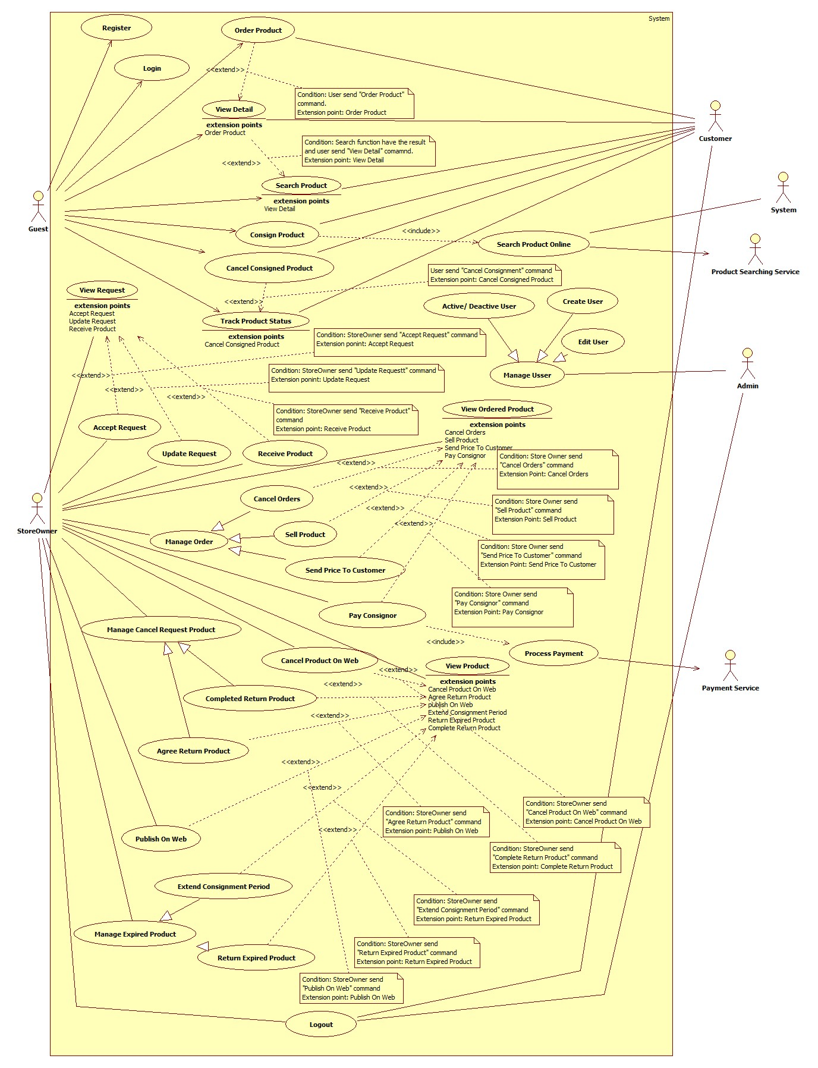

Figure : System Overview Use Case

### List of Use Case

#### <Guest> Overview Use Case

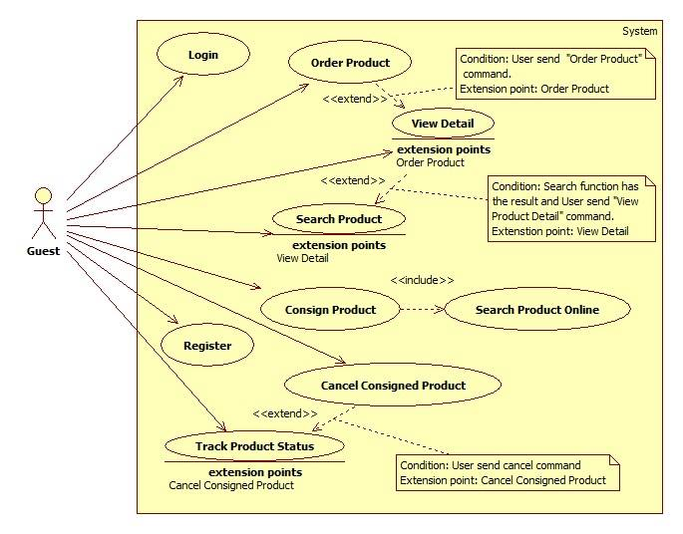

Figure : <Guest> Overview Use Case

##### <Guest> Consign product

**Use Case Diagram**



Figure : <Guest> Consign Product

**Use Case Specification**

|  |  |  |  |
| --- | --- | --- | --- |
| **USE CASE – HPS001** | | | |
| **Use Case No.** | **HPS001** | Use Case Version | 2.0 |
| **Use Case Name** | Consign Product | | |
| **Author** | Huynh Cong Duc | | |
| **Date** | May 23, 2015 | Priority | High |
| **Actor**:   * Guest * Customer   **Summary**:   * This use case allows user to send consigning-product request.   **Goal**:   * User sends consigning requests successfully.   **Triggers**:   * User sends command to consign product.   **Preconditions**: N/A  **Post Conditions**:   * **Success**: Show success message. * **Fail:** Show error message.   **Main Success Scenario**:   |  |  |  | | --- | --- | --- | | No | Actor Action | System Response | | 1 | User sends command to consign product. | System requires user to input following information of product:   * “Chọn cách ký gửi”   + User chooses the way to check their information with 2 options: “Tên sản phẩm” and “Mã sản phẩm”.   + “Tên sản phẩm” is chosen by default. * “Tên sản phẩm”:   + Free text input.   + Min-length: 5 characters.   + Max-length: 100 characters.   + Required. * “Mã số”:   + Free text input.   + Required. * “Loại”:   + Option (example: Giày, Áo, Quần, Thắt lưng…).   + Required. * “Hãng”:   + Free text input.   + Max-length: 50 characters. * “Độ Mới”:   + Free text input.   + Format: number 1 -> 99   + Required. * “Mô tả”: free text input.   Systems also shows following component:   * “Bước kế”: send command completed inputting values.   [Exception: 1, 2, 3, 4] | | 2 | User inputs and sends product’s information to system.  [Alternative 1, 2] | System calls “Search Product Online” function to get a list of products with provided product’s information. System then show this list to user with following information:   * “Tên”: label. * “Hình ảnh”: link. * “Chọn”: user chooses one of listed products. System will default choose first product.   Systems also shows following component:   * “Không phải sản phẩm của bạn”: send command to finish choosing product without product chosen. * “Trở về”: send command to go back to providing-product’s information step.   “Bước kế”: send command to finish choosing product with a product chosen. | | 3 | User chooses a product and inform system.  [Alternative 3, 4, 5, 6] | System get chosen product and get its price as basic price. System gets all suitable stores for product based on category, calculates suggested price of each store then shows it to user with following information:   * “Tên”: label. * “Điện thoại”: label * “Địa chỉ”: label. * “Giá”: label. * “Chọn”: user chooses one of listed stores. System will default choose first store.   When user has already choose a store, system will require user to input:   * “Giá mong muốn”:   + Free text input:   + Format: number   + Required.   Systems also shows following component:   * “Trở về”: Send command to go back to product-choosing step. * “Bước kế”: Send command to finish choosing store.   [Exception 5] | | 4 | User chooses a store and informs system.  [Alternative 7, 8] | System requires user to provide personal information listed below:   * “Tên”:   + Free text input.   + Min-length: 5 characters.   + Max-length: 50 characters.   + Required. * “Địa chỉ”: free text input. * “Điện thoại”:   + Free text input.   + Min-length: 9 characters.   + Max-length: 11 characters.   + Number format.   + Required. * Email:   + Free text input.   + Email format.   + Regular expression: “^[a-zA-Z0-9_.+-]+@[a-zA-Z0-9-]+\.[a-zA-Z0-9-.]+$". * “Cách thoan toán”: user chooses one of 2 options: “Tiền mặt” and “Tài khoản paypal”. * “Mã tài khoản”: free text input. * “Hình ảnh”:   + A large box for product’s image.   + Required. * “Ngày hẹn”:   + “Từ ngày”:     - User picks a date.     - Default date: the next day.     - Required.   + “Đến ngày”     - User picks a date.     - Default date: the next 4 day.     - Required. * “Cách giao hàng": user chooses one of two options: “Cửa hàng đến nhận” or “Tự mang đến”.   Systems also show following component:   * “Chọn ảnh”: choose an image in user pc (when there is no chosen image). * “Trở về”: send command to go back to store-choosing step. * “Gửi yêu cầu”: send command to complete inputting personal information.   For customer, system will use information of customer’s profile to fill some fields automatically.  For guest, the first time guest consigns, system will save information and save it for the next time guest consign. But it will only last a short time.  [Exception 6, 7, 8, 9, 10, 11,12] | | 5 | User inputs and sends personal information to system.  [Alternative 9, 10, 11, 12, 13, 14] | System completes consigning request with all the information user provides. A successful message will be shown with information about consigned product. |   **Alternative Scenario**:   |  |  |  | | --- | --- | --- | | No | Actor Action | System Response | | 1 | User chooses “Tên sản phẩm” option. | “Tên sản phẩm”, “Hãng” will be shown and “Mã sản phẩm” will be hided. System will use “Tên sản phẩm” and “Hãng” fields to check similar products online. | | 2 | User types in “Mã sản phẩm” input in providing-product’s information step. | “Mã sản phẩm” will be shown and “Tên sản phẩm” with “Hãng” will be hided. System will use “Mã sản phẩm” field to check exact products online. | | 3 | User sends request to go back to providing-product’s information step in product-choosing step. | Systems shows providing product’s info step. | | 4 | System find exact products online with provided information when searching product by “Mã sản phẩm” in product-choosing step. | System will show user store-choosing step with suggested prices of each store. | | 5 | System cannot find any products online with provided information when searching product by “Tên sản phẩm” in product-choosing step. | System will show user store-choosing step without suggested price. Instead of that in “Giá” information will show “Thương lượng” text. | | 6 | User clicks “Không phải sản phẩm của bạn” | System will show user store-choosing step without suggested price. Instead of that in “Giá” information will show “Thương lượng” text. | | 7 | User sends request to go back to product-choosing step in store-choosing step when system can find list of products with provided product’s information. | System will show user product-choosing step. | | 8 | User sends request to go back to product-choosing step in store-choosing step when system cannot find any product online with provided product’s information. | System will show user providing product’s information step. | | 9 | User have already chosen a product in product-choosing step. | “Hình ảnh” will show an image of chosen product automatically. | | 10 | User chooses “Tiền mặt” option in providing personal info step. | “Mã tài khoản” free text input will be hidden. | | 11 | User chooses “Tài khoản paypal” option in providing personal info step. | “Mã tài khoản” free text input will be shown and be required. | | 12 | User selects image in providing product’s info step. | System requires user to browse image in user’s computer and upload on page. | | 13 | User changes image in providing product’s info step. | System requires user to browse image in user’s computer and upload on page. | | 14 | User sends request to go back to store-choosing step. | Systems shows store-choosing step. |   **Exceptions**:   |  |  |  | | --- | --- | --- | | No | Actor Action | System Response | | 1 | “Tên sản phẩm” text input and “Mã sản phẩm” text input are empty | System shows error message: “Xin nhập tên hoặc mã sản phẩm”. | | 2 | Inputted value of “Tên sản phẩm” field is less than 5 characters or longer than 100 characters. | System shows error message: “Yêu cầu 5 đến 100 ký tự”. | | 3 | “Loại” is not selected. | System shows error message: “Xin chọn loại sản phẩm”. | | 4 | Cannot find products with provided “Mã sản phẩm”. | System shows error message: “Không thể tìm thấy sản phẩm với mã số này”. | | 5 | “Giá mong muốn” is empty or not number format | System shows error message: “Xin nhập đúng giá”. | | 5 | Inputted value of “Full name” field is less than 5 characters or longer than 50 characters. | System shows error message: “Tên phải từ 5 đến 50 ký tự”. | | 6 | “Từ ngày” date is not selected. | System shows error message: “Xin chọn ngày hẹn đầu”. | | 7 | “Đến ngày” date is not selected. | System shows error message: “Xin chọn ngày hẹn cuối”. | | 8 | “Từ ngày” date is bigger than “Đến ngày” date. | System shows error message: “Từ ngày phải nhỏ hơn đến ngày”. | | 9 | Inputted value of “Điện thoại” field is empty or invalid. | System shows error message: “Xin nhập đúng số điện thoại”. | | 10 | Inputted value of “Email” field is not empty and invalid. | System shows error message: “Xin nhập đúng email”. | | 11 | Inputted value of “Mã tài khoản” field is required and is empty or invalid. | System shows error message: “Xin nhập đúng mã tài khoản”. |   **Relationships**:   * Including use-case: Include Search Product Online.   **Business Rules**:   * When request is sent successfully, consignment’s status is “waiting” and product’s status is “not available”. This request will be checked by store owner as new request. System will send message and email to user to confirm request has been sent successfully. * If user provides correct UPC, system will find correct product. * If user provides name not UPC in providing-product’s information step, system fill find online similar product with information of “Tên sản phẩm”, “Loại” and “Hãng” (not necessary) then return a list of product with similar information and show it to user. System also shows a message: “Nếu không tìm thấy sản phẩm của bạn, có thể bạn đã nhập sai tên. Vui lòng nhấn quay lại để sửa thông tin”. * If list of products is too much (greater than 10 items) or empty (no item), system will skip product-choosing step and require user choose a store in next step with no suggested price. Store owner will come, check and negotiate with user later when user’s request is accepted. * In store-choosing step, system finds stores that sell this kind of product, based on their category. Then system uses price of chosen product in product-choosing step as basic price. System will calculate suggestion price for each store based on basic price and formula of each store. System also shows a message: “Giá cửa hàng đề nghị có thể không chính xác. Cửa hàng sẽ kiểm tra và định giá chính xác khi đến nhận hàng”. * Formula for suggested price: $([Basic Price] * 60\%) * (1 ± formula/100)$* If there is no product found online, there will be no suggest price. Instead of that, In “Giá” column will show “Thương lượng” and a message: “Chúng tôi không thể tìm thấy sản phẩm của bạn. Cửa hàng sẽ lưu lại yêu cầu ký gửi này và định giá sản phẩm của bạn khi đến nhận hàng” will be shown. * After sending consignment request, user will receive a code to track product’s status and also consignment’s status. User can also use it to cancel consignment or extend it. * Store owner will contact and receive product on one of the day user chose. But store owner has the right to refuse request if it’s not what store owner need, and also refuse accepting product when checking it if product doesn’t resemble the information user provided. * For customer, store owner will use information in consignment, not customer’s information. So that, consignor is no need to be customer. But this deal will be saved in customer’s history. | | | |

##### <Guest> Track product status

**Use Case Diagram**



Figure : <Guest> Track Product Status

**Use Case Specification**

|  |  |  |  |
| --- | --- | --- | --- |
| **USE CASE – HPS002** | | | |
| **Use Case No.** | HPS002 | Use Case Version | 2.0 |
| **Use Case Name** | Track Product Status | | |
| **Author** | Huynh Cong Duc | | |
| **Date** | May 29, 2015 | Priority | High |
| **Actor**:   * Guest * Customer   **Summary**:   * This use case allows user to track product status.   **Goal**:   * User views product’s current status successfully.   **Triggers**:   * User sends tracking product’s status command.   **Preconditions**: N/A  **Post Conditions**:   * **Success:** View product’s current status. * **Fail:** Show error message.   **Main Success Scenario**:   |  |  |  | | --- | --- | --- | | Step | Actor Action | System Response | | 1 | User sends tracking product’s status command. | System shows guest following:   * “Mã sản phẩm”: free text input * “Kiểm tra”: send command to track product’s status.   In case of Customer, System will show a table with every consignment customer has done in history with following information:   * “Tên sản phẩm”: label. * “Mã ký gửi”: label. * “Ngày ký gửi”: label.   System also show “Xem” component to view details of it. | | 2 | User sends command to track product’s status with “Mã sản phẩm”.  [Alternative 1] | System finds product with provided code and shows guest with following information:   * “Hình ảnh”: A large field to show image of product. * “Tên sản phẩm”: label. * “Loại”: label. * “Hãng”: label * “Ngày ký gửi”: label. * “Trạng thái”: label. * “Người ký gửi”:   + “Tên”: label.   + “Địa chỉ”: label.   + “Điện thoại”: label.   + “Email”: label. * “Cửa hàng”: label.   System also shows following:   * “Hủy ký gửi”: send command to cancel consignment.   [Exception: 1] |   **Alternative Scenario**:   |  |  |  | | --- | --- | --- | | No | Actor Action | System Response | | 1 | System cannot find product with inputted “Mã sản phẩm”. | System shows message: “Sản phẩm với mã số này không tồn tại”. |   **Exceptions**:   |  |  |  | | --- | --- | --- | | No | Actor Action | System Response | | 1 | Inputted value of “Mã sản phẩm” field is empty. | System shows error message: “Xin nhập mã sản phẩm”. |   **Relationships**:   * Extending Use-case: Cancel Consigned Product (Guest sends a request to cancel a consigned products).   **Business Rules**:   * Guest can only track product’s status by code, while customer can view all the consignments in history. * Code is ID of consignment. * User can only cancel product before it is ordered. | | | |

##### <Guest> Cancel Consigned Product

**Use Case Diagram**



Figure : <Guest> Cancel Consigned Product

**Use Case Specification**

|  |  |  |  |
| --- | --- | --- | --- |
| **USE CASE – HPS003** | | | |
| **Use Case No.** | HPS003 | Use Case Version | 2.0 |
| **Use Case Name** | Cancel Consigned Product | | |
| **Author** | Huynh Cong Duc | | |
| **Date** | May 29, 2015 | Priority | High |
| **Actor**:   * Guest * Member   **Summary**:   * This use case allows user to cancel a consigned product.   **Goal**:   * User cancels a consigned product successfully.   **Triggers**:   * User sends canceling consigned product command.   **Preconditions**:   * User has valid code and is viewing a consigned product’s information. * Status of product is neither “Ordered”, “Cancelled” “Sold”, “Refused”, “Expired”, nor “Completed”.   **Post Conditions**:   * **Success:** Product’s status is changed to “Canceled”. * **Fail:** Show error message.   **Main Success Scenario**:   |  |  |  | | --- | --- | --- | | Step | Actor Action | System Response | | 1 | User sends canceling consigned product command.  [Alternative 1, 2] | System shows a confirming message if guest really wants to cancel this consigned product with two options “Đồng ý” and “Không”. | |  | User chooses “Đồng ý” option.  [Alternative 3] | Product’s status is changed to “Đã hủy” or “Đăng ký hủy”. |   **Alternative Scenario**:   |  |  |  | | --- | --- | --- | | Step | Actor Action | System Response | | 1 | User sends canceling consigned product command when product is not received | System shows a message to make sure they really want to cancel it with 2 options: “Đồng ý” or “Không”. | | 2 | User sends canceling consigned product command when product is already received but not ordered. | System shows a message to make sure they really want to cancel it with a price for storing product and 2 options: “Đồng ý” hoặc “Không”. | | 3 | Guest chooses “No” option. | Message will disappear. |   **Exceptions**: N/A  **Relationships**:   * Extended Use-case: Track product status.   **Business Rules**:   * Product can only be cancelled before it’s ordered. * If user cancels before store owner gets product, consign product process will be stopped. Consignment’s status is “Cancelled” and product’s status is “not available”, as display “Hoàn tất hủy”. * If user cancels after store owner gets product, user will be informed to take back product in a specific time and pay a forfeit for canceling consignment. After that time and user doesn’t come to take back product, store owner will have it. Consignment’s status is “Cancelled” and product’s status is “Cancelled”, as display “Đăng ký hủy”. | | | |

##### <Guest> Search Product

**Use Case Diagram**



Figure : <Guest> Search Product

**Use Case Specification**

|  |  |  |  |
| --- | --- | --- | --- |
| **USE CASE –** HPS004 | | | |
| **Use Case No.** | HPS004 | Use Case Version | 2.0 |
| **Use Case Name** | Search Product | | |
| **Author** | Nguyen Huy Hoang | | |
| **Date** | May 22, 2015 | Priority | High |
| **Actor**:   * Guest/Customer   **Summary**:   * This use case allows user to search product information by its name and category.   **Goal**:   * A list of products will be shown to user.   **Triggers**:   * User can search product to get product’s information. * User can choose top product’s category include: “Nam”, “Nữ”, “Trẻ em” or “Tất cả”, inputs to a free text input and send “Search Product” command.   **Preconditions**:   * User is in home page or category page.   **Post Conditions**:   * Success: Show search results which include a list of product. * Fail: Show an error message.   **Main Success Scenario**:   |  |  |  | | --- | --- | --- | | Step | Actor Action | System Response | | 1 | User choose product’s category include: “Nam”, “Nữ”, “Trẻ em” or “Tất cả”. |  | | 2 | User inputs the product’s name into free text input. |  | | 3 | User send “Search Product” command.  [Alternative 1] | System will show a list of product as a grid and order by product name.  [Exception 1] |   **Alternative Scenario**:   |  |  |  | | --- | --- | --- | | No | Actor Action | System Response | | 1 | Search not found | System will show a message: “Không tìm thầy sản phẩm nào phù hợp.” |   **Exceptions**:   |  |  |  | | --- | --- | --- | | No | Actor Action | System Response | | 1 | User not fill in product name and send “Search Product” command. | Show message: “Vui lòng nhập tên sản phẫm.” |   **Relationships**:   * Extending Use-cases: Extended by View Detail (Search function has the result and user send “View Product Detail” command).   **Business Rules**:   * Search by product name and category. * All products with relative name which user inputted will be show. The results will show list of product as a gird. * Product status is “On web” or “Ordered” will be show. | | | |

##### <Guest> Order Product

**Use Case Diagram**



Figure : <Guest> Order Product

**Use Case Specification**

|  |  |  |  |
| --- | --- | --- | --- |
| **USE CASE –** HPS005 | | | |
| **Use Case No.** | HPS005 | Use Case Version | 2.0 |
| **Use Case Name** | Order Product | | |
| **Author** | Nguyen Huy Hoang | | |
| **Date** | May 22, 2015 | Priority | High |
| **Actor**:   * Guest * Customer   **Summary**:   * This use case allows user order product.   **Goal**:   * Product will be ordered by user.   **Triggers**:   * User send “Order Product” command.   **Preconditions**:   * User is in product detail page.   **Post Conditions**:   * Success: Show success message, create an order of this product with user information * Fail: Show an error message.   **Main Success Scenario**:   |  |  |  | | --- | --- | --- | | Step | Actor Action | System Response | | 1 | User send “Order Product” command.  [Alternative 1] | System will navigate to enter user’s information include:   * “Tên”: Free text input, max length: 50. * “Email”: Free text input, regular expression: “^[a-zA-Z0-9_.+-]+@[a-zA-Z0-9-]+\.[a-zA-Z0-9-.]+$". * “Địa Chỉ”: Free text input. * “Số Điện Thoại”: Free text input, min length: 9, max length: 11. * A command to finish action. | | 2 | User input information. |  | | 3 | User send “Confirm Information” command.  [Alternative 2] | System create an order of this product with user information.  [Exception 1,2] | |  |  |  |   **Alternative Scenario**:   |  |  |  | | --- | --- | --- | | No | Actor Action | System Response | | 1 | If product have been ordered | System will show message: “Món hàng này đã có A người đặt, có thể bạn sẽ không mua được món hàng, vui lòng liên hệ với chủ cửa hàng để biêt thêm." With A is number of orders. | | 2 | If product is not special product. | System will send sms to notify price to user. |   **Exceptions**:   |  |  |  | | --- | --- | --- | | No | Actor Action | System Response | | 1 | User not fills all required textbox | Show message: “Vui lòng nhập thông tin vào nhưng ô bắt buộc.” | | 2 | User enter phone number is existed in another order of this product. | Show message: “Số điện thoại đã sử dụng để đặt món hàng này”. |   **Relationships**:   * Extending Use-cases: Extend from Product Detail (Search function has the result and user send “View Product Detail” command).   **Business Rules**:   * All require fill must be filled. * User can’t use same phone number to order same product. * If user login into system, user’s information is autofill. * On success scenario, system will send SMS to customer to notify success order. * Product status is change to “ordered”. | | | |

#### <Customer> Overview User Case



Figure : <Customer> Overview User Case

#### <Store Owner> Overview Use Case

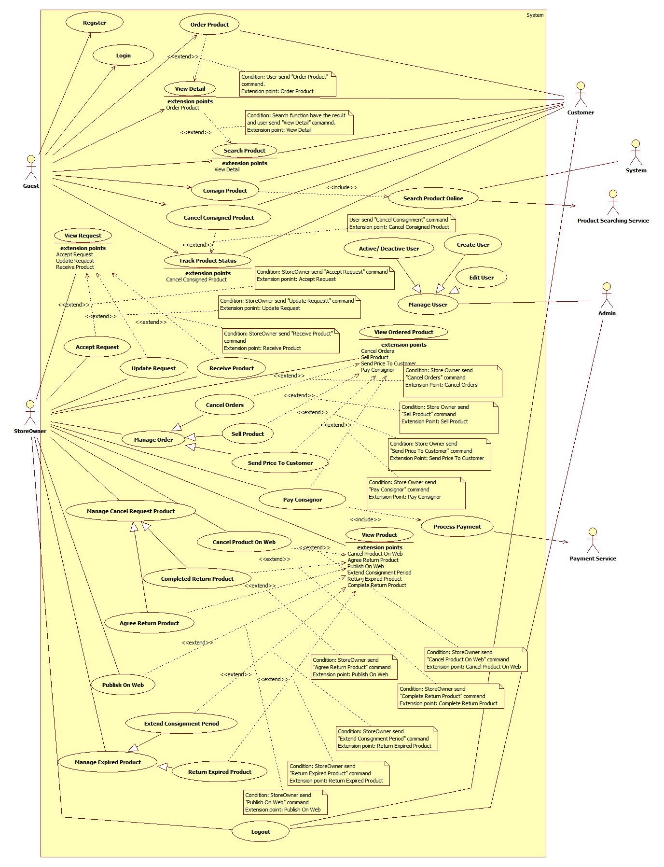

Figure : <Store Owner> Overview Use Case

##### <Store Owner> View Request

**Use Case Diagram**

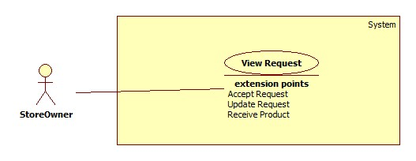

Figure : <Store Owner> View Request

**Use Case Specification**

|  |  |  |  |
| --- | --- | --- | --- |
| **USE CASE – HPS006** | | | |
| **Use Case No.** | HPS006 | Use Case Version | 2.0 |
| **Use Case Name** | View Request | | |
| **Author** | Huynh Cong Duc | | |
| **Date** | August 8, 2015 | Priority | High |
| **Actor**:   * Store Owner.   **Summary**:   * Show list of request for current store.   **Goal**:   * Store Owner view list of new request.   **Triggers**:   * Store Owner send request the system to view request list.   **Preconditions**:   * Store Owner has logged onto the system.   **Post Conditions**:   * **Success**: List of request is shown. * **Fail**: Show error message.   **Main Success Scenario**:   |  |  |  | | --- | --- | --- | | Step | Actor Action | System Response | | 1 | Store owner send request the system to view new request list. | System shows request list include following information:   * “Tên sản phẩm”: label. * “Tên khách hàng”: label. * “Ngày hẹn”: label. * “Giá”: label. * “Trạng thái”: label.   System also shows on each row a “Xem” component for viewing details of that request. | | 2 | Store owner chooses a request to view details. | System shows details of that request with listed information:   * “Ảnh”: image of product. * “Tên sản phẩm”: label. * “Loại”: label. * “Hãng”: label. * “Mô tả”: label. * “Độ mới”: label. * “Họ tên”: label. * “Điện thoại”: label. * “Email”: label. * “Địa chỉ”: label. * “Mã tài khoản”: label. * “Ngày ký gửi”: label. * “Ngày hẹn”: label. * “Cách giao hàng”: label. * “Ngày giao hàng”:   + Default by the first date of “Ngày hẹn”.   + Required. * “Giá tham khảo”: label. * “Giá mong muốn”: label.   If consignment’s status is “Chờ xử lý”, details will be label. System also shows some components below:   * “Đồng ý”: accept this request. * “Từ chối”: refuse this request. * “Đóng”: close details to go back to list new request.   If consignment’s status is “Chấp nhận yêu cầu”, details information will be able to edit with new field:   * “Giá thỏa thuận”:   + Free text input.   + Format: number.   + Required.   System also shows some components below:   * “Cập nhật”: update request. * “Chấp nhận”: receive product. * “Từ chối”: refuse product. * “Đóng”: close details to go back to list request.   [Exception: 1] |   **Alternative**: N/A  **Exceptions**:   |  |  |  | | --- | --- | --- | | No | Actor Action | System Response | | 1 | Store Owner sends command to view details when request has already handled. | System shows message: “Yêu cầu này đã được xử lý”. |   **Relationships**:   * Extending Use-case: Accept Request (Store Owner sends command to accept request, Update Request (Store Owner sends command to update request), Receive Product (Store Owner sends command to receive product).   **Business Rules**:   * Filter bar shall be shown to help Store Owner find consignment faster. * List are sorted by request date in chronological order. The the oldest request appears first in the list, while the newest one appears last. * This list shows only requests. If product has been received, request will disappear in this list. * Store Owner show be able to view status of request to do right action. | | | |

##### <Store Owner> Accept Request

**Use Case Diagram**

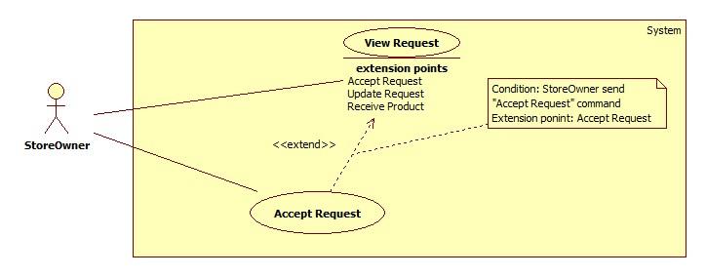

Figure : <Store Owner> Accept Request

**Use Case Specification**

|  |  |  |  |
| --- | --- | --- | --- |
| **USE CASE – HPS007** | | | |
| **Use Case No.** | HPS007 | Use Case Version | 2.0 |
| **Use Case Name** | Accept Request | | |
| **Author** | Huynh Cong Duc | | |
| **Date** | August 8, 2015 | Priority | High |
| **Actor**:   * Store Owner.   **Summary**:   * Store Owner accepts a new request.   **Goal**:   * Store Owner successfully accepts a request.   **Triggers**:   * Store Owner send command to accept a request.   **Preconditions**:   * Store Owner has logged onto the system. * Store Owner is viewing details of a new request.   **Post Conditions**:   * **Success**: Successfully accept a request. * **Fail**: Show error message.   **Main Success Scenario**:   |  |  |  | | --- | --- | --- | | Step | Actor Action | System Response | | 1 | While viewing details of a new request, Store Owner sends command to accept a request with appointment date.  [Alternative 1] | System saves appointment date and changes this request to “Chấp nhận yêu cầu”. |   **Alternative**:   |  |  |  | | --- | --- | --- | | No | Actor Action | System Response | | 1 | Store Owner sends command to refuse request | System requires a reason from Store Owner then changes this request to “Từ chối yêu cầu”. |   **Exceptions**:   |  |  |  | | --- | --- | --- | | No | Actor Action | System Response | | 1 | Store Owner sends command to accept request when request has already handled. | System shows message: “Yêu cầu này đã được xử lý”. |   **Relationships**:   * Extended Use-case: View Request.   **Business Rules**:   * After accepting request, this request’s status will change to “Chấp nhận yêu cầu”. Consignment’s status is “Accepted” and product’s status is “Not available”. * If store Owner cancels request, this request’s status will change to “Từ chối yêu cầu”. Consignment’s status is “Refused” and product’s status is “Not available”. * System will send message and email to consignor to confirm action on request. * If accepted request has the value of “Cách giao hàng” is “Cửa hang đến nhận” and “Ngày giao hàng” is current day, system will notify Store Owner in mobile application about this request immediately. | | | |

##### <Store Owner> Update Request

**Use Case Diagram**

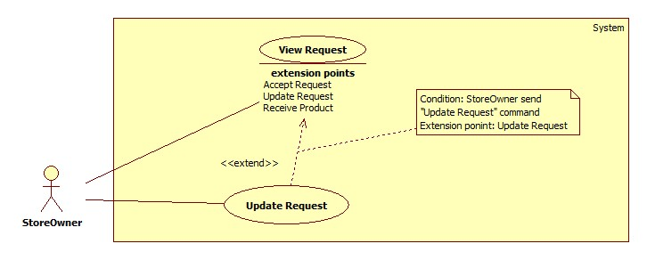

Figure : <Store Owner> Update Request

**Use Case Specification**

|  |  |  |  |
| --- | --- | --- | --- |
| **USE CASE – HPS008** | | | |
| **Use Case No.** | HPS008 | Use Case Version | 2.0 |
| **Use Case Name** | Update Request | | |
| **Author** | Huynh Cong Duc | | |
| **Date** | August 8, 2015 | Priority | High |
| **Actor**:   * Store Owner.   **Summary**:   * Store Owner update an accepted request.   **Goal**:   * Store Owner successfully update an accepted request.   **Triggers**:   * Store Owner send command to update request.   **Preconditions**:   * Store Owner has logged onto the system. * Store Owner is viewing details of an accepted request.   **Post Conditions**:   * **Success**: Successfully update accepted request. * **Fail**: Show error message.   **Main Success Scenario**:   |  |  |  | | --- | --- | --- | | Step | Actor Action | System Response | | 1 | While viewing details of an accepted request, Store Owner sends command to update it. | System update this request with provided information.  [Exception 1,2] |   **Alternative**: N/A  **Exceptions**:   |  |  |  | | --- | --- | --- | | No | Actor Action | System Response | | 1 | Store Owner does not provide valid information. | System show a message: “Xin nhập đúng thông tin”. | | 2 | Store Owner sends command to update when this request is already handled. | System show a message: “Yêu cầu này đã được xử lý”. |   **Relationships**:   * Extended Use-case: View Request.   **Business Rules**:   * After updating request, this request’s information will be changed. * Consignment’ status remains as “Accepted” and product’s status is “Not available”, as display “Chấp nhận yêu cầu” * If updated request has “Ngày giao hàng” is current date and “Cách giao hàng” is “Cửa hàng đến nhận”, system will inform Store Owner in mobile application about this request immediately. * System will send message and email to consignor to inform updated request. | | | |

##### <Store Owner> Receive Product

**Use Case Diagram**

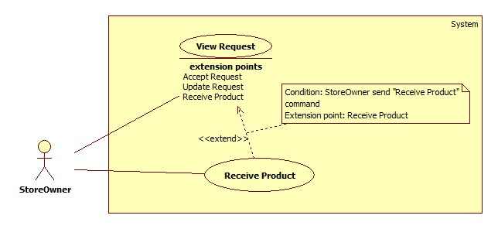

Figure : <Store Owner> Receive Product

**Use Case Diagram**

|  |  |  |  |
| --- | --- | --- | --- |
| **USE CASE – HPS009** | | | |
| **Use Case No.** | HPS009 | Use Case Version | 2.0 |
| **Use Case Name** | Receive Product | | |
| **Author** | Huynh Cong Duc | | |
| **Date** | August 8, 2015 | Priority | High |
| **Actor**:   * Store Owner.   **Summary**:   * Store Owner can receive product.   **Goal**:   * Store Owner successfully receive product.   **Triggers**:   * Store Owner send command to receive product.   **Preconditions**:   * Store Owner has logged onto the system. * Store Owner is viewing details of an accepted request.   **Post Conditions**:   * **Success**: Successfully accept product. * **Fail**: Show error message.   **Main Success Scenario**:   |  |  |  | | --- | --- | --- | | Step | Actor Action | System Response | | 1 | While viewing details of an accepted request, Store Owner sends command to receive product.  [Alternative 1] | System saves provided information and changes this request to “Đã nhận hàng”.  [Exception 1, 2] |   **Alternative**:   |  |  |  | | --- | --- | --- | | No | Actor Action | System Response | | 1 | Store Owner sends command to refuse product. | System requires a reason from Store Owner then changes this request to “Từ chối sản phẩm”. |   **Exceptions**:   |  |  |  | | --- | --- | --- | | No | Actor Action | System Response | | 1 | Store Owner does not provide valid information. | System shows message: “Xin nhập đúng thông tin”. | | 2 | Store Owner sends command to accept product when this request is already handled. | System shows message: “Yêu cầu này đã được xử lý”. |   **Relationships**:   * Extended Use-case: View Request.   **Business Rules**:   * When product is received, its status is displayed as “Đã nhận hàng” and this product will disappear in the request list and appear in product management. Consignment’s status now is “Received” and product’s is “Available”. * If product is refused, its sstatus will be displayed as “Từ chối sản phẩm”. Consignment’s status now is “Refuse” and product’s is “Not available”. * After accepting product, Store Owner will store the product and set the day to go on web for shopping. * Mobile application have the same function as this, to receive product and bring it back to store. * System will send message and email to consignor to confirm action on product. | | | |

##### <Store Owner> View Product

**Use Case diagram**

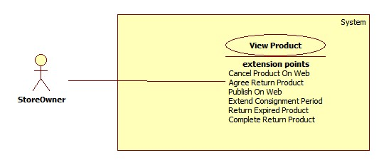

Figure : <Store Owner> View Product

**Use Case Specification**

|  |  |  |  |
| --- | --- | --- | --- |
| **USE CASE – HPS010** | | | |
| **Use Case No.** | **HPS010** | Use Case Version | 2.0 |
| **Use Case Name** | View Product | | |
| **Author** | Quan Tien Dan | | |
| **Date** | May 26, 2015 | Priority | High |
| **Actor**:   * Store Owner   **Summary**:   * This use case allows store owner to view products which was received from consignor.   **Goal**:   * Successfully displays some basic information of product to store owner.   **Triggers**:   * Store owner sends view product command.   **Preconditions**:   * Guest is logged in as Store Owner.   **Post Conditions**:   * **Success**: Information of product which was received is display to store owner. * **Fail**: Show error message.   **Main Success Scenario**:   |  |  |  | | --- | --- | --- | | Step | Actor Action | System Response | | 1 | Store owner sends view available product command. | System loads and displays information of products in table with following information:  + STT : label.  + Tên sản phẩm: label.  + Tên khách hàng: label.  + Trạng thái : label.  + Chi tiết : send command to view detail.  [Exception 1] |   **Alternative Scenario**: N/A  **Exceptions**:   |  |  |  | | --- | --- | --- | | No | Actor Action | System Response | | 1 | Error occurs during get available product information phase. | System shows error. |   **Relationships**:   * Extending Use-case: Publish On Web (Store owner sends publish on web command), Return Expired Product (Store owner sends return expired product command), Cancel Product On Web (Store owner sends cancel product on web command), Agree Return Product (Store owner sends agree cancel product command), Extend Consignment Period (Store owner sends extend consignment period command), Complete Return Product (Store owner sends complete return product command).   **Business Rules**:   * Only product with consignment status is “Received” can be displayed in this table. * Product will be displayed in this specific order: product status is available will display first, then product with on web status will display, next is product with canceled status and expired status. Product with completed status will be displayed lastest. * System will display the first 10 products. * System will display product which belongs to this store owner. | | | |

##### <Store Owner> Publish On Web

**Use Case diagram**

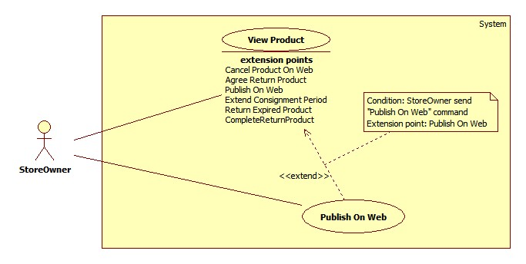

Figure : <Store Owner> Publish On Web

**Use Case Specification**

|  |  |  |  |
| --- | --- | --- | --- |
| **USE CASE – HPS011** | | | |
| **Use Case No.** | **HPS011** | Use Case Version | 2.0 |
| **Use Case Name** | Publish On Web | | |
| **Author** | Quan Tien Dan | | |
| **Date** | May 26, 2015 | Priority | High |
| **Actor**:   * Store Owner   **Summary**:   * This use case allows store owner to publish product on web.   **Goal**:   * Successfully publish product so it can be found by search function.   **Triggers**:   * When store owner sends publish product on web command.   **Preconditions**:   * Guest is logged in as Store Owner. * Product status must be “Available”.   **Post Conditions**:   * **Success**: Product status is changed to “On Web” and can be found by search function. * **Fail**: Show error, no information has been changed.   **Main Success Scenario**:   |  |  |  | | --- | --- | --- | | Step | Actor Action | System Response | | 1 | Store owner send view available product detail command. | System load product detail information into pop-up with following information:   * Tên sản phẩm:   + Free text input.   + Min-length: 5 characters.   + Max-length: 100 characters.   + Required. * Số seri:   + Free text input.   + Min-length: 5 characters.   + Max-length: 50 characters.   + Required. * Độ mới:   + Free text input.   + Number (1-99). * Loại sản phẩm:   + Single choice option. * Hãng:   + Min-length: 5 characters.   + Max-length: 50 characters.   + Required. * Mùa:   + Multi-choice option. * Tự động gửi giá:   + Single choice option. * Mô tả:   + Free text area. * Ảnh sản phẩm:   + Image. | | 2 | Store owner enters or modifies product detail information.  Store owner sends publish product on web command.  [Alternative 1] | System validates inputted data. [Exception 1,2,3]  System update product detail information in database.  System notifies store owner after complete.  System redirects to view available product page. |   **Alternative Scenario**:   |  |  |  | | --- | --- | --- | | Step | Actor Action | System Response | | 1 | Store owner dismiss popup. | System closes popop, redirect to view product page.  No information is recorded. |   **Exceptions**:   |  |  |  | | --- | --- | --- | | Step | Actor Action | System Response | | 1 | “Tên sản phẩm” is empty. | System show message “Vui lòng nhập tên sản phẩm”. | | 2 | “Hãng sản phẩm” is empty. | System show message “Vui lòng nhập hãng sản phẩm”. | | 3 | “Độ mới” is not a number or less than 0 or greater than 100. | System show message “Vui lòng nhập đúng độ mới của sản phẩm”. |   **Relationships**:   * Extended Use-case: View Product.   **Business Rules**:   * Only product in “Available” status can be published on web. * System will change product status on database base on product id, product status is changed to “On Web”. * If store owner chooses seasons for product, it will be display on home page during those season. If store owner doesn’t choose any season, it will display in “Sản phẩm nổi bật” category. * If store owner chooses “Tự động gửi giá” is “Có”, when product is ordered, system will automatic send product price to customer. * If store owner doesn’t choose new image for product, product image will remain as the image at beginning. * Product name, product brand and new status can not be empty. | | | |

##### <Store Owner> Agree Cancel Product

**Use Case diagram**

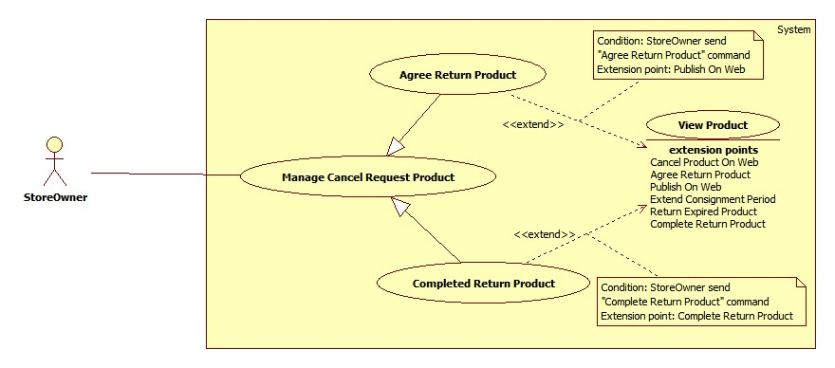

Figure : <Store Owner> Agree Cancel Product

**Use Case Specification**

|  |  |  |  |
| --- | --- | --- | --- |
| **USE CASE – HPS012** | | | |
| **Use Case No.** | **HPS012** | Use Case Version | 2.0 |
| **Use Case Name** | Agree Cancel Product | | |
| **Author** | Quan Tien Dan | | |
| **Date** | May 26, 2015 | Priority | High |
| **Actor**:   * Store Owner   **Summary**:   * This use case allows store owner to review cancel product request from consignor.   **Goal**:   * Handle consignor cancel product request and send notification to consignor.   **Triggers**:   * When store owner sends view cancel product request.   **Preconditions**:   * Guest is logged in as Store Owner. * Product status must be “Request Cancel”.   **Post Conditions**:   * **Success**: Product status is changed to “Not Yet Receive”. * **Fail**: Show error message. No information has been changed.   **Main Success Scenario**:   |  |  |  | | --- | --- | --- | | Step | Actor Action | System Response | | 1 | Store owner sends view canceled product detail command. | System load product’s information into pop-up with following information:   * Họ tên : label. * Địa chỉ : label. * Số điện thoại : label. * Email : label. * Tên sản phẩm : label. * Mã hàng kí gửi: label. * Giá kí gửi : label. * Ngày nhận hàng : label. * Ngày đăng kí hủy kí gửi : label. | | 2 | Store owner sends agree return product command.  [Alternative 1]  [Alternative 2] | System asks store owner to enter cancel fee. | | 3 | Store owner enters cancel fee and send process command. | System validates inputted data.  [Exception 1].  System update database.  System notifies to consignor via SMS or email.  System redirects to view product page. |   **Alternative Scenario**:   |  |  |  | | --- | --- | --- | | Step | Actor Action | System Response | | 1 | Store owner sends disagree cancel request command. | System update database.  System notifies to consignor via SMS or email.  System redirects to view product page. | | 2 | Store owner dismiss popup. | System closes popup, redirect to view product page.  No information is recorded. | |  |  |  |   **Exceptions**:   |  |  |  | | --- | --- | --- | | Step | Actor Action | System Response | | 1 | Cancel fee is not a number of less than 0. | System shows error “Vui lòng tiền phạt hủy kí gửi” and asks store owner to re-enter. |   **Relationships**:   * Extended Use-case: View Product.   **Business Rules**:   * Product status will be changed from “Request Cancel” to “Not Yet Receive” if store owner agrees consignor cancel request. * Product status will be changed from “Request Cancel” to “On Web” if store owner doens’t agree consignor cancel request. * If consignor has both phone and email information system will send SMS and email to consignor. If not system will send SMS to consignor. * Consignor will receive message about time to take back product and cancel fee of this cancellation if store owner agrees consignor cancel request. * Consignor will receive notification if store owner doesn’s agree consignor cancel request. * System will suggest cancel fee to store owner with this fomular:   + Cancel fee = 30 % x negotiated price. | | | |

##### <Store Owner> Complete Return Product

**Use Case diagram**



Figure : <Store Owner> Complete Return Product

**Use Case Specification**

|  |  |  |  |
| --- | --- | --- | --- |
| **USE CASE – HPS013** | | | |
| **Use Case No.** | **HPS013** | Use Case Version | 2.0 |
| **Use Case Name** | Complete Return Product | | |
| **Author** | Quan Tien Dan | | |
| **Date** | May 26, 2015 | Priority | High |
| **Actor**:   * Store Owner   **Summary**:   * This use case allows store owner to return product to consignor after agree consignor cancel product request.   **Goal**:   * Return product and complete consignment.   **Triggers**:   * When store owner send complete return product command.   **Preconditions**:   * Guest is logged in as Store Owner. * Product status must be “NotYetReceive”.   **Post Conditions**:   * **Success**: Product status is changed to “Not Available”, and update this consignment status to “Completed”. * **Fail**: Show error message. No information has been changed.   **Main Success Scenario**:   |  |  |  | | --- | --- | --- | | Step | Actor Action | System Response | | 1 | Store owner send view canceled product detail command. | System load product’s information into pop-up with following information:   * Họ tên : label. * Địa chỉ : label. * Số điện thoại : label. * Email : label. * Tên sản phẩm : label. * Mã hàng kí gửi: label. * Giá kí gửi : label. * Ngày nhận hàng : label. * Ngày đăng kí hủy kí gửi : label. | | 2 | Store owner sends complete return product command.  [Alternative 1] | System shows pop-up requires store owner to enter cancel product fee. | | 3 | Store owner enter cancel product fee.  [Alternative 2] | System validates inputted data.  [Exception 1]  System update database.  System redirects to view canceled product page. |   **Alternative Scenario**:   |  |  |  | | --- | --- | --- | | Step | Actor Action | System Response | | 1 | Store owner dismiss popup. | System closes popop, redirect to view product page.  No information is recorded. | | 2 | Store owner dismiss popup. | System closes popop. |   **Exceptions**:   |  |  |  | | --- | --- | --- | | Step | Actor Action | System Response | | 1 | Cancel product fee is not valid | System show message “Vui lòng nhập tiền phạt” and requires store owner to re-enter. |   **Relationships**:   * Extended Use-case: View Product.   **Business Rules**:   * Product status will be changed to “Not Availalbe”. * Consignment status will be changed to “Completed”. * Consignor must request cancel product before can take back product. | | | |

##### <Store Owner> Return Expired Product

**Use Case diagram**

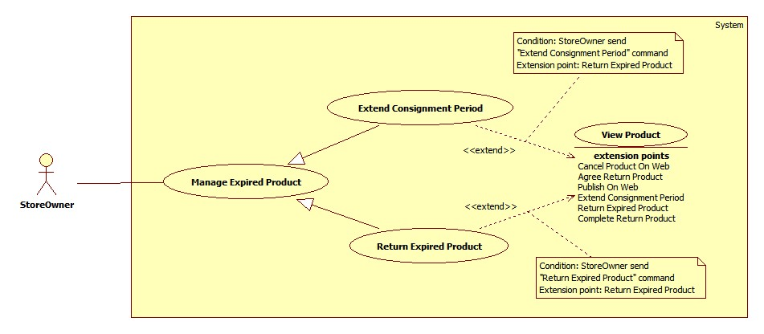

Figure : <Store Owner> Return Expired Product

**Use Case Specification**

|  |  |  |  |
| --- | --- | --- | --- |
| **USE CASE – HPS014** | | | |
| **Use Case No.** | **HPS014** | Use Case Version | 2.0 |
| **Use Case Name** | Return Expired Product | | |
| **Author** | Quan Tien Dan | | |
| **Date** | May 26, 2015 | Priority | High |
| **Actor**:   * Store Owner   **Summary**:   * This use case allows store owner to return expired product to consignor.   **Goal**:   * Successfully return expired product.   **Triggers**:   * Store owner sends return expired product command.   **Preconditions**:   * Guest is logged in as Store Owner. * Product status must be “Expired”.   **Post Conditions**:   * **Success**: Product status is changed to “Not Available”. * **Fail**: Show error message.   **Main Success Scenario**:   |  |  |  | | --- | --- | --- | | Step | Actor Action | System Response | | 1 | Store owner sends view expired detail product command. | System loads information of expired products into pop-up with following information:   * Họ tên:   + Label. * Địa chỉ:   + Label. * Số điện thoại:   + Label. * Email:   + Label. * Tên sản phẩm:   + Label. * Mã hàng kí gửi:   + Label. * Ngày kí gửi:   + Label. * Giá thỏa thuận:   + Label. * Số ngày quá hạn:   + Label. | | 2 | Store owner sends return expired product command.  [Alternative 1] | System show suggest stored fee.  System show remain stored fee if exist.  System asks store owner to confirm. | | 3 | Store owner enter total stored fee and send complete command. | System validats inputted data.  [Exception 1]  System updates database.  System redirects to view expired product page. |   **Alternative Scenario**:   |  |  |  | | --- | --- | --- | | No | Actor Action | System Response | | 1 | Store owner dismiss popup. | System closes popop, redirect to view product page.  No information is recorded. |   **Exceptions**:   |  |  |  | | --- | --- | --- | | No | Actor Action | System Response | | 1 | Cancel fee is not valid. | System shows message “Vui lòng nhập phí hủy kí gửi”. |   **Relationships**:   * Extended Use-case: View Product.   **Business Rules**:   * Stored fee is suggested by system with this formula : * If negotiated price >= 1.000.000 vnd.   (Stored fee = 10.000 x Overdue Days ) + remain extend fee (vnd).   * If negotiated price < 1.000.000 vnd.   (Stored fee = 5.000 x Overdue Days ) + remain extend fee (vnd).   * Overdue Days is counted right after consignment is overdue. * Product status is changed from “Expired” to “Not Available”, consignment status is changed from “Expired” to “Completed”. | | | |

##### <Store Owner> Cancel Product On Web

**Use Case diagram**

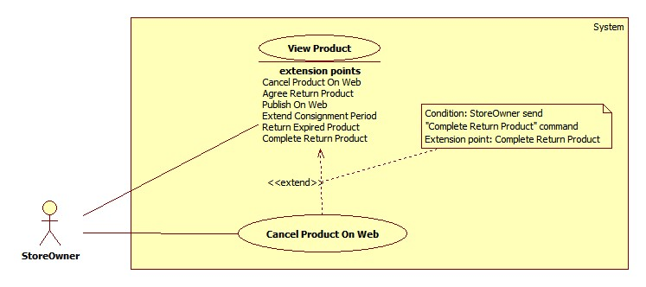

Figure : <Store Owner> Cancel Product On Web

**Use Case Specification**

|  |  |  |  |
| --- | --- | --- | --- |
| **USE CASE – HPS015** | | | |
| **Use Case No.** | **HPS015** | Use Case Version | 2.0 |
| **Use Case Name** | Cancel Product On Web | | |
| **Author** | Quan Tien Dan | | |
| **Date** | May 26, 2015 | Priority | High |
| **Actor**:   * Store Owner   **Summary**:   * This use case allows store owner to cancel product when consignor come to store and ask to take back product.   **Goal**:   * Sucessfully return product to consignor.   **Triggers**:   * When store owner send cancel product on web command.   **Preconditions**:   * Guest is logged in as Store Owner. * Product status must be “On Web”.   **Post Conditions**:   * **Success**: Product status is changed to “NotAvailable”. Consignment status is changed to “Canceled” * **Fail**: Show error message. No information has been changed.   **Main Success Scenario**:   |  |  |  | | --- | --- | --- | | Step | Actor Action | System Response | | 1 | Store owner sends view product detail command. | System loads and displays product information with following information:   * Tên sản phẩm:   + Free text input.   + Min-length: 5 characters.   + Max-length: 50 characters.   + Required. * Số seri:   + Free text input.   + Min-length: 5 characters.   + Max-length: 50 characters.   + Required. * Ngày mua hàng:   + Label.   + Not editable. * Loại sản phẩm:   + Single choice option. * Hãng:   + Min-length: 5 characters.   + Max-length: 50 characters.   + Required. * Mùa:   + Multi-choice option. * Tự động gửi giá:   + Single choice option. * Mô tả:   + Free textarea. * Ảnh sản phẩm:   + Image. | | 2 | Store owner sends cancel product on web command.  [Alternative 1] | System shows pop-up requires store owner to enter cancel product fee. | | 3 | Store owner enter cancel product fee.  [Alternative 2] | System validates inputted data.  [Exception 1]  System update database.  System redirects to view on web product page. |   **Alternative Scenario**:   |  |  |  | | --- | --- | --- | | Step | Actor Action | System Response | | 1 | Store owner dismiss popup. | System closes popop, redirect to view product page.  No information is recorded. | | 2 | Store owner dismiss popup. | System closes current popop |   **Exceptions**:   |  |  |  | | --- | --- | --- | | Step | Actor Action | System Response | | 1 | Cancel fee is not valid. | System shows message “Vui lòng nhập phí hủy kí gửi”. |   **Relationships**:   * Extended Use-case: View Product.   **Business Rules**:   * Consignor has to pay canceled fee if they want to take back product. * If product has been ordered, they can not request cancel product. * Consignor must provide consignment identifier and consignor phone number to store owner, if those information is matched with store owner data, consignor can request take back product. | | | |

##### <Store Owner> Extend Consignment Period

##### Use Case diagram



Figure : <Store Owner> Extend Consignment Period

**Use Case Specification**

|  |  |  |  |
| --- | --- | --- | --- |
| **USE CASE – HPS016** | | | |
| **Use Case No.** | **HPS016** | Use Case Version | 2.0 |
| **Use Case Name** | Extend Consignment Period | | |
| **Author** | Quan Tien Dan | | |
| **Date** | May 26, 2015 | Priority | High |
| **Actor**:   * Store Owner   **Summary**:   * This use case allows store owner to extend consignment period which was expired.   **Goal**:   * Successfully extend consignment period.   **Triggers**:   * Store owner sends extend consignment period command.   **Preconditions**:   * Guest is logged in as Store Owner.   **Post Conditions**:   * **Success**: Product status is changed to “On Web”. * **Fail**: N/A.   **Main Success Scenario**:   |  |  |  | | --- | --- | --- | | Step | Actor Action | System Response | | 1 | Store owner sends view expired detail product command. | System loads information of expired products into pop-up with following information:   * Họ tên: Label. * Địa chỉ: Label. * Số điện thoại: Label. * Email: Label. * Tên sản phẩm: Label. * Mã hàng kí gửi: Label. * Ngày kí gửi: Label. * Giá thỏa thuận: Label. * Số ngày quá hạn: Label. | | 2 | Store owner sends extend consignment period command.  [Alternative 1] | System show suggest stored fee.  System asks store owner to confirm about the extension. | | 3 | Store owner enter stored fee and send complete command. | System validates inputted data.  [Exception 1]  System updates database.  System redirects to view expired product page. |   **Alternative Scenario**:   |  |  |  | | --- | --- | --- | | No | Actor Action | System Response | | 1 | Store owner dismiss popup. | System closes popop, redirect to view product page.  No information is recorded. |   **Exceptions**:   |  |  |  | | --- | --- | --- | | No | Actor Action | System Response | | 1 | Stored fee is not valid | System shows error and asks store owner to re-enter stored fee. |   **Relationships**:   * Extended Use-case: View Product.   **Business Rules**:   * After extend consignment period, this consignment will be expired after 30 days later. * If consignor is late to extend consignment period, they have to pay stored fee. * Stored fee is suggested by system with this formula :   + If negotiated price >= 1.000.000 vnd.   Stored fee = 10.000 x Overdue Days (vnd).   * + If negotiated price < 1.000.000 vnd.   Stored fee = 5.000 x Overdue Days (vnd).   * Overdue Days is counted right after consignment is overdue. * System will save stored fee if exist to database. | | | |

##### <Store Owner> View Ordered Product

**Use Case diagram**

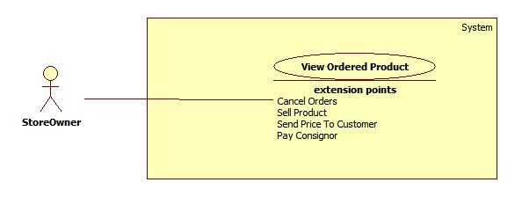

Figure : <Store Owner> View Ordered Product

**Use Case Specification**

|  |  |  |  |
| --- | --- | --- | --- |
| **USE CASE – HPS025** | | | |
| **Use Case No.** | **HPS017** | Use Case Version | 2.0 |
| **Use Case Name** | View Ordered Product | | |
| **Author** | Quan Tien Dan | | |
| **Date** | May 26, 2015 | Priority | High |
| **Actor**:   * Store Owner   **Summary**:   * This use case allows store owner to view products which was ordered or sold.   **Goal**:   * Successfully view ordered products.   **Triggers**:   * Store owner sends view ordered product command.   **Preconditions**:   * Guest is logged in as Store Owner.   **Post Conditions**:   * **Success**: Ordered or sold products is display to store owner. * **Fail**: Show error message.   **Main Success Scenario**:   |  |  |  | | --- | --- | --- | | Step | Actor Action | System Response | | 1 | Store owner sends view ordered product command. | System loads and displays information of ordered products in table with following information:  + STT : label.  + Tên khách hàng: label.  + Tên sản phẩm: label.  + Trạng thái : label.  + Chi tiết : send command to view detail.  [Exception 1] |   **Alternative Scenario**: N/A  **Exceptions**:   |  |  |  | | --- | --- | --- | | No | Actor Action | System Response | | 1 | Error occurs during get ordered product information phase. | System shows error. |   **Relationships**:   * Extending Use-case: Send Product Price To Customer (Store owner sends send product price to customer command), Cancel Orders (Store owner sends cancel all orders command), Sell Product (Store owner sends sell product command), Pay Consignor (Store owner sends pay consignor command).   **Business Rules**:   * Only product in “Ordered” status can be displayed in this table. * Product will be displayed in this specific order: product status is ordered will display first. Product with sold status will be displayed lastest. * System will display the first 10 available products. * System will display product which belongs to this store owner. | | | |

##### <Store Owner> Pay Consignor

**Use Case diagram**

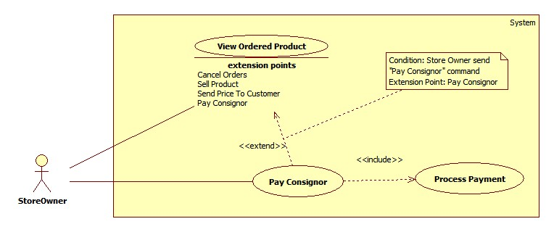

Figure : <Store Owner> Pay Consignor

**Use Case Specification**

|  |  |  |  |
| --- | --- | --- | --- |
| **USE CASE – HPS018** | | | |
| **Use Case No.** | **HPS018** | Use Case Version | 2.0 |
| **Use Case Name** | Pay Consignor | | |
| **Author** | Quan Tien Dan | | |
| **Date** | May 26, 2015 | Priority | High |
| **Actor**:   * Store Owner   **Summary**:   * This use case allows store owner to pay consignor after sell their product.   **Goal**:   * Complete consignment and return money to consignor.   **Triggers**:   * When store owner send pay consignor command.   **Preconditions**:   * Guest is logged in as Store owner and is on view sold product page.   **Post Conditions**:   * **Success**: Change product status to “Not Available” and consignment status to “Completed”. * **Fail**: Show error message. No information has been changed.   **Main Success Scenario**:   |  |  |  | | --- | --- | --- | | Step | Actor Action | System Response | | 1 | Store owner sends view product detail command. | System loads information about the product into pop-up with following information.   * Họ tên:   + Label. * Địa chỉ:   + Label. * Số điện thoại:   + Label. * Email:   + Label. * Tài khoản Paypal:   + Label. * Tên sản phẩm:   + Label. * Mã kí gửi:   + Label. * Giá kí gửi:   + Label. * Giá thực bán:   + Label. * Ngày kí gửi:   + Label. * Tiền trả khách hàng:   + Input field.   + Editable | | 2 | Store owner enters return price | System validated inputted data. [Exception 1]. | | 3 | Store owner sends process normal payment command.  [Alternative 1]  [Alternative 2] | System update database.  System redirects to view ordered product page. |   **Alternative Scenario**:   |  |  |  | | --- | --- | --- | | Step | Actor Action | System Response | | 1 | Store owner dismiss popup. | System closes popop, redirect to view ordered product page.  No information is recorded. | | 2 | Store owner sends pay consignor via payment service.  Store owner processes payment on payment service page.  Store owner send return to HPS website | System loads information online payment with following information.   * Cmd: text, hidden. * Business: text, hidden. * ReturnURL: text, hidden. * Rm: number, hidden. * Item_name: text, hidden. * Item_number: number, hidden. * Currency_code: text, hiddent. * Amount : number, hidden.   System redirect to payment service page.  System retrieves return value of payment process. [Exception 2]  System updates database.  System redirects to view ordered product page. |   **Exceptions**:   |  |  |  | | --- | --- | --- | | Step | Actor Action | System Response | | 1 | If inputted value is not valid. | System shows notification and requests store owner to re-enter the value. | | 2 | Returned value of paypent service is not valid | System cancel payment, redirect to view ordered product page.  No information has been changed. |   **Relationships**:   * Extended Use-case: View Ordered Product. * Extending Use-case: Process Payment (Store owner sends pay consignor via payment service command).   **Business Rules**:   * The amount of money which return to consignor must be greater than 0. * The amount of money is negotiated by consignor and store owner. * Store owner cannot change receiver’s information. * System will load payment information from database. * Store owner has to provide right information about their online payment account. * Only consignment which has consignor online payment account can performance this use case. * When payment is completed, system will send SMS to consignor to notify them about the payment. | | | |

##### <Store Owner> Send Product Price To Customer

**Use Case diagram**

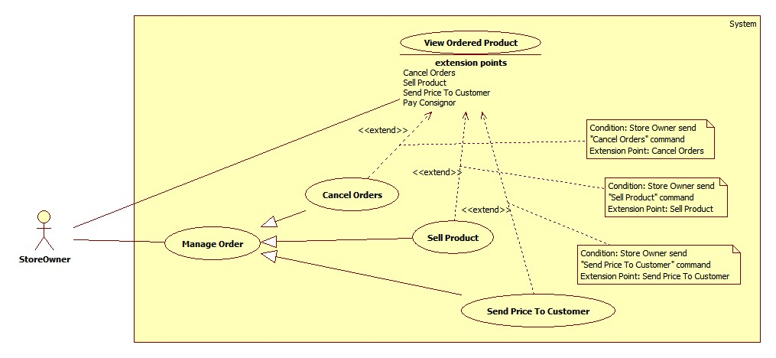

Figure : <Store Owner> Send Product Price To Customer

**Use Case Specification**

|  |  |  |  |
| --- | --- | --- | --- |
| **USE CASE – HPS019** | | | |
| **Use Case No.** | **HPS019** | Use Case Version | 2.0 |
| **Use Case Name** | Send Product Price To Customer | | |
| **Author** | Quan Tien Dan | | |
| **Date** | May 26, 2015 | Priority | Normal |
| **Actor**:   * Store Owner   **Summary**:   * This use case allows store owner to send product price to customer who ordered this product.   **Goal**:   * Successfully send product information to customer.   **Triggers**:   * Store owner sends send product price to customer command.   **Preconditions**:   * Guest is logged in as Store Owner. * Product has been ordered by at least 1 customer. * Product “IsSpecial” value is 1.   **Post Conditions**:   * **Success**: Send SMS or email to customer about product price. * **Fail**: N/A.   **Main Success Scenario**:   |  |  |  | | --- | --- | --- | | Step | Actor Action | System Response | | 1 | Store owner sends view ordered product detail command. | System loads and displays information of ordered products in table with following information:   * Giá kí gửi: Label. * Giá gửi khách hàng: Free input text. * Danh sách người đặt mua: table with 5 columns:   + checkbox   + Tên khách hàng : label   + Ngày đặt mua: label   + Thông tin liên hệ : label   + Chi tiết : label | | 2 | Store owner chooses 1 or more customer.  Store enter price which is sent to customer.  Store owner sends send product price to customer command.  [Alternative 1] | System validates inputted data. [Exception 1,2]  System notifies to customer.  System updates database.  System redirects to view ordered product page. |   **Alternative Scenario**:   |  |  |  | | --- | --- | --- | | No | Actor Action | System Response | | 1 | Store owner dismiss popup. | System closes popop, redirect to view ordered product page.  No information is recorded. |   **Exceptions**:   |  |  |  | | --- | --- | --- | | No | Actor Action | System Response | | 1 | Store doesn’t choose any customer. | System shows error message “Vui lòng chọn ít nhất một khách hàng”. | | 2 | Selling price is not number or less than 0 or is empty. | System shows error message “Vui lòng nhập gửi khách hàng”. |   **Relationships**:   * Extended Use-case: View Ordered Product.   **Business Rules**:   * Store owner must check at least one customer to send product price. * If store owner already sent product price to customer, “Chi tiết” column will display as “Đã gửi giá xxx ngàn đồng” with xxx is the price store owner has sent. * Only orders which has “Waiting” status can be display in “Danh sách người đặt mua” table. | | | |

##### <Store Owner> Cancel Orders

**Use Case diagram**



Figure : <Store Owner> Cancel Orders

**Use Case Specification**

|  |  |  |  |
| --- | --- | --- | --- |
| **USE CASE – HPS020** | | | |
| **Use Case No.** | **HPS020** | Use Case Version | 2.0 |
| **Use Case Name** | Cancel Orders | | |
| **Author** | Quan Tien Dan | | |
| **Date** | May 26, 2015 | Priority | Normal |
| **Actor**:   * Store Owner   **Summary**:   * This use case allows store owner to cancel all orders which relates to this product.   **Goal**:   * Successfully cancel all orders.   **Triggers**:   * Store owner sends cancel all orders command.   **Preconditions**:   * Guest is logged in as Store Owner. Product has been ordered by at least 1 customer.   **Post Conditions**:   * **Success**: Send SMS or email to customer about order cancellation. * **Fail**: N/A.   **Main Success Scenario**:   |  |  |  | | --- | --- | --- | | Step | Actor Action | System Response | | 1 | Store owner sends view ordered product detail command. | System loads and displays information of ordered products in table with following information:   * Giá kí gửi: Label. * Giá gửi khách hàng: Free input text. * Danh sách người đặt mua: table with 5 columns:   + checkbox   + Tên khách hàng : label   + Ngày đặt mua: label   + Thông tin liên hệ : label   + Chi tiết : label | | 2 | Store owner sends cancel all orders command.  [Alternative 1] | System updates database.  System notifies to customer.  System redirects to view ordered product page. |   **Alternative Scenario**:   |  |  |  | | --- | --- | --- | | No | Actor Action | System Response | | 1 | Store owner dismiss popup. | System closes popop, redirect to view ordered product page.  No information is recorded. |   **Exceptions**: N/A  **Relationships**:   * Extended Use-case: View Ordered Product.   **Business Rules**:   * Other orders will be cancel and system will send notification to customer who has ordered this product. * System will notify consignor that his/her product has been sold. * Product status will be changed to “Sold”. | | | |

##### <Store Owner> Sell Product

**Use Case diagram**



Figure : <Store Owner> Sell Product

**Use Case Specification**

|  |  |  |  |
| --- | --- | --- | --- |
| **USE CASE – HPS021** | | | |
| **Use Case No.** | **HPS021** | Use Case Version | 2.0 |
| **Use Case Name** | Sell Product | | |
| **Author** | Quan Tien Dan | | |
| **Date** | May 26, 2015 | Priority | High |
| **Actor**:   * Store Owner   **Summary**:   * This use case allows store owner to sell product to customer who ordered this product.   **Goal**:   * Successfully view sell product.   **Triggers**:   * Store owner sends sell product command.   **Preconditions**:   * Guest is logged in as Store Owner.   **Post Conditions**:   * **Success**: Product status is changed to “Sold”. * **Fail**: Show error message.   **Main Success Scenario**:   |  |  |  | | --- | --- | --- | | Step | Actor Action | System Response | | 1 | Store owner sends view ordered product detail command. | System loads and displays information of ordered products in table with following information:   * Giá kí gửi: Label. * Giá gửi khách hàng: Free input text. * Danh sách người đặt mua: table with 5 columns:   + checkbox   + Tên khách hàng : label   + Ngày đặt mua: label   + Thông tin liên hệ : label   + Chi tiết : label | | 2 | Store owner chooses 1 customer and send sell product command.  [Alternative 1] | System validates inputted data. [Exception 1] | | 3 | Store owner enters selling price and send complete sell product command.  [Alternative 2] | System validates inputted data. [Exception 2]  System updates database.  System redirects to view canceled product page. |   **Alternative Scenario**:   |  |  |  | | --- | --- | --- | | No | Actor Action | System Response | | 1 | Store owner dismiss popup. | System closes popop, redirect to view ordered product page.  No information is recorded. | | 1 | Store owner dismiss popup. | System closes current popop. |   **Exceptions**:   |  |  |  | | --- | --- | --- | | No | Actor Action | System Response | | 1 | Store doesn’t choose any customer or choose more than one customer. | System shows error message “Vui lòng chỉ chọn một khách hàng”. | | 2 | Selling price is not number or less than 0 or is empty. | System shows error message “Vui lòng nhập giá bán”. |   **Relationships**:   * Extended Use-case: View Ordered Product.   **Business Rules**:   * Other orders will be cancel and system will send nofitication to customer who has ordered this product. * System will notify consignor that his/her product has been sold. * Product status will be changed to “Sold”. | | | |

#### <Admin> Overview Use Case



##### < Admin > Create User

**Use Case diagram**



Figure : < Admin > Create User

**Use Case Specification**

|  |  |  |  |
| --- | --- | --- | --- |
| **USE CASE – HPS022** | | | |
| **Use Case No.** | **HPS022** | Use Case Version | 2.0 |
| **Use Case Name** | Create User | | |
| **Author** | Nguyen Huy Hoang | | |
| **Date** | August 7, 2015 | Priority | High |
| **Actor**:   * Admin   **Summary**:   * This use case allows admin add new user.   **Goal**:   * New user is added to database.   **Triggers**:   * Admin send “add new user” command.   **Preconditions**:   * Guest must login with role Admin.   **Post Conditions**:   * Success: New user is inserted to database. * Fail: Show an error message, nothing is changed in database.   **Main Success Scenario**:   |  |  |  | | --- | --- | --- | | Step | Actor Action | System Response | | 1 | Admin send “add new user” command. | System pop-up for admin input include the following information:   * “Tên Đăng Nhập”: free text input, min length: 6, max length: 50, required. * “Mật Khẩu”: free text input, min length: 8, max length: 20, required. * “Điện Thoại: free text input, format: number, * “Email”: free text input, regular expression: “^[a-zA-Z0-9_.+-]+@[a-zA-Z0-9-]+\.[a-zA-Z0-9-.]+$". * “Tên”: free text input. Max length : 50. * “Đia Chỉ”: free text input. * “Tài Khoản Paypal”: free text input. * “Quyền Hạn”: select option include: “Chủ Cửa Hàng” and “Thành Viên”, required. * A command to finish action. | | 2 | Admin input information and send command to finish add new user.  [Alternative 1] | [Exception 1,2]  Add new user to database and show list new user. |   **Alternative Scenario**:   |  |  |  | | --- | --- | --- | | No | Actor Action | System Response | | 1 | Admin dismiss pop-up. | Nothing to change. |   **Exceptions**:   |  |  |  | | --- | --- | --- | | No | Actor Action | System Response | | 1 | User not fills all required field. | Show message: “Vui lòng nhập thông tin vào nhưng ô bắt buộc.” | | 2 | User invalid format | Show message: “Vui lòng nhập đúng thông tin”. |   **Relationships**: N/A  **Business Rules**:   * Status of new user is set to “active”. | | | |

##### < Admin > Edit User



Figure : < Admin > Edit User

**Use Case Specification**

|  |  |  |  |
| --- | --- | --- | --- |
| **USE CASE – HPS023** | | | |
| **Use Case No.** | **HPS023** | Use Case Version | 2.0 |
| **Use Case Name** | Edit User | | |
| **Author** | Nguyen Huy Hoang | | |
| **Date** | August 7, 2015 | Priority | High |
| **Actor**:   * Admin   **Summary**:   * This use case allows admin edit user information.   **Goal**:   * User information is updated to database.   **Triggers**:   * Admin send “edit user” command.   **Preconditions**:   * Guest must login with role Admin.   **Post Conditions**:   * Success: User information is updated to database. * Fail: Show an error message, nothing is changed in database.   **Main Success Scenario**:   |  |  |  | | --- | --- | --- | | Step | Actor Action | System Response | | 1 | Admin send “edit user” command. | System pop-up for admin input include the following information:   * “Điện Thoại: free text input, format: number, * “Email”: free text input, regular expression: “^[a-zA-Z0-9_.+-]+@[a-zA-Z0-9-]+\.[a-zA-Z0-9-.]+$". * “Tên”: free text input. Max length : 50. * “Đia Chỉ”: free text input. * “Tài Khoản Paypal”: free text input. * A command to finish action. | | 2 | Admin change information and send command to finish edit user.  [Alternative 1] | [Exception 1]  Add new user to database and show list new user. |   **Alternative Scenario**:   |  |  |  | | --- | --- | --- | | No | Actor Action | System Response | | 1 | Admin dismiss pop-up. | Nothing to change. |   **Exceptions**:   |  |  |  | | --- | --- | --- | | No | Actor Action | System Response | | 1 | User invalid format | Show message: “Vui lòng nhập đúng thông tin”. |   **Relationships**: N/A  **Business Rules**:   * Admin can’t change username and password of user. * Old information of user will be filled. | | | |

##### < Admin > Active/Deactive User

**Use Case diagram**



Figure : < Admin > Active/Deactive User

**Use Case Specification**

|  |  |  |  |
| --- | --- | --- | --- |
| **USE CASE – HPS024** | | | |
| **Use Case No.** | **HPS024** | Use Case Version | 2.0 |
| **Use Case Name** | Active/Deactive User | | |
| **Author** | Nguyen Huy Hoang | | |
| **Date** | August 7, 2015 | Priority | High |
| **Actor**:   * Admin   **Summary**:   * This use case allows admin change user status.   **Goal**:   * User status is updated to database.   **Triggers**:   * Admin send “change user status” command.   **Preconditions**:   * Guest must login with role Admin.   **Post Conditions**:   * Success: User status is updated to database. * Fail: Show an error message, nothing is changed in database.   **Main Success Scenario**:   |  |  |  | | --- | --- | --- | | Step | Actor Action | System Response | | 1 | Admin send “change user status” command. | System show new status of user. |   **Alternative Scenario**: N/A  **Exceptions**: N/A  **Relationships**:   * Extending Use-cases: Extend from Edit User (Admin send “change user status” command).   **Business Rules**:   * If current status of user is Active, change to Deactivate, and if current status of user is Deactivate, change to Active. | | | |

#### <System> Search Product Online

**Use Case diagram**



Figure : <System> Search Product Online

**Use Case Specification**

|  |  |  |  |
| --- | --- | --- | --- |
| **USE CASE – HPS025** | | | |
| **Use Case No.** | **HPS025** | Use Case Version | 2.0 |
| **Use Case Name** | Search Product Online | | |
| **Author** | Quan Tien Dan | | |
| **Date** | May 26, 2015 | Priority | High |
| **Actor**:   * System   **Summary**:   * This use case allows system search product based on information that was given by consignor.   **Goal**:   * System return list of product which match with information that consignor has provided.   **Triggers**:   * When consignor send consign command.   **Preconditions**:   * Guest consigns product and has inputted necessary information.   **Post Conditions**:   * **Success**: Return list of products. * **Fail**: Return nothing.   **Main Success Scenario**:   |  |  |  | | --- | --- | --- | | Step | Actor Action | System Response | | 1 | System gets data which is provided by consignor.  System send search product command. | System sends search product detail to price suggestion services.  [Exception 1]  System gets return value.  System parses return value to list of products.  [Exception 2]  System returns result. |   **Alternative Scenario**: N/A  **Exceptions**:   |  |  |  | | --- | --- | --- | | Step | Actor Action | System Response | | 1 | System returns empty list. | Error occurs during search product detail phase. | | 2 | System returns message “Too many result” | Return result has more than 10 items |   **Relationships**: N/A  **Business Rules**:   * Product name or UPC (Universal Product Code) information must be provided to system. * If return result is more than 10 items, system will return empty list. * If return result is less than 10 items, system will return list of product which contain those items. * If return result is empty, system will return empty list. * Product price is the lowest new price of the product. * Product has following information: Product name, lowest new price of the product, product image. | | | |

## Software System Attribute

### Usability

#### Graphic User Interface

* Texts and labels should be written in Vietnamese.

#### Usability

* Staff should need less than one week of training to use this system

#### Installation

* The system should be easy to deploy. Customer can deploy successfully and learn to configure, maintain the system within one day of training.
* The attached manual guide must be clear. Installation can be done by users themselves.

### Reliability

N/A

### Availability

N/A

### Security

* Each role of user has a specific permission to interact with system.

### Maintainability

N/A

### Portability

Application can run on every OS supported web browser.

### Performance

N/A

## Conceptual Diagram

### Conceptual Diagram

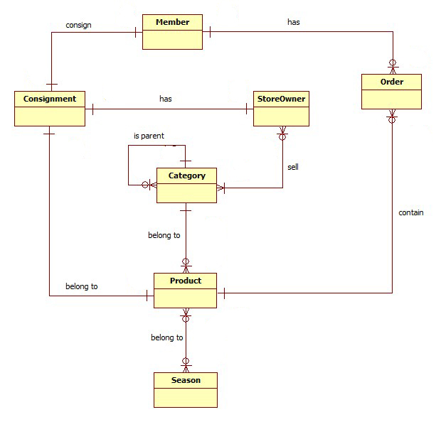

Figure : Conceptual Diagram

**Data Dictionary**

|  |  |
| --- | --- |
| **Entity Data dictionary: describe content of all entities** | |
| **Entity Name** | **Description** |
| Consignment | Describe all consignments in the system. |
| Customer | Describe all customers in the system. |
| Store Owner | Describe all store owners in the system. |
| Product | Describe all products in the system. |
| Category | Describe all product categories in the system. |
| Order | Describe all orders in the system. |
| Season | Describe all seasons. |

# Report No. 4 Software Design Description

## Design Overview

* This document part describes the details about technical and user interface design of HPS system. The document includes system architectural design, component diagram, detailed description, interaction diagram, user interface design and database design.
* The architectural design gives us the information of how HPS system is organized.
* The component diagram describes the architecture of HPS main component and sub-system.
* The detailed description describes the implement details of HPS system. This part include class diagram, class diagram explanation and interaction diagram.
* The user interface design give us the user graphic interface of HPS system.
* The database design show us how data of HPS system is stored and the relationship between entities in HPS database.

## System Architectural Design

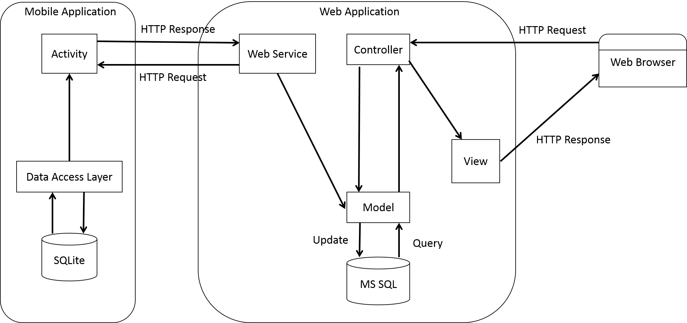

Figure : HPS System Architectural

### Web Application Architecture Description

* The system is developed from MVC architecture style and customized with passive model to adapt to JAVA MVC, RESTful web service technologies.
* **Model** is a part of application which uses to storage and retrieval data.
* View is the part of the application that visualizes the data to help user **easily** to view, update or customize them.
* **Controller** is the parts of the application that acts like event handler to handles user interaction. Typically controller read data from a request and returns respective view for user.
* **Web** **Service** is the parts of the application which use to provide interface for mobile application to do some background operation such as get consignment, update consignment status…

### Mobile Application Architecture Description

* The application is developed as an Android native application. In general, the application architecture follow by Android architecture.
* **Activity** is basic core of an Android application that handles user input, call web service…
* **Data** **Transfer** Object is the parts of the application that mapping SQLite database to storage and retrieval the consignment’s orders which assigned for employee.

## Component Diagram

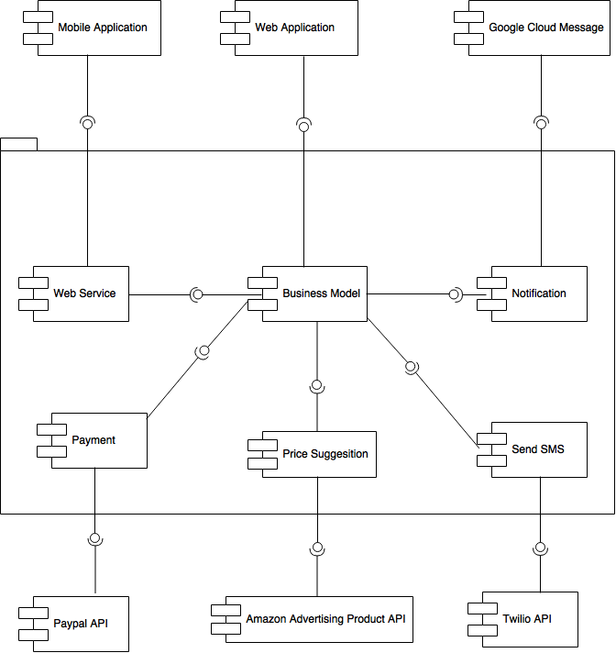

Figure : Component Diagram

|  |  |
| --- | --- |
| **Component dictionary: describe component** | |
| **Component Name** | **Description** |
| Web Service | Content all web service of the system. |
| Business Model | Handle business process. |
| Notification | Use to send notification message to mobile. |
| Google Cloud Message | Use to push notification to mobile application. |
| Mobile Application | Android Application. |
| Web Application | Web Application. |
| Web Service | Use to connect with mobile application. |
| Payment | Use to call Paypal API |
| Paypal API | Use to online payment. |
| Price Suggestion | Use to call Amazon Advertising Product API. |
| Send SMS | Use to call Twilio API. |
| Amazon Advertising Product API | Use to get price suggestion. |
| Twilio API | Use to send SMS. |

## Detailed Description

### Class Diagram

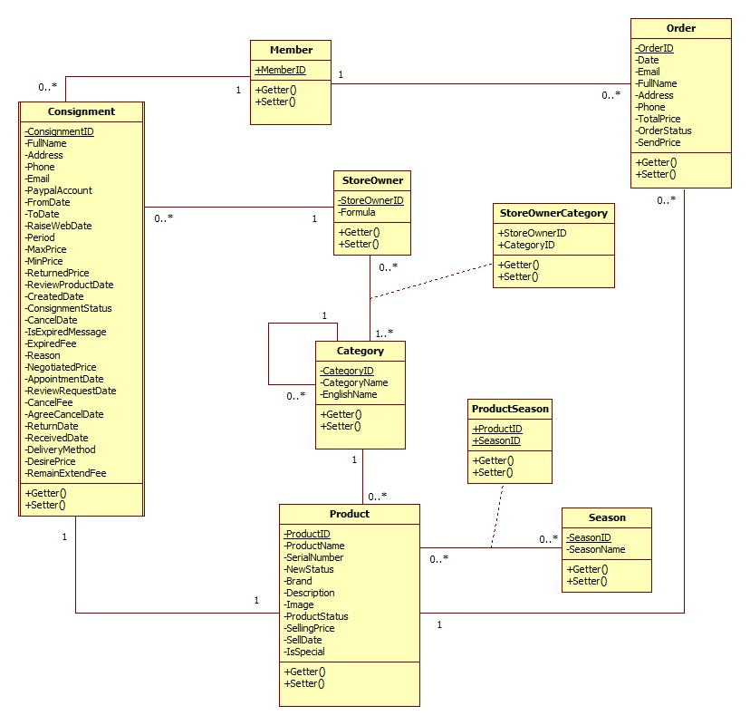

Figure : Class Diagram

### Class Diagram Explanation

#### Consignment

Attribute

|  |  |  |  |
| --- | --- | --- | --- |
| **Attribute** | **Type** | **Visibility** | **Description** |
| ConsignmentID | String | Private | Unique identifier of Consignment |
| ProductID | int | Private | ID of Product |
| MemberID | int | Private | ID of Member |
| StoreOwnerID | int | Private | ID of StoreOwner |
| FullName | String | Private | Full name of customer |
| Address | String | Private | Address of customer |
| Phone | String | Private | Phone of customer |
| Email | String | Private | Email of customer |
| PaypalAccount | String | Private | Paypal account of customer |
| FromDate | DateTime | Private | Date Store Owner can receive |
| ToDate | DateTime | Private | The last date Store Owner can receive |
| RaiseWebDate | DateTime | Private | Date publish product on website |
| Period | Integer | Private | Period of consignment |
| MaxPrice | float | Private | Max price suggest to customer |
| MinPrice | float | Private | Min price suggest to customer |
| ReturnedPrice | float | Private | Price return to customer |
| ReviewProductDate | DateTime | Private | Date receive or refuse Product |
| CreatedDate | DateTime | Private | Date create |
| ConsignmentStatusID | int | Private | ID of ConsignmentStatus |
| CancelDate | DateTime | Private | Date Customer request cancel consignment |
| IsExpiredMessage | int | Private | Send message expired consignment |
| ExpiredFee | float | Private | Fee of expired consignment |
| Reason | String | Private | Reason of canceled consignment |
| NegotiatedPrice | float | Private | Negotiated price |
| AppointmentDate | DateTime | Private | Appointment date to receive product |
| ReviewRequestDate | DateTime | Private | Date accept or refuse consignment request |
| CancelFee | float | Private | Fee of cancel consignment |
| AgreeCancelDate | DateTime | Private | Date StoreOwner agree request cancel consignment |
| ReturnDate | DateTime | Private | Date return product to customer |
| ReceivedDate | DateTime | Private | Receive product Date |
| DeliveryMethod | int | Private | Method to delivery product |
| DesirePrice | float | Private | Desire price of customer |
| RemainExtendFee | float | Private | Fee to extend consignment |

Method

|  |  |  |  |
| --- | --- | --- | --- |
| **Method** | **Return type** | **Visibility** | **Description** |
| Getter | Attribute Type | Public | Get attribute value |
| Setter | Void | Public | Set value of attribute |

#### Product

Attribute

|  |  |  |  |
| --- | --- | --- | --- |
| **Attribute** | **Type** | **Visibility** | **Description** |
| ProductID | int | Private | Unique identifier of Product |
| ProductName | String | Private | Name of Product |
| SerialNumber | String | Private | Serial number of Product |
| NewStatus | int | Private | Product new status |
| CategoryID | int | Private | ID of Category |
| Brand | String | Private | Brand of Product |
| Description | String | Private | Description of Product |
| Image | String | Private | Image of Product |
| ProductStatusID | int | Private | ID of ProductStatus |
| SellingPrice | float | Private | Selling Price |
| SellDate | DateTime | Private | Selling Date |
| IsSpecial | int | Private | Is special product |

Method

|  |  |  |  |
| --- | --- | --- | --- |
| **Method** | **Return type** | **Visibility** | **Description** |
| Getter | Attribute type | Public | Get attribute value |
| Setter | Void | Public | Set value of attribute |

#### Order

Attribute

|  |  |  |  |
| --- | --- | --- | --- |
| **Attribute** | **Type** | **Visibility** | **Description** |
| OrderID | int | Private | Unique identifier of Order |
| CustomerID | int | Private | ID of Customer |
| Date | DateTime | Private | Order date |
| Email | String | Private | Email of customer |
| FullName | String | Private | Full name of customer |
| Address | String | Private | Address of customer |
| Phone | String | Private | Phone of Product |
| TotalPrice | float | Private | Price of Order |
| OrderStatusID | int | Private | ID of OrderStatus |
| ProductID | int | Private | ID of Product |
| SendPrice | int | Private | Price is sent to customer |

Method

|  |  |  |  |
| --- | --- | --- | --- |
| **Method** | **Return type** | **Visibility** | **Description** |
| Getter | Attribute type | Public | Get attribute value |
| Setter | Void | Public | Set value of attribute |

#### StoreOwner

Attribute

|  |  |  |  |
| --- | --- | --- | --- |
| **Attribute** | **Type** | **Visibility** | **Description** |
| StoreOwnerID | int | Private | Unique identifier of StoreOwner |
| AccountID | String | Private | AccountID of StoreOwner |
| Formula | float | Private | Formula to calculate consignment price suggestion |

Method

|  |  |  |  |
| --- | --- | --- | --- |
| **Method** | **Return type** | **Visibility** | **Description** |
| Getter | Attribute type | Public | Get attribute value |
| Setter | Void | Public | Set value of attribute |

#### Member

Attribute

|  |  |  |  |
| --- | --- | --- | --- |
| **Attribute** | **Type** | **Visibility** | **Description** |
| MemberID | int | Private | Unique identifier of Member |
| AccountID | String | Private | AccountID of Member |

Method

|  |  |  |  |
| --- | --- | --- | --- |
| **Method** | **Return type** | **Visibility** | **Description** |
| Getter | Attribute type | Public | Get attribute value |
| Setter | Void | Public | Set value of attribute |

#### StoreOwnerCategory

Attribute

|  |  |  |  |
| --- | --- | --- | --- |
| **Attribute** | **Type** | **Visibility** | **Description** |
| StoreOwnerID | int | Private | Unique identifier of StoreOwnerCategory |
| CategoryID | String | Private | Unique identifier of StoreOwnerCategory |

Method

|  |  |  |  |
| --- | --- | --- | --- |
| **Method** | **Return type** | **Visibility** | **Description** |
| Getter | Attribute type | Public | Get attribute value |
| Setter | Void | Public | Set value of attribute |

#### ProductSeason

Attribute

|  |  |  |  |
| --- | --- | --- | --- |
| **Attribute** | **Type** | **Visibility** | **Description** |
| ProductID | int | Private | Unique identifier of ProductSeason |
| SessonID | int | Private | Unique identifier of ProductSeason |

Method

|  |  |  |  |
| --- | --- | --- | --- |
| **Method** | **Return type** | **Visibility** | **Description** |
| Getter | Attribute type | Public | Get attribute value |
| Setter | Void | Public | Set value of attribute |

#### Season

Attribute

|  |  |  |  |
| --- | --- | --- | --- |
| **Attribute** | **Type** | **Visibility** | **Description** |
| SeasonID | int | Private | Unique identifier of Season |
| SessonName | String | Private | Name of Season |

Method

|  |  |  |  |
| --- | --- | --- | --- |
| **Method** | **Return type** | **Visibility** | **Description** |
| Getter | Attribute type | Public | Get attribute value |
| Setter | Void | Public | Set value of attribute |

#### Category

Attribute

|  |  |  |  |
| --- | --- | --- | --- |
| **Attribute** | **Type** | **Visibility** | **Description** |
| CategoryID | int | Private | Unique identifier of Category |
| CategoryName | String | Private | Name of Category |
| ParentID | int | Private | ID of parent category |
| EnglishName | String | Private | English name to search product on amazon API |

Method

|  |  |  |  |
| --- | --- | --- | --- |
| **Method** | **Return type** | **Visibility** | **Description** |
| Getter | Attribute type | Public | Get attribute value |
| Setter | Void | Public | Set value of attribute |

### Interaction Diagram

#### Sequence Diagram

##### <Guest> Consign Product

**Summary:** This diagram shows how Guest can consign product.

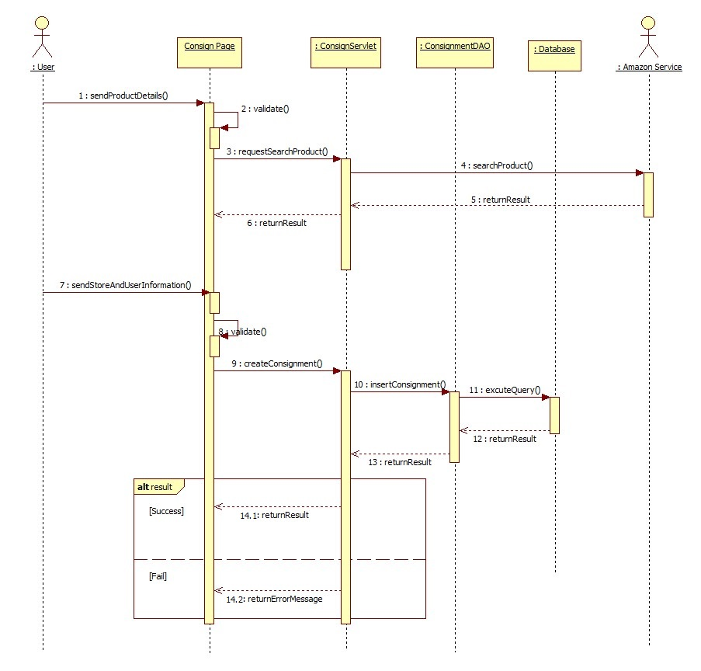

Figure 35: <Guest> Consign product

##### <Guest> Search Product

**Summary:** This diagram shows how Guest can search product.

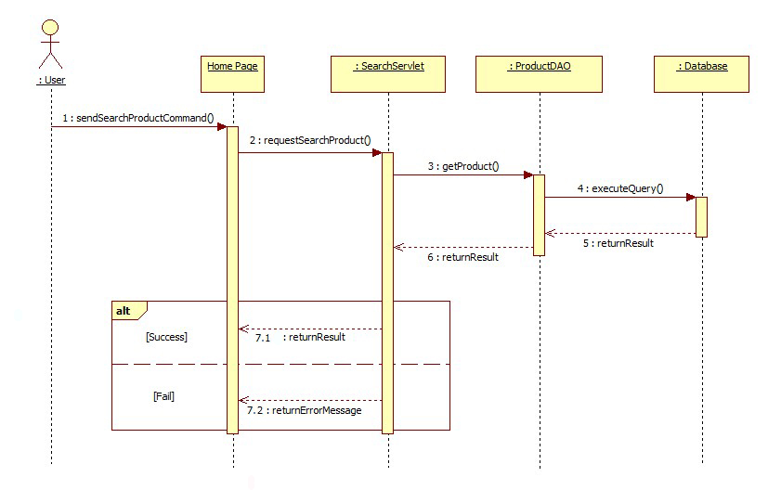

Figure : <Guest> Search product

##### <Guest> Order Product

**Summary:** This diagram shows how Guest can order product

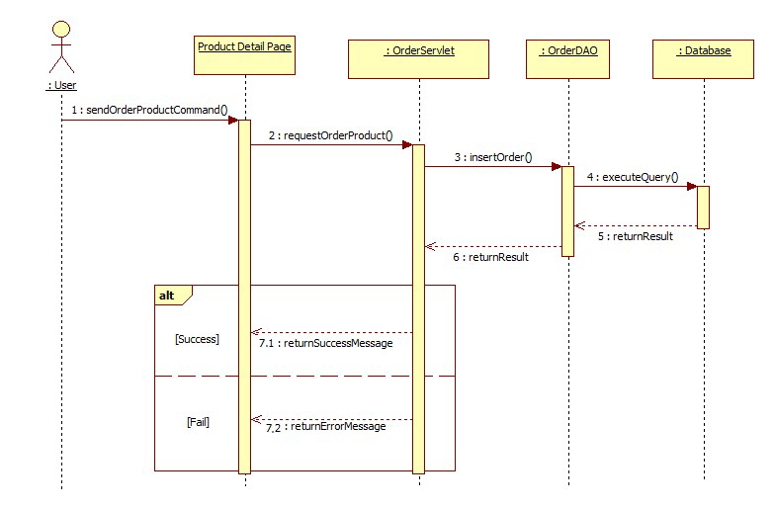

Figure 37: <Guest> Order product

##### <Store Owner> Accept Request

**Summary:** This diagram shows how store owner accept a request

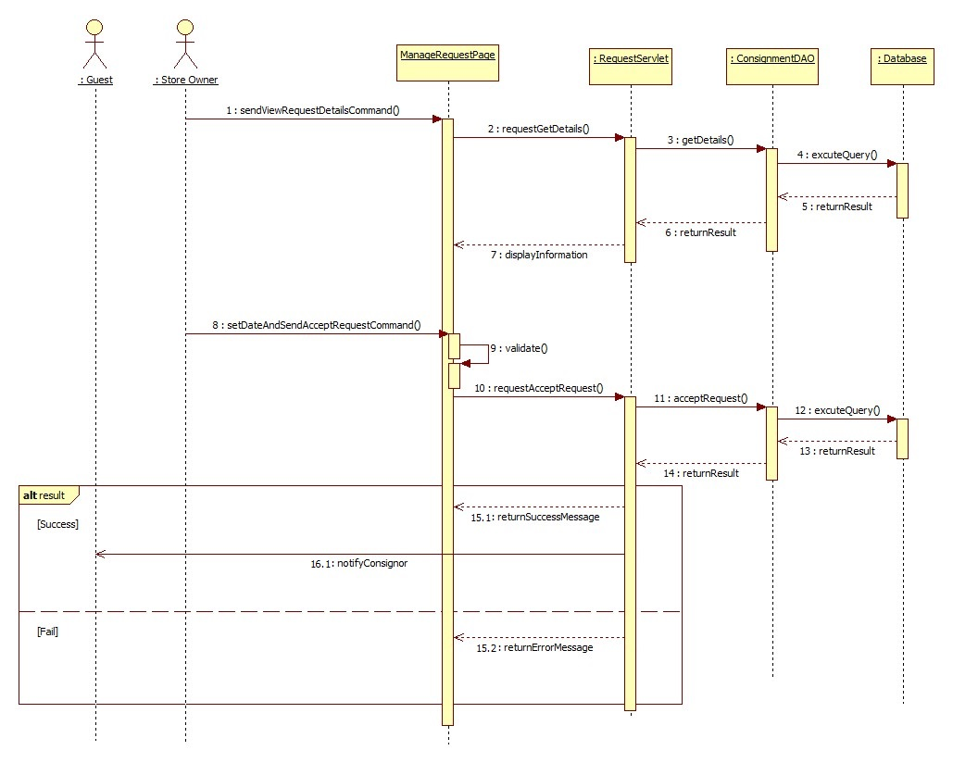

Figure : <Store Owner> Accept Request

##### <Store Owner> Update Request

**Summary**: This diagram shows how store owner update consignment information and notify to consignor.

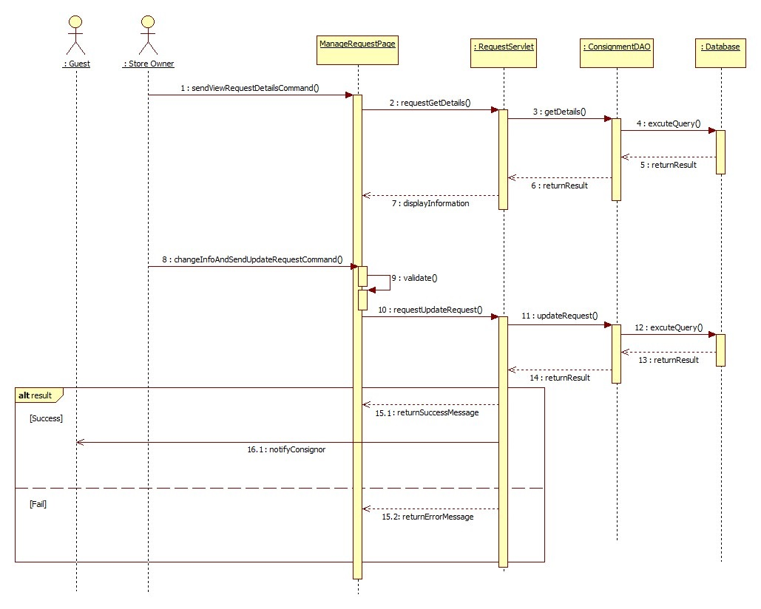

Figure : <Store Owner> Update Request

##### <Store Owner> Receive Product

**Summary**: This diagram shows how store owner accepts and receives product from consignor.

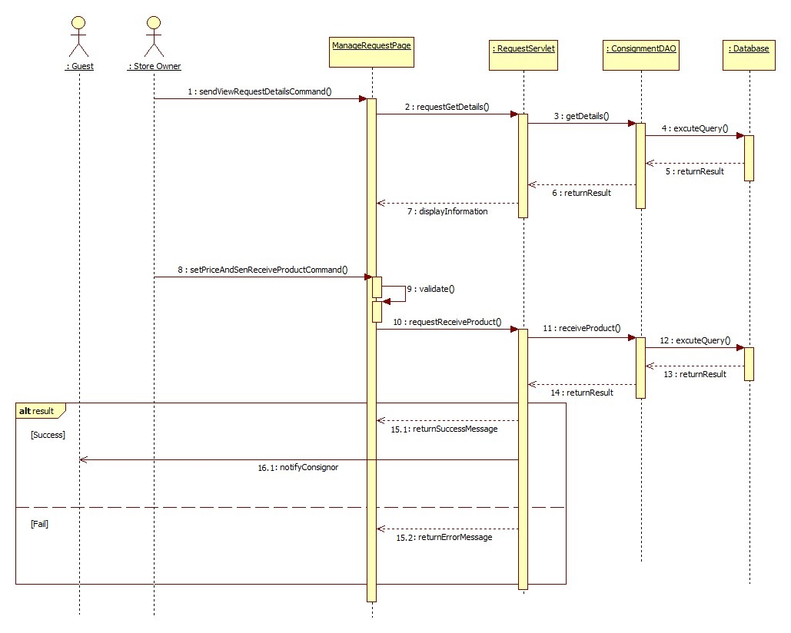

Figure : <Store Owner> Receive Product

##### <Store Owner> View Product

**Summary**: This diagram shows how store owner view received product of their store.

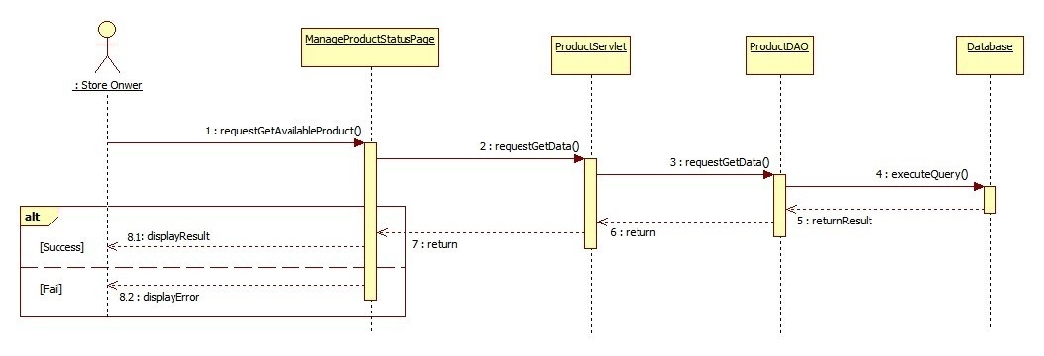

Figure 41: <Store Owner> View product

##### <Store Owner> Publish On Web

**Summary**: This diagram shows how store owner publish a product to website.

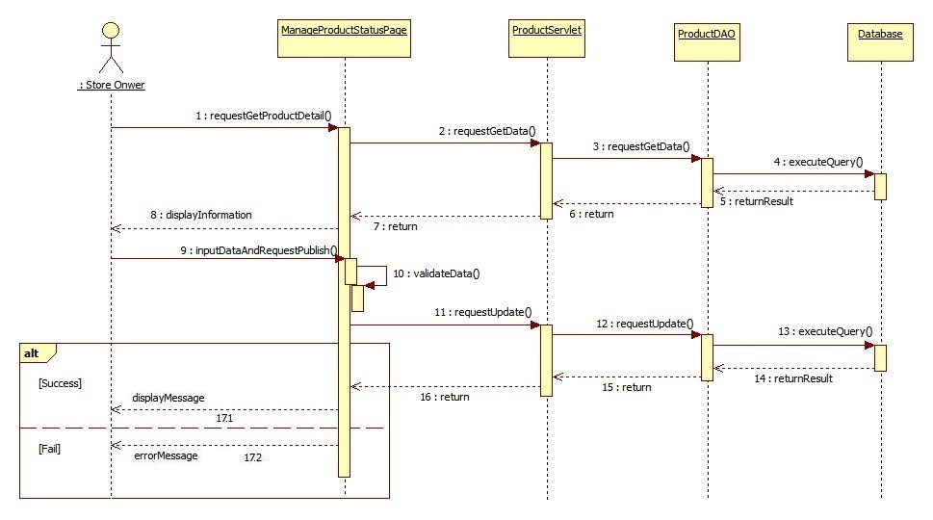

Figure 42: <Store Owner> Publish on web

##### <Store Owner> Agree Return Product

**Summary**: This diagram shows how store owner agree a cancel consignment request.

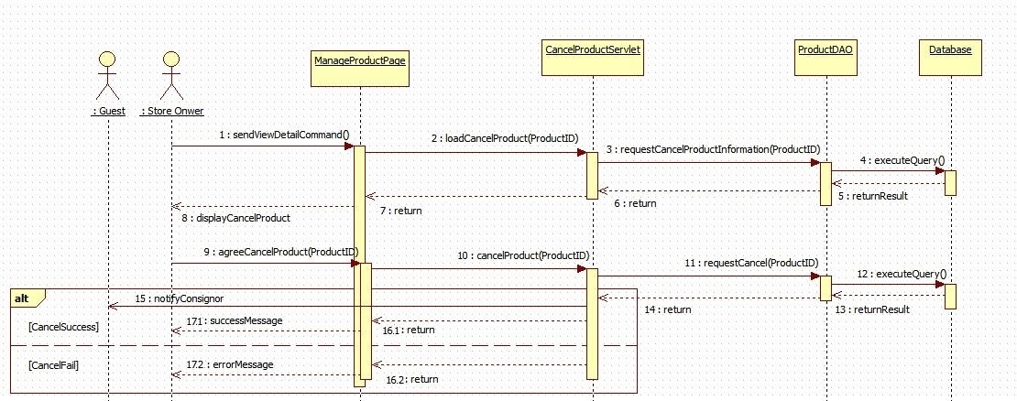

Figure 43: <Store Owner> Agree return product

##### <Store Owner> Send Product Price To Customer

**Summary**: This diagram shows how store owner send product price to customer who has ordered product.



Figure 44: <Store Owner> Send product price to customer

##### <Store Owner> Sell Product

**Summary**: This diagram shows how store owner sell a product which ordered by one or more customer.



Figure 45: <Store Owner> Sell product

##### <Store Owner>Pay Consignor

**Summary**: This diagram shows how store owner pay consignor without online payment method.



Figure 46: <Store Owner> Pay Consignor

##### <Store Owner> Cancel Orders

**Summary**: This diagram shows how store owner cancel all orders which relates to their product.



Figure 47: <Store Owner> Cancel orders

##### <Store Owner> Extend Consignment Period

**Summary**: This diagram shows how store owner help consignor to extend consignment period after it’s over.

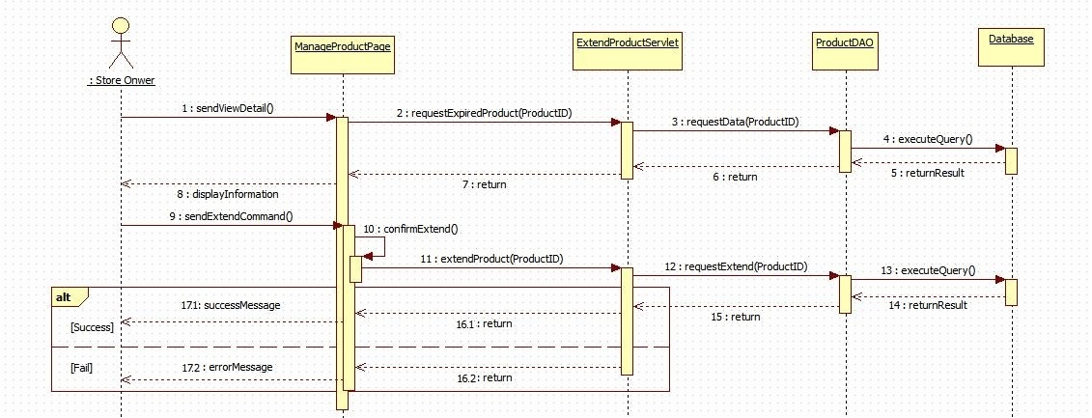

Figure 48: <Store Owner> Extend consignment period

##### <System> Search Product Online

**Summary**: This diagram shows how system find product with information that was given by consignor.



Figure 49: <System> Search product online

#### Activity Diagram

##### <Store Owner> Login

**Summary:** This diagram shows how Store Owner login into system



Figure . <Store Owner> Login

|  |  |  |
| --- | --- | --- |
| 1. Start | 2. Store Owner touch “Đăng Xuất” tab | 3. Show confirm dialog |
| 4a. Store Owner touch “Hủy” button | 4b. Store Owner touch “Xác Nhận” button | 5a. Dismiss dialog |
| 5b. call logout() and navigate to login activity | 6a. Finish | 6b. Finish |

##### <StoreOwner> Receive Nofitication

**Summary:** This diagram shows how Store Owner receive notification



Figure . <Store Owner> Receive notification

|  |  |  |
| --- | --- | --- |
| 1. Send Notification | 2. Push Notification | 3. Store Owner touch on notification |
| 4. Navigate to menu activity | 5. Finish |  |

##### <Store Owner> View Task

**Summary:** This diagram shows how Store Owner receive notification



Figure . <Store Owner> View task

|  |  |  |
| --- | --- | --- |
| 1. Start | 2. Touch tab | 3. Call menu activity |
| 4a. Store Owner touch “Sản phẩm cần nhận” | 4b. Store Owner touch “Sản phẩm đã nhận” | 4b. Store Owner touch “Sản phẩm đã từ chối” |
| 5a. Call getProduct() | 5b. Call getReceivedProduct() | 5c. Call getCanceledProduct() |
| 6a. Show product list | 6b. Show received product list | 6c. Show canceled product list |
| 7a. Finish | 7b. Finish | 7c. Finish |

##### <Store Owner> Auto Synchronize

**Summary:** This diagram shows how Mobile Application auto synchronize data.



Figure . <Store Owner> Auto synchronize

|  |  |  |
| --- | --- | --- |
| 1. Start | 2. Call checkState() | 3a. Finish |
| 3b. Check data in local device, if exist data have not committed, update to server | 4a. Call getNewData() | 4b. call updateData() |
| 5. Send data to web service | 4. Remove not committed data | 7. Call getNewData() |
| 8. Get data from web service | 9. Insert data into local device | 10. Finish |

##### <StoreOwner> Accept Product

**Summary:** This diagram shows how StoreOwner receive product.



Figure . <Store Owner> Accept product

|  |  |  |
| --- | --- | --- |
| 1. Start | 2. Call getProductDetail() | 3. Show product detail |
| 4. Store Owner change customer information and enter “Giá kí gửi tối đa” | 5. Store Owner touch “Chấp Nhận” button | 6. Show confirm dialog |
| 7a. Store Owner touch “Hủy” button to cancel action | 7b. Store Owner touch “Đồng ý” button | 8a. Dismiss confirm dialog |
| 8b. Call checkState() | 9a. Navigate back | 10b. Update data in local device and dismiss dialog |
| 10c. Call service to update data in server and dismiss dialog | 11b. Navigate back | 11c. Send data to web service |
| 12. Navigate back | 13. Finish |  |

##### <StoreOwner> Cancel Product

**Summary:** This diagram shows how StoreOwner cancel product.



Figure . <Store Owner> Cancel product

|  |  |  |
| --- | --- | --- |
| 1. Start | 2. Call getProductDetail() | 3. Show product detail |
| 4. Store Owner touch “Từ chối” button | 5. Show confirm dialog with text box | 6a. Store Owner enter “Lí do từ chối”. |
| 6b. Store Owner touch “Đồng ý” button. | 6c. Store Owner touch “Hủy” button to cancel action. | 7. Dismiss confirm dialog |
| 7a. Navigate back | 8. Call checkState() | 9a. Update data in local device and dismiss dialog. |
| 9b. Call service to update data in server and dismiss dialog. | 10a. Navigate back | 10b. Send data to web service |
| 11. Navigate back | 12. Finish |  |

##### <StoreOwner> View History

**Summary:** This diagram shows how StoreOwner view history



Figure . <Store Owner> View history

|  |  |  |
| --- | --- | --- |
| 1. Start | 2. Touch tab | 3. Call history menu activity |
| 4a. Store Owner touch “Sản phẩm đã nhận” | 4b. Store Owner touch “Sản phẩm đã từ chối” | 5a. Call getHistoryReceivedProduct() |
| 5c. Call getHistoryCanceledProduct() | 6a. show history received product list | 6b. show history canceled product list |
| 7a. Finish | 7b. Finish |  |

## User Interface Design

### Guest/Customer Interface Design

#### Login



Figure : Login

**Fields**

|  |  |  |  |  |  |  |  |
| --- | --- | --- | --- | --- | --- | --- | --- |
| **No** | **Field Name** | **Description** | **Read Only** | **Mandatory** | **Control Type** | **Data Type** | **Length** |
| 1 | Username | Fill user name | No | Yes | Textbox | String | N/A |
| 2 | Password | Fill password | No | Yes | Password | String | N/A |

**Buttons/Hyperlinks**

|  |  |  |  |  |
| --- | --- | --- | --- | --- |
| **No** | **Function** | **Description** | **Validation** | **Outcome** |
| 1 | Sign in | Login into the system | N/A | Transfer to home page |
| 2 | Register | Move to register page | N/A | Transfer to register page |

#### View Home Page



Figure : View Home Page

**Buttons/Hyperlinks**

|  |  |  |  |  |
| --- | --- | --- | --- | --- |
| **No** | **Function** | **Description** | **Validation** | **Outcome** |
| 1 | Consign | Move to consign page | N/A | Transfer to consign page |
| 2 | Check Product | Move to check consignment status page | N/A | Transfer to check product status page |
| 3 | Login | Move to login page | N/A | Transfer to login page |
| 4 | View Detail | View Product Detail | N/A | Transfer to view product detail page |
| 5 | Filter Product | Click to filter product by category | N/A | Show filter product |

#### Search Product



Figure : Search Product

**Fields**

|  |  |  |  |  |  |  |  |
| --- | --- | --- | --- | --- | --- | --- | --- |
| **No** | **Field Name** | **Description** | **Read Only** | **Mandatory** | **Control Type** | **Data Type** | **Length** |
| 1 | Category | Choose product category | No | Yes | Combo box | String | N/A |
| 2 | ProductName | Fill product name | No | Yes | Textbox | String | N/A |

**Buttons/Hyperlinks**

|  |  |  |  |  |
| --- | --- | --- | --- | --- |
| **No** | **Function** | **Description** | **Validation** | **Outcome** |
| 1 | Search Product | Search product by category and name. | N/A | Show list product. |

#### View Detail



Figure : View Detail

**Fields**

|  |  |  |  |  |  |  |  |
| --- | --- | --- | --- | --- | --- | --- | --- |
| **No** | **Field Name** | **Description** | **Read Only** | **Mandatory** | **Control Type** | **Data Type** | **Length** |
| 2 | ProductDetail | Detail Of product | Yes | Yes | Label | String | N/A |

**Buttons/Hyperlinks**

|  |  |  |  |  |
| --- | --- | --- | --- | --- |
| **No** | **Function** | **Description** | **Validation** | **Outcome** |
| 1 | Order Product | Click to order product | N/A | Transfer to order product page |

#### Order Product



Figure : Order Product

**Fields**

|  |  |  |  |  |  |  |  |
| --- | --- | --- | --- | --- | --- | --- | --- |
| **No** | **Field Name** | **Description** | **Read Only** | **Mandatory** | **Control Type** | **Data Type** | **Length** |
| 1 | CustomerName | Fill customer name | No | Yes | Textbox | String | N/A |
|  | Email | Fill email | No | Yes | Textbox | String | N/A |
|  | Address | Fill address | No | Yes | Textbox | String | N/A |
|  | Phone | Fill phone | No | Yes | Textbox | String | N/A |

**Buttons/Hyperlinks**

|  |  |  |  |  |
| --- | --- | --- | --- | --- |
| **No** | **Function** | **Description** | **Validation** | **Outcome** |
| 1 | Order Product | Click to order product | N/A | Show order successful message |

#### Consign Product

#### Consign Product – Step 1





**Fields**

|  |  |  |  |  |  |  |  |
| --- | --- | --- | --- | --- | --- | --- | --- |
| **No** | **Field Name** | **Description** | **Read Only** | **Mandatory** | **Control Type** | **Data Type** | **Length** |
| 1 | Consigning steps | Every step of consigning process | Yes | Yes | Label | String | N/A |
| 4 | ProductName | Fill product’s name | No | Yes | Textbox | String | 5-100 |
| 5 | Category | Choose a category | No | Yes | Drop down list | String | N/A |
| 6 | Brand | Fill Brand | No | Yes | Textbox | String | 1-100 |
| 7 | newStatus | Fill new status | No | Yes | Textbox | Integer | N/A |
| 8 | Description | Fill description | No | Yes | Textbox | String | N/A |
| 10 | SerialNumber | Fill serial number | No | Yes | Textbox | String | 1-20 |

**Buttons/Hyperlinks**

|  |  |  |  |  |
| --- | --- | --- | --- | --- |
| **No** | **Function** | **Description** | **Validation** | **Outcome** |
| 2 | Search Product By Name | Search product by name and brand | N/A | Show productName and Brand fields to input |
| 3 | Search Product By Serial | Search product by serial | N/A | Show Serial Number field to input |
| 9 | Go step 2 (Search Product) | Complete inputting product’s information and search product | N/A | Return a list of product with similar information |

#### Consign Product – Step 2

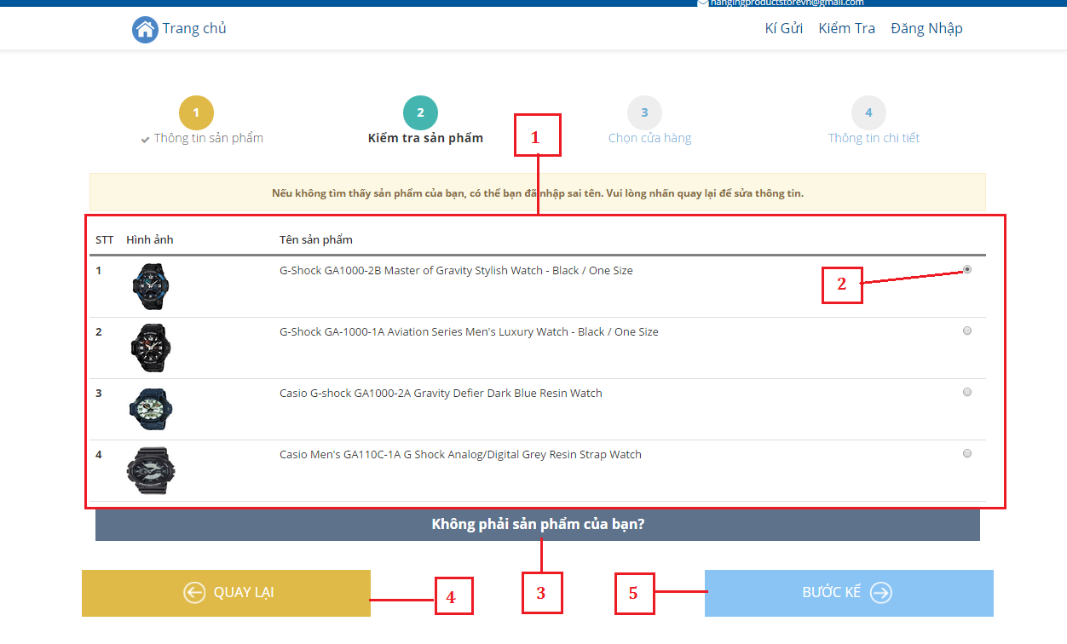

**Fields**

|  |  |  |  |  |  |  |  |
| --- | --- | --- | --- | --- | --- | --- | --- |
| **No** | **Field Name** | **Description** | **Read Only** | **Mandatory** | **Control Type** | **Data Type** | **Length** |
| 1 | ProductList | List of product found online | Yes | Yes | Label | String | N/A |

**Buttons/Hyperlinks**

|  |  |  |  |  |
| --- | --- | --- | --- | --- |
| **No** | **Function** | **Description** | **Validation** | **Outcome** |
| 2 | ChooseProduct | Click to choose a product for details | N/A | Product is checked |
| 3 | Not Found Product | Click if not find product in list | N/A | Go next to step 3 without chosen product |
| 4 | BackStep1 | Go back to step 1 | N/A | Go back to step 1 |
| 5 | GoStep3 | Go to step 3 | N/A | Go next to step 3 with chosen product |

#### Consign Product – Step 3



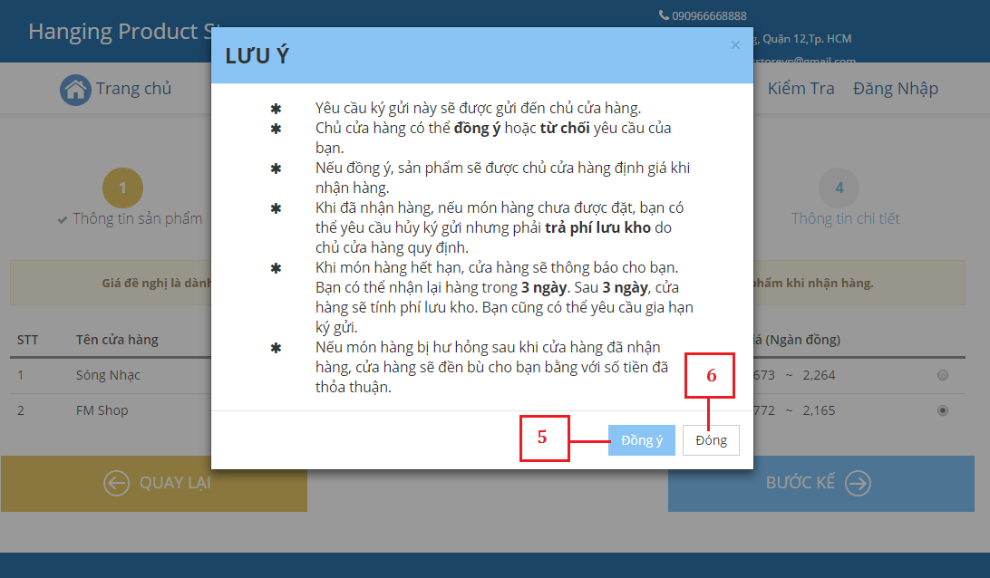

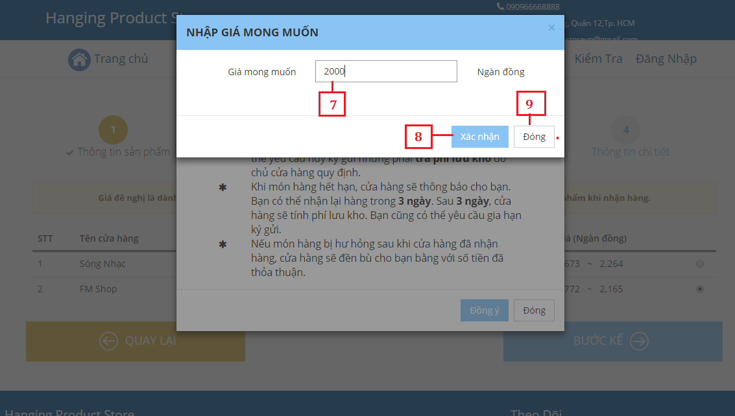

**Fields**

|  |  |  |  |  |  |  |  |
| --- | --- | --- | --- | --- | --- | --- | --- |
| **No** | **Field Name** | **Description** | **Read Only** | **Mandatory** | **Control Type** | **Data Type** | **Length** |
| 1 | StoreList | List of store which do business on the kind of product | Yes | Yes | Label | String | N/A |
| 7 | DesirePrice | Fill desired price | No | Yes | Textbox | Float | N/A |

**Buttons/Hyperlinks**

|  |  |  |  |  |
| --- | --- | --- | --- | --- |
| **No** | **Function** | **Description** | **Validation** | **Outcome** |
| 2 | Choose Store | Choose a store to consign product | N/A | Store will be checked |
| 3 | BackStep2 | Go back to step 2 | N/A | Back to step 2 |
| 4 | Complete  Choosing Store | Complete choosing a store to consign | N/A | A modal with consignment rule is shown. |
| 5 | Complete reading rule | Already read consignment’s rule | N/A | A modal shows up to input desire price |
| 6 | Close Rule Modal | Close the modal of rule and go back to choose store | N/A | Modal is closed and list of store will be shown. |
| 8 | Complete inputting Price | Complete inputting desire price for product | N/A | Go to step 4 |
| 9 | CloseModal | Close the modal for inputting desire price | N/A | List of store will be shown. |

#### Consign Product – Step 4



**Fields**

|  |  |  |  |  |  |  |  |
| --- | --- | --- | --- | --- | --- | --- | --- |
| **No** | **Field Name** | **Description** | **Read Only** | **Mandatory** | **Control Type** | **Data Type** | **Length** |
| 1 | CustomerName | Fill name of consignor/who consigns product. | No | Yes | Textbox | String | 5-50 |
| 2 | Address | Fill address | No | Yes | Textbox | String | N/A |
| 3 | Phone | Fill phone | No | Yes | Textbox | String | N/A |
| 4 | Email | Fill email | No | Yes | Textbox | String | N/A |
| 5 | Payment Method | Choose an option how to pay customer after product is sold | No | Yes | Combo box | String |  |
| 6 | PaypalAccount | Fill paypal account | No | Yes | Textbox | String | N/A |
| 7 | ProductImage | Image of product | Yes | Yes | Label | String | N/A |
| 9 | FromDate | Choose start date for receiving product | No | Yes | Textbox | String | N/A |
| 10 | ToDate | Choose end date for receiving product | No | Yes | Textbox | String | N/A |
| 11 | DeliveryMethod | Choose a way to delivery product | No | Yes | Combo box | String | N/A |

**Buttons/Hyperlinks**

|  |  |  |  |  |
| --- | --- | --- | --- | --- |
| **No** | **Function** | **Description** | **Validation** | **Outcome** |
| 8 | ChangeImage | Change image of product | N/A | Image is changed |
| 12 | BackStep3 | Go back to step 3 | N/A | Back to step 3 |
| 13 | Complete inputting | Complete inputting information | N/A | A modal with rule for consigning process will be shown |
| 14 | SendConsignmentRequest | Send consignment request | N/A | Consignment request is sent successfully with a success message |
| 15 | CloseModal | Close the modal | N/A | Step 4 will be shown |

#### Consign Product – Success



**Fields**

|  |  |  |  |  |  |  |  |
| --- | --- | --- | --- | --- | --- | --- | --- |
| **No** | **Field Name** | **Description** | **Read Only** | **Mandatory** | **Control Type** | **Data Type** | **Length** |
| 1 | Consignment Information | Success message with consignment information | Yes | Yes | Label | String | N/A |

**Buttons/Hyperlinks**

|  |  |  |  |  |
| --- | --- | --- | --- | --- |
| **No** | **Function** | **Description** | **Validation** | **Outcome** |
| 3 | ConsignAgain | Consign another product | N/A | Start consign a new product |

#### Track Product Status



**Fields**

|  |  |  |  |  |  |  |  |
| --- | --- | --- | --- | --- | --- | --- | --- |
| **No** | **Field Name** | **Description** | **Read Only** | **Mandatory** | **Control Type** | **Data Type** | **Length** |
| 1 | Consignment ID | Fill consignment ID | No | Yes | Textbox | String | N/A |
| 3 | ConsignmentInfo | Information of consignment | Yes | Yes | Label | String | N/A |

**Buttons/Hyperlinks**

|  |  |  |  |  |
| --- | --- | --- | --- | --- |
| **No** | **Function** | **Description** | **Validation** | **Outcome** |
| 2 | TrackProductStatus | Find product with consignment ID | N/A | Information of consigned product is shown |
| 3 | CancelProduct | Cancel consigned product | N/A | Product’s consigning process is stoped/ A request to cancel product is sent to store Owner |

### Store Owner Interface Design

#### Mobile Interface Design

##### Login



Figure : Mobile Login

**Fields**

|  |  |  |  |  |  |  |  |
| --- | --- | --- | --- | --- | --- | --- | --- |
| **No** | **Field Name** | **Description** | **Read Only** | **Mandatory** | **Control Type** | **Data Type** | **Length** |
| 1 | Username | Fill user name | No | Yes | Textbox | String | N/A |
| 2 | Password | Fill password | No | Yes | Password | String | N/A |

**Buttons/Hyperlinks**

|  |  |  |  |  |
| --- | --- | --- | --- | --- |
| **No** | **Function** | **Description** | **Validation** | **Outcome** |
| 1 | Sign in | Login into the system | N/A | Transfer to home page |

##### View Task



Figure : Mobile View Task

**Fields**

|  |  |  |  |  |  |  |  |
| --- | --- | --- | --- | --- | --- | --- | --- |
| **No** | **Field Name** | **Description** | **Read Only** | **Mandatory** | **Control Type** | **Data Type** | **Length** |
| 1 | Date | Show current date | Yes | Yes | Textbox | String | N/A |

**Buttons/Hyperlinks**

|  |  |  |  |  |
| --- | --- | --- | --- | --- |
| **No** | **Function** | **Description** | **Validation** | **Outcome** |
| 2 | ViewProduct | Touch to show products need to receive. | N/A | Move to Task Activity |
| 3 | ViewReceivedProduct | Touch to show received product on current date | N/A | Move to Received Product Activity |
| 4 | ViewCanceledProduct | Touch to show canceled product on current date | N/A | Move to Canceled Product Activity |
| 5 | ViewNavigationDrawler | Touch to show navigation drawler | N/A | Show navigation drawler |

##### View Product List



Figure : Mobile View Product List

**Buttons/Hyperlinks**

|  |  |  |  |  |
| --- | --- | --- | --- | --- |
| **No** | **Function** | **Description** | **Validation** | **Outcome** |
| 1 | ProductList | Touch to show product detail | N/A | Show product detail |
| 2 | Back | Touch to back to pre-activity | N/A | Back to pre-activity |
| 3 | Search | Touch to filter product list | N/A | Show filtered product list. |

##### Search Product



Figure : Mobile Search Product

**Fields**

|  |  |  |  |  |  |  |  |
| --- | --- | --- | --- | --- | --- | --- | --- |
| **No** | **Field Name** | **Description** | **Read Only** | **Mandatory** | **Control Type** | **Data Type** | **Length** |
| 2 | ProductName | Fill product name to search | No | Yes | Textbox | String | N/A |

**Buttons/Hyperlinks**

|  |  |  |  |  |
| --- | --- | --- | --- | --- |
| **No** | **Function** | **Description** | **Validation** | **Outcome** |
| 1 | ProductList | Touch to show product detail | N/A | Show product detail |

##### View Navigation Drawler



Figure : Mobile View Navigation Drawler

**Buttons/Hyperlinks**

|  |  |  |  |  |
| --- | --- | --- | --- | --- |
| **No** | **Function** | **Description** | **Validation** | **Outcome** |
| 1 | ViewMenu | Touch to move to menu activity | N/A | Move to menu Activity |
| 2 | ViewHistoruMenu | Touch to move to history menu activity | N/A | Move to history menu activity |
| 3 | Logout | Touch to logout | N/A | Logout |

##### Receive or Accept Product



**Fields**

|  |  |  |  |  |  |  |  |
| --- | --- | --- | --- | --- | --- | --- | --- |
| **No** | **Field Name** | **Description** | **Read Only** | **Mandatory** | **Control Type** | **Data Type** | **Length** |
| 11 | ProductDetail | Product details | Yes | Yes | Textbox | String | N/A |
| 1 | NewStatus | Fill new status | No | Yes | Textbox | String | N/A |
| 2 | CustomerName | Fill customer name | No | Yes | Textbox | String | N/A |
| 3 | address | Fill phone | No | Yes | Textbox | String | N/A |
| 4 | phone | Fill new status | No | Yes | Textbox | String | N/A |
| 5 | NegotiatedPrice | Fill negotiage price | No | Yes | Textbox | String | N/A |
| 6 | PaymentMethod | Choose payment method | No | Yes | RadioButton | String | N/A |
| 14 | Reason | Fill reason to cancel product | No | Yes | Textbox | String | N/A |

**Buttons/Hyperlinks**

|  |  |  |  |  |
| --- | --- | --- | --- | --- |
| **No** | **Function** | **Description** | **Validation** | **Outcome** |
| 12 | CancelProduct | Touch to receive product | N/A | Show dialog confirm |
| 13 | AcceptProduct | Touch to cancel product | N/A | Show dialog confirm |
| 7 | Agree | Touch to confirm receive product | N/A | Show successful message |
| 8 | NotAgree | Touch to dismiss dialog | N/A | Dismiss dialog |
| 9 | Dissmiss | Touch to dismiss dialog | N/A | Dismiss dialog |
| 10 | Confirm | Touch to confirm cancel product | N/A | Show successful message |

#### Web Interface Design

##### View Available Product

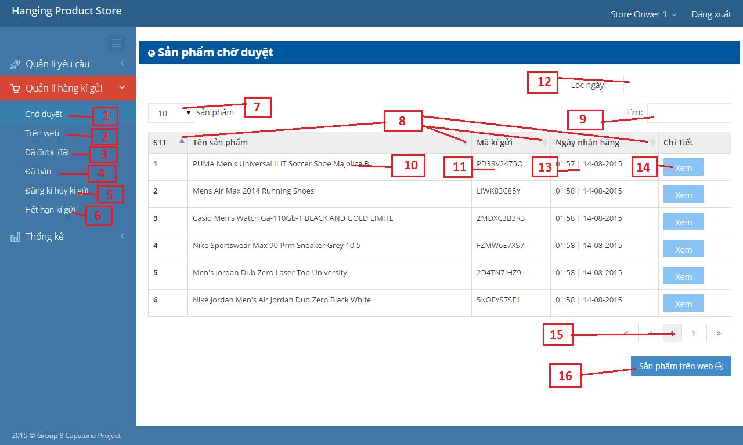

Figure : Web View Available Product

**Fields**

|  |  |  |  |  |  |  |  |
| --- | --- | --- | --- | --- | --- | --- | --- |
| **No** | **Field Name** | **Description** | **Read Only** | **Mandatory** | **Control Type** | **Data Type** | **Length** |
| 7 | Change items per page. | Change current items per page. | No | Yes | Dropdown list | String | N/A |
| 8 | Sort | Sort data with specific order. | No | Yes | Ratio button | Boolean | N/A |
| 9 | Search keyworks | Keyworks for seach funtion | No | Yes | Textbox | String | N/A |
| 10 | Product Name | Name of the product | Yes | Yes | Label | String | N/A |
| 11 | Consignment ID | Unique identifier of each consignment | Yes | Yes | Label | String | N/A |
| 12 | Datetime picker | Range of 2 days for search function | No | Yes | Datetime picker | String | N/A |
| 13 | Receive product date | Date when consignor received product | Yes | Yes | Label | String | N/A |

**Buttons/Hyperlinks**

|  |  |  |  |  |
| --- | --- | --- | --- | --- |
| **No** | **Function** | **Description** | **Validation** | **Outcome** |
| 1 | View available product | Click to move to view available product page | N/A | Redirect to view available product page |
| 2 | View on web product | Click to move to view on web product page | N/A | Redirect to view available product page |
| 3 | View ordered product | Click to move to view ordered product page | N/A | Redirect to view ordered product page |
| 4 | View Sold Product | Click to move to view sold product page | N/A | Redirect to view sold product page |
| 5 | View canceled product | Click to move to view canceled product page | N/A | Redirect to view cancled product page |
| 6 | View expired product | Click to move to view expired product page | N/A | Redirect to view expired product page |
| 14 | View detail | View detail of each product | N/A | Product detail information is displayed. |
| 15 | Change current page | Change current page. | N/A | Items of next page is displayed. |
| 16 | Next tab | Move to next tab of product management page. | N/A | Move to view on web product page. |

##### Publish Product



Figure : Publish Product

**Fields**

|  |  |  |  |  |  |  |  |
| --- | --- | --- | --- | --- | --- | --- | --- |
| **No** | **Field Name** | **Description** | **Read Only** | **Mandatory** | **Control Type** | **Data Type** | **Length** |
| 1 | Product Name | Name of the product | No | Yes | Textbox | String | N/A |
| 2 | Product serial number | Universal product code of the product | No | Yes | Textbox | String | N/A |
| 3 | New status | The status of the product | No | Yes | Textbox | Number format | N/A |
| 4 | Category | Category of the product | No | Yes | Drop down list | String | N/A |
| 5 | Brand | Brand of the product | No | Yes | Textbox | String | N/A |
| 6 | Season | Which season product will be displayed | No | Yes | Check box | String | N/A |
| 7 | Auto send price | When ordered, will system send price to customer automatically | No | Yes | Ratio button | String | N/A |
| 8 | Product image | Image of the product | No | Yes | Image | Image | N/A |
| 10 | Description | The detail information of the product | No | Yes | Textarea | String | N/A |

**Buttons/Hyperlinks**

|  |  |  |  |  |
| --- | --- | --- | --- | --- |
| **No** | **Function** | **Description** | **Validation** | **Outcome** |
| 9 | Change picture | Click to replace current image of product | N/A | Display new image |
| 11 | Publish product | Click to publish product. | N/A | Redirect to vew available product page. |
| 12 | Close pop-up | Click to close pop-up | N/A | Close pop-up and display view available product page. |

##### Sell Product

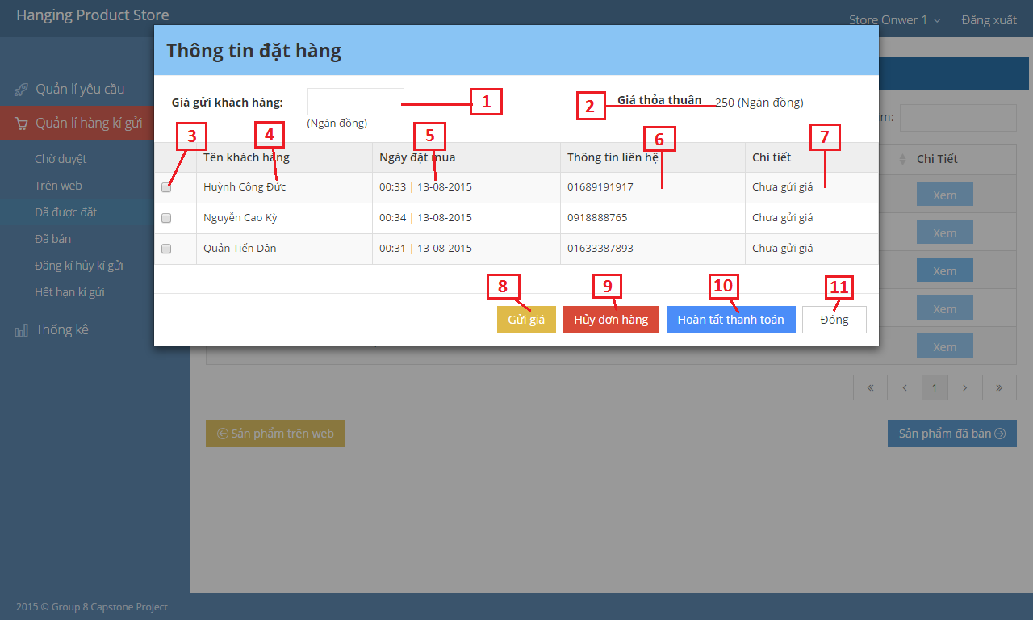

Figure : Sell Product

**Fields**

|  |  |  |  |  |  |  |  |
| --- | --- | --- | --- | --- | --- | --- | --- |
| **No** | **Field Name** | **Description** | **Read Only** | **Mandatory** | **Control Type** | **Data Type** | **Length** |
| 1 | Product Name | Name of the product | No | Yes | Textbox | String | N/A |
| 2 | Product serial number | Universal product code of the product | No | Yes | Textbox | String | N/A |
| 3 | New status | The status of the product | No | Yes | Textbox | Number format | N/A |
| 4 | Category | Category of the product | No | Yes | Drop down list | String | N/A |
| 5 | Brand | Brand of the product | No | Yes | Textbox | String | N/A |
| 6 | Season | Which season product will be displayed | No | Yes | Check box | String | N/A |
| 7 | Auto send price | When ordered, will system send price to customer automatically | No | Yes | Ratio button | boolean | N/A |

**Buttons/Hyperlinks**

|  |  |  |  |  |
| --- | --- | --- | --- | --- |
| **No** | **Function** | **Description** | **Validation** | **Outcome** |
| 8 | Send price | Send product price to customer | N/A | Redirect to view ordered product page. |
| 9 | Cancel orders | Cancel all orders which relates to this product | N/A | Redirect to view ordered product page. |
| 10 | Close pop-up | Click to close current pop-up | N/A | Close pop-up and display view ordered product page. |
| 11 | Complete order | Click to open complete order pop-up. | N/A | Complete order pop-up is shown. |

##### Pay Consignor



Figure : Pay Consignor

**Fields**

|  |  |  |  |  |  |  |  |
| --- | --- | --- | --- | --- | --- | --- | --- |
| **No** | **Field Name** | **Description** | **Read Only** | **Mandatory** | **Control Type** | **Data Type** | **Length** |
| 1 | Consignor name | Name of consignor | Yes | Yes | Label | String | N/A |
| 2 | Consignor address | Address of consignor | Yes | Yes | Label | String | N/A |
| 3 | Consignor phone number | Phone numer of consignor | Yes | Yes | Label | String | N/A |
| 4 | Consignor email address | Email address of consignor | Yes | Yes | Label | String | N/A |
| 5 | Consignor paypal account | Paypal account of consignor | Yes | Yes | Label | String | N/A |
| 6 | Product name | Name of the product | Yes | Yes | Label | String | N/A |
| 7 | Consignment ID | Unique identifier of each consignment | Yes | Yes | Label | String | N/A |
| 8 | Negotiated price | Negotiated price between store owner and consignor | Yes | Yes | Label | String | N/A |
| 9 | Selling price | The amount that store owner sold this product | Yes | Yes | Label | String | N/A |
| 10 | Consigned date | Date when consignor consign product | Yes | Yes | Label | String | N/A |
| 11 | Returned price | The amount that store owner return to consignor | No | Yes | Textbox | Number | N/A |

**Buttons/Hyperlinks**

|  |  |  |  |  |
| --- | --- | --- | --- | --- |
| **No** | **Function** | **Description** | **Validation** | **Outcome** |
| 12 | Pay consignor | Pay consignor via payment service | N/A | Redirect to payment page. |
| 13 | Pay consignor | Cancel all orders which relates to this product | N/A | Redirect to view sold product page. |
| 14 | Close pop-up | Click to close current pop-up | N/A | Close pop-up and display view sold product page. |

##### Cancel Product

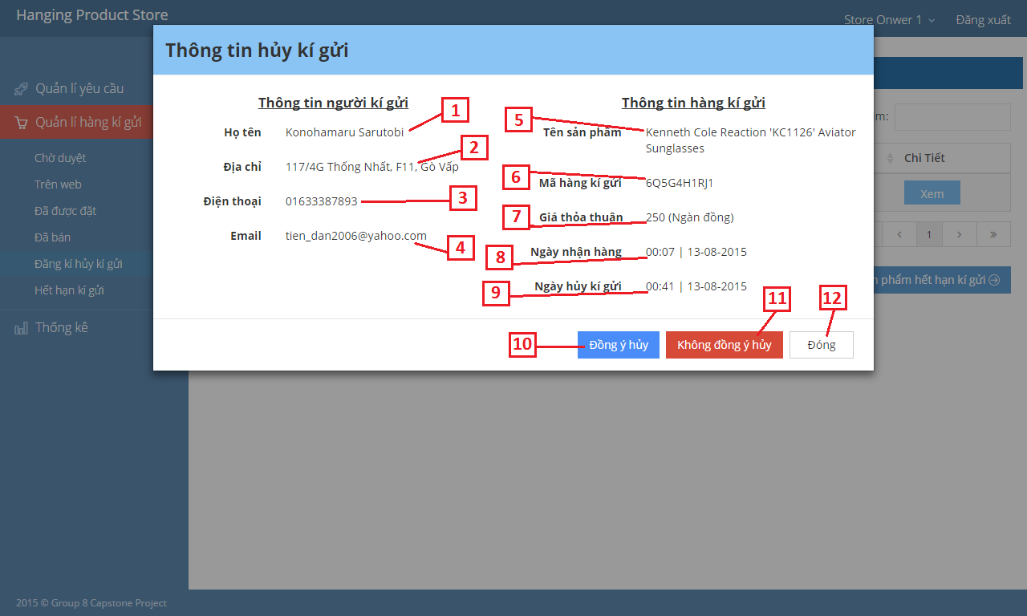

Figure : Cancel Product

**Fields**

|  |  |  |  |  |  |  |  |
| --- | --- | --- | --- | --- | --- | --- | --- |
| **No** | **Field Name** | **Description** | **Read Only** | **Mandatory** | **Control Type** | **Data Type** | **Length** |
| 1 | Consignor name | Name of consignor | Yes | Yes | Label | String | N/A |
| 2 | Consignor address | Address of consignor | Yes | Yes | Label | String | N/A |
| 3 | Consignor phone number | Phone numer of consignor | Yes | Yes | Label | String | N/A |
| 4 | Consignor email address | Email address of consignor | Yes | Yes | Label | String | N/A |
| 5 | Product name | Name of the product | Yes | Yes | Label | String | N/A |
| 6 | Consignment ID | Unique identifier of each consignment | Yes | Yes | Label | String | N/A |
| 7 | Negotiated price | Negotiated price between store owner and consignor | Yes | Yes | Label | String | N/A |
| 8 | Consigned date | Date when consignor consign product | Yes | Yes | Label | String | N/A |
| 9 | Canceled date | Date when consignor request cancel product | Yes | Yes | Label | String | N/A |

**Buttons/Hyperlinks**

|  |  |  |  |  |
| --- | --- | --- | --- | --- |
| **No** | **Function** | **Description** | **Validation** | **Outcome** |
| 10 | Agree cancel | Agree consignor cancel request | N/A | Redirect to view canceled product page. |
| 11 | Disagree cancel | Disagree consignor cancel request | N/A | Redirect to view canceled product page. |
| 12 | Close pop-up | Click to close current pop-up | N/A | Close pop-up and display view canceled product page. |

##### Extend Consignment Period

Figure : Extend Consignment Period

**Fields**

|  |  |  |  |  |  |  |  |
| --- | --- | --- | --- | --- | --- | --- | --- |
| **No** | **Field Name** | **Description** | **Read Only** | **Mandatory** | **Control Type** | **Data Type** | **Length** |
| 1 | Consignor name | Name of consignor | Yes | Yes | Label | String | N/A |
| 2 | Consignor address | Address of consignor | Yes | Yes | Label | String | N/A |
| 3 | Consignor phone number | Phone numer of consignor | Yes | Yes | Label | String | N/A |
| 4 | Consignor email address | Email address of consignor | Yes | Yes | Label | String | N/A |
| 5 | Product name | Name of the product | Yes | Yes | Label | String | N/A |
| 6 | Consignment ID | Unique identifier of each consignment | Yes | Yes | Label | String | N/A |
| 7 | Consigned date | Date when consignor consign product | Yes | Yes | Label | String | N/A |
| 8 | Negotiated price | Negotiated price between store owner and consignor | Yes | Yes | Label | String | N/A |
| 9 | Overdue date | Number of overdue days | Yes | Yes | Label | Number | N/A |

**Buttons/Hyperlinks**

|  |  |  |  |  |
| --- | --- | --- | --- | --- |
| **No** | **Function** | **Description** | **Validation** | **Outcome** |
| 10 | Extend consignment period | Extend consignment period. | N/A | Show confirm extend consignment period pop-up |
| 11 | Receive product | Receive product when consignor doesn’t want to extent. | N/A | Show confirm receive product pop-up |
| 12 | Close pop-up | Click to close current pop-up | N/A | Close pop-up and display view expired product page. |

##### Manage Request

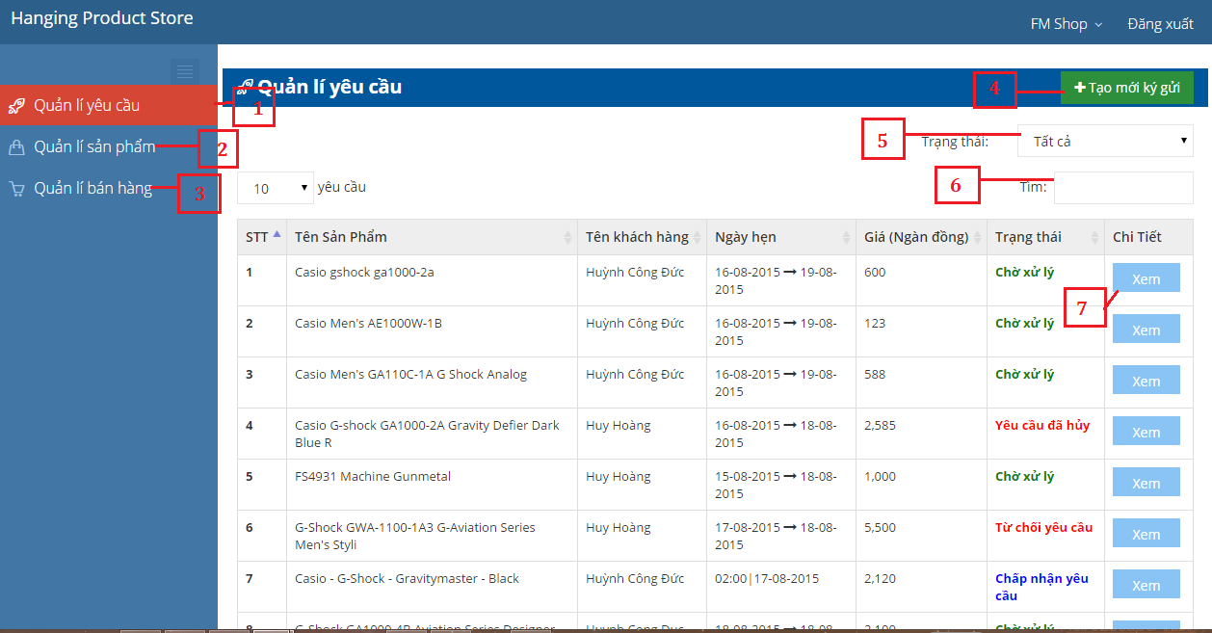

Figure : Manage Request

**Fields**

|  |  |  |  |  |  |  |  |
| --- | --- | --- | --- | --- | --- | --- | --- |
| 1. **No** | **Field Name** | **Description** | **Read Only** | **Mandatory** | **Control Type** | **Data Type** | **Length** |
| 5 | Filter Status | Choose a values to filter request by status | No | Yes | Combo box | String | N/A |
| 6 | Search box | Input to search value in table | No | Yes | Textbox | String | N/A |

**Buttons/Hyperlinks**

|  |  |  |  |  |
| --- | --- | --- | --- | --- |
| **No** | **Function** | **Description** | **Validation** | **Outcome** |
| 1 | View New Request | Click to view request list | N/A | Request list is shown |
| 2 | View Available Product | Click to view available product list | N/A | Available product list is shown |
| 3 | View Sold Product | Click to view sold product list | N/A | Sold product list is shown |
| 4 | Add New Consignment | Click to show a modal to add new consignment | N/A | A modal for adding new consignment is shown |
| 7 | View Details | Click to view details of consignment | N/A | A modal with detailed of consignment is shown |

* + - 1. **View Request Detail**

Figure : View Request Detail

**Fields**

|  |  |  |  |  |  |  |  |
| --- | --- | --- | --- | --- | --- | --- | --- |
| **No** | **Field Name** | **Description** | **Read Only** | **Mandatory** | **Control Type** | **Data Type** | **Length** |
| 1 | Product Name | Name of product | Yes | Yes | Label | String | N/A |
| 2 | Category | Category of product | Yes | Yes | Label | String | N/A |
| 3 | Brand | Brand of product | Yes | Yes | Label | String | N/A |
| 4 | Description | Description of product | Yes | Yes | Label | String | N/A |
| 5 | newStatus | New status of product | Yes | Yes | Label | String | N/A |
| 6 | Product Image | Image of product | Yes | Yes | Label | String | N/A |
| 7 | Created Date | Date that consignment is created | Yes | Yes | Label | String | N/A |
| 8 | FromDate-ToDate | Date that customer has set | Yes | Yes | Label | String | N/A |
| 9 | Delivery Method | Method to delivery product | Yes | Yes | Label | String | N/A |
| 10 | Appoinment Date | Date that product is considered to be received | No | Yes | Datetime picker | String | N/A |
| 11 | MinPrice – MaxPrice | Price which is gotten online | Yes | Yes | Label | String | N/A |
| 12 | DesirePrice | Price that customer want | Yes | Yes | Label | String | N/A |
| 13 | Customer Name | Name of customer | Yes | Yes | Label | String | N/A |
| 14 | Phone | Phone number | Yes | Yes | Label | String | N/A |
| 15 | Email | Email | Yes | Yes | Label | String | N/A |
| 16 | Address | Address of customer | Yes | Yes | Label | String | N/A |
| 17 | Paypal Account | Paypal account for payment later | Yes | Yes | Label | String | N/A |

**Buttons/Hyperlinks**

|  |  |  |  |  |
| --- | --- | --- | --- | --- |
| **No** | **Function** | **Description** | **Validation** | **Outcome** |
| 1 | Accept Request | Accept the request | N/A | Request is accepted |
| 2 | Refuse Request | Refuse the request with reason | N/A | Request is refused |
| 3 | Close Details | Close current modal | N/A | Current modal is closed and go back to view new request list |

* + - 1. **Accepted Request Details**

Figure : Accepted Request Details

**Fields**

|  |  |  |  |  |  |  |  |
| --- | --- | --- | --- | --- | --- | --- | --- |
| **No** | **Field Name** | **Description** | **Read Only** | **Mandatory** | **Control Type** | **Data Type** | **Length** |
| 1 | Product Name | Fill name of product | No | Yes | Textbox | String | N/A |
| 2 | Category | Choose category | No | Yes | Textbox | String | N/A |
| 3 | Brand | Fill brand | No | Yes | Textbox | String | N/A |
| 4 | Description | Fill description | No | Yes | Textbox | String | N/A |
| 5 | newStatus | Fill new status | No | Yes | Textbox | Integer | N/A |
| 6 | IsSpecial | Check if product is special or rare | No | Yes | Check box | String | N/A |
| 7 | Product Image | Image of product | Yes | Yes | Label | String | N/A |
| 8 | Created Date | Date that consignment is created | Yes | Yes | Label | String | N/A |
| 9 | FromDate-ToDate | Date that customer has set | Yes | Yes | Label | String | N/A |
| 10 | Delivery Method | Choose a way to delivery product | No | Yes | Combo box | String | N/A |
| 11 | Appoinment Date | Choose a date that product is considered to be received | No | Yes | Datetime picker | String | N/A |
| 12 | MinPrice – MaxPrice | Price which is gotten online | Yes | Yes | Label | String | N/A |
| 13 | DesirePrice | Price that customer want | Yes | Yes | Label | String | N/A |
| 14 | Negotiated Price | Fill negotiated price that customer accept | No | Yes | Textbox | Float | N/A |
| 15 | Customer Name | Fill name of customer | Yes | Yes | Textbox | String | N/A |
| 16 | Phone | Fill phone number | Yes | Yes | Textbox | String | N/A |
| 17 | Email | Fill email | Yes | Yes | Label | String | N/A |
| 18 | Address | Fill address | Yes | Yes | Label | String | N/A |
| 19 | Payment method | Choose a way to pay customer later | No | Yes | Combo box | String | N/A |
| 20 | Paypal Account | Fill aypal account | No | Yes | Textbox | String | N/A |

**Buttons/Hyperlinks**

|  |  |  |  |  |
| --- | --- | --- | --- | --- |
| **No** | **Function** | **Description** | **Validation** | **Outcome** |
| 21 | Update Request | Update current request | N/A | Request is updated |
| 22 | Receive Product | Receive product | N/A | Product is received |
| 23 | Refuse Product | Refuse product with reason | N/A | Product is refused |
| 24 | Close Details | Close current modal | N/A | Current modal is closed and go back to view accepted request list |

### Admin Interface Design

#### View User



**Fields**

|  |  |  |  |  |  |  |  |
| --- | --- | --- | --- | --- | --- | --- | --- |
| **No** | **Field Name** | **Description** | **Read Only** | **Mandatory** | **Control Type** | **Data Type** | **Length** |
| 1 | User’s Table | Table to show users | Yes | Yes | Data Table | N/A | N/A |

**Buttons/Hyperlinks**

|  |  |  |  |  |
| --- | --- | --- | --- | --- |
| **No** | **Function** | **Description** | **Validation** | **Outcome** |
| 2 | Edit User | Clicks to edit user | N/A | Redirect edit user page. |
| 3 | Create User | Clicks to create user | N/A | Redirect to create user page. |
| 4 | Logout | Click to logout | N/A | Logout. |

#### Edit User



**Fields**

|  |  |  |  |  |  |  |  |
| --- | --- | --- | --- | --- | --- | --- | --- |
| **No** | **Field Name** | **Description** | **Read Only** | **Mandatory** | **Control Type** | **Data Type** | **Length** |
| 1 | Username | Show username | Yes | Yes | Label | String | N/A |
| 2 | Phone | Change phone | No | Yes | Textbox | String | N/A |
| 3 | Name | Change name | No | Yes | Textbox | String | N/A |
| 4 | Paypal Account | Change paypal account | No | Yes | Textbox | String | N/A |
| 5 | Email | Change email | No | Yes | Textbox | String | N/A |
| 6 | Address | Change address | No | Yes | Textbox | String | N/A |

**Buttons/Hyperlinks**

|  |  |  |  |  |
| --- | --- | --- | --- | --- |
| **No** | **Function** | **Description** | **Validation** | **Outcome** |
| 7 | Change User’s Status | Active or deactive user | N/A | Show new user’s status |
| 11 | Edit User | Clicks to edit user | N/A | Show successful message |

## Database Design

### Entity Relationship Diagram

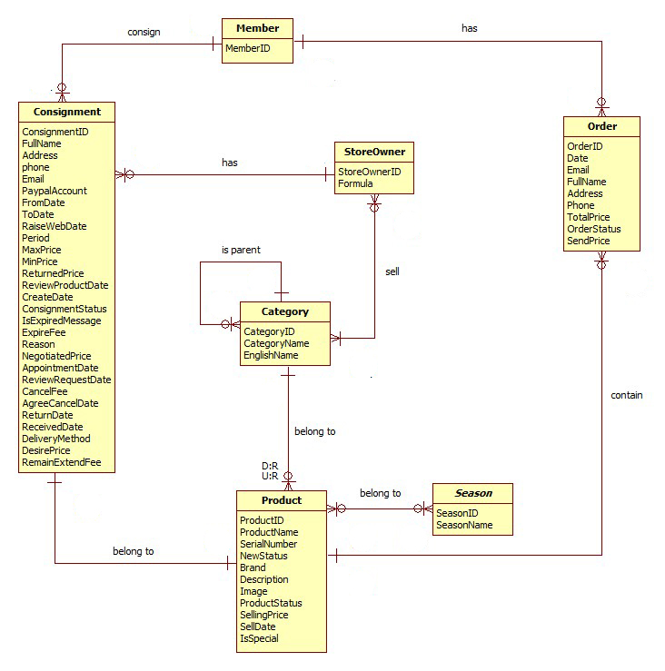

Figure : Entity Relationship Diagram

### Entity Dictionary

|  |  |
| --- | --- |
| **Entity Data dictionary: describe content of all entities** | |
| **Entity Name** | **Description** |
| StoreOwner | Describe all storeowners profiles in the system. |
| Member | Describe all members profiles in the system. |
| Consignment | Describe all consignments in the system. |
| Product | Describe all products in the system. |
| Order | Describe all orders in the system |
| Category | Describe all product categories |
| Season | Describe all seasons. |

## Algorithms

### Price Suggestion

#### Define Problem

When user consign product, they enter product name or product serial. We base on this information to get suggestion price for them.

#### Solution

To archive the goal above, we use **Amazon Product Avertising API** to get product infomation base on product name or product serial.

We can get product information from amazon following:

* If search product by product serial, **Amazon Product Avertising API** will return exactly 1 product if product serial is exist. We will using this product information.
* If search product by product name, **Amazon Product Avertising API** will return list product correctpond with product name. If list product is less than 10 products, we will get this list and show to user choose 1 of them.

#### Flowchart

##### Search product by product name



Figure : Search Product By Product Name Flow Chart

##### Search product by product serial



Figure : Search Product By Serial Flow Chart

### Consignment State

The consignment’s states describes as below:

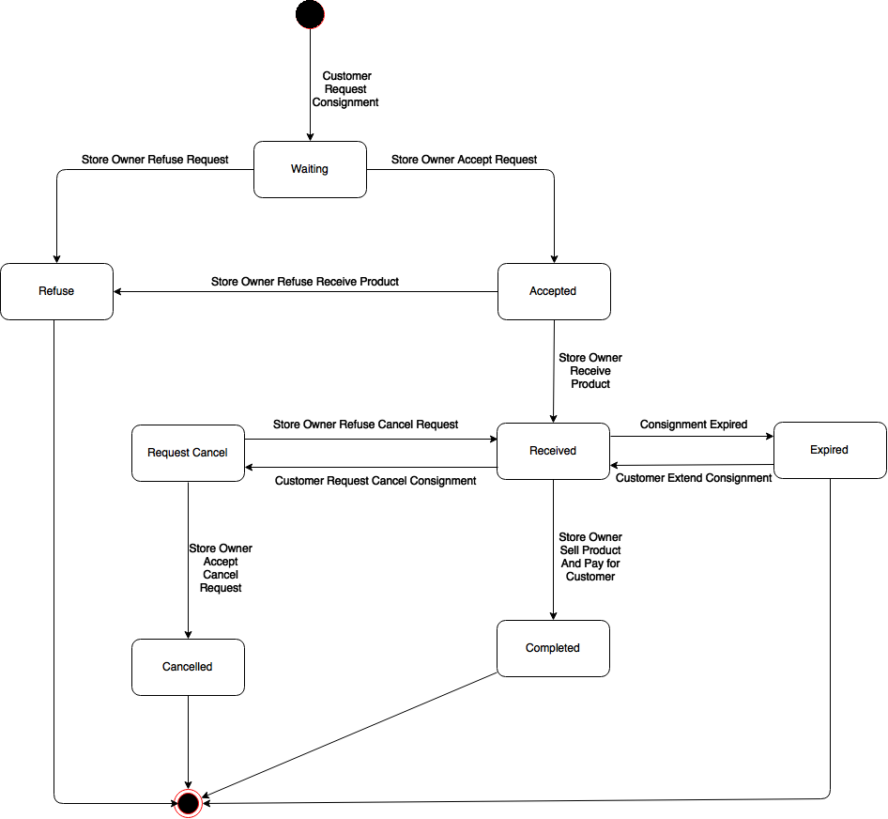

Figure : State Chart

|  |  |
| --- | --- |
| **State** | **Description** |
| Waiting | Customer requests new consignment |
| Refused | Storeowner refuses consignment’s request |
| Accepted | Storeowner accepts consignment’s request |
| Received | Storeowner receives product |
| Completed | Storeowner pays for customer |
| Request Cancel | Customer requests cancel consignment |
| Cancelled | Storeowner accepts request cancel |
| Expired | Consignment is overdue |

Figure : Consignment State Dictionary

|  |  |  |  |
| --- | --- | --- | --- |
| **Stimulus** | **Description** | **State before** | **State after** |
| Create request | Customer creates new consignment | N/A | Waiting |
| Accept request | Store owner accept consignment request | Waiting | Accepted |
| Refuse request | Store owner refuse consignment request | Waiting | Refused |
| Receive product | Store owner receive product | Accepted | Received |
| Request cancel | Customer request cancel their consignment | Received | Request Cancel |
| Agree cancel | Store owner agree customer cancel request | Request Cancel | Cancelled |
| Disagree cancel | Store owner disagree customer cancel request | Request Cancel | Received |
| Expire | Customer consignment is overdue | Received | Expired |
| Extend | Customer extend their consignment period | Expired | Received |
| Pay | Store owner pay for customer consignment | Received | Completed |

# Report No. 5 System Implement & Test Description

## Introduction

### Overview

This section contains in detail of all necessary information about system implementation and testing of HPS System includes all test plans, test cases, test results and test environment.

### Test Approach

- Goal: To test the whole system based on the core flow.

- Method: System testing, Black box testing.

## Database Relationship Diagram

### Physical Diagram



Figure : Physical Diagram

### Data Dictionary

|  |  |
| --- | --- |
| **Entity Data dictionary: describe content of all entities** | |
| **Entity Name** | **Description** |
| Account | Describe all accounts in the system. |
| StoreOwner | Describe all storeowner profiles in the system. |
| Member | Describe all member profiles in the system. |
| Consignment | Describe all consignments in the system. |
| Product | Describe all products in the system. |
| Order | Describe all orders in the system |
| Category | Describe all product categories |
| StoreOwner_Category | Describe all product categories that storeowner can accept |
| Season | Describe all seasons in the system |
| Product_Season | Describe all seasons of product |
| ProductStatus | Describe all statuses of product |
| ConsignmentStatus | Describe all statuses of consignment |
| OrderStatus | Describe all statuses of order |
| Brand | Describe brands in the system |

|  |  |  |  |  |
| --- | --- | --- | --- | --- |
| **Table Name** | **Attributes** | **Description** | **Domain** | Null |
| Account | AccountID (PK) | Unique identifier of each account | varchar(50) | No |
| Password | Password of this account | varchar(20) | No |
| Status | Status of this account | varchar(15) | No |
| FullName | Fullname of the owner this account | nvarchar(50) | No |
| Address | Address of this owner | nvarchar(250) | Yes |
| Phone | Phone of this owner | varchar(15) | Yes |
| Email | Email of this owner | varchar(50) | Yes |
| PaypalAccount | Paypal account of this owner | varchar(100) | Yes |
| Role | Rold of this account | varchar(10) |  |
| GcmID | Google Cloud Message to send notification. | text | Yes |
| Brand | BrandID (PK) | Unique identifier of each brand | int | No |
| BrandName | Name of this brand | nvarchar(50) | Yes |
| Category | CategoryID (PK) | Unique identifier of each cagegory. | int | No |
| CategoryName | Vietnamese name of this category | nvarchar(50) | Yes |
| ParentID | Parent category of this category | int | Yes |
| EnglishName | English name of this category | varchar(50) | Yes |
| Consignment | ConsignmentID (PK) | Unique identifier of each consignment | char(10) | No |
| ProductID | Product identifier of this consignment. | int | No |
| MemberID | Member identifier of this consignment | int | No |
| StoreOwnerID | Store owner identifier of this consignment | int | No |
| FullName | Consignor full name | nvarchar(50) | Yes |
| Address | Consignor address | nvarchar(250) | Yes |
| Phone | Consignor phone number | varchar(15) | No |
| Email | Consignor email | varchar(50) | Yes |
| PaypalAccount | Consignor paypal account | varchar(100) | Yes |
| FromDate | Earliest date that consignor want store owner to take product | datetime | No |
| ToDate | Lastest date that consignor want store owner to take product | datetime | No |
| RaiseWebDate | Date when product has been raise on web | datetime | Yes |
| Period | Consignment period | int | No |
| MaxPrice | Highest suggestion price that store owner offer to consignor. | float | Yes |
| MinPrice | Lowest suggestion price that store owner offer to consignor. | float | Yes |
| ReturnedPrice | The amount of money store owner return to consignor after send their product. | float | Yes |
| ReviewProductDate | Date when store owner review product. | datetime | Yes |
| CreatedDate | Date when consignor has created consignment | datetime | No |
| ConsignmentStatusID | Status of consignment | int | No |
| CancelDate | Date that consignor request cancel consignment | datetime | Yes |
| isExpiredMessage | Does system notify consignor when their consignment is expired | int | Yes |
| ExpiredFee | The stored fee of the product | float | Yes |
| Reason | Reason why refuse consignment request or product | nvarchar(200) | Yes |
| NegotiatedPrice | Negotiated price between consignor and store owner about the product | float | Yes |
| AppointmentDate | Date when store owner will come and check product. | datetime | Yes |
| ReviewRequestDate | Date when store owner review consignment request. | datetime | Yes |
| CancelFee | Cancel fee when consignor cancel their product. | float | Yes |
| AgreeCancelDate | Date when store owner return product to consignor. | datetime | Yes |
| ReturnDate | Date when store owner return money to consignor after sell consignor product. | datetime | Yes |
| ReceivedDate | Date when consignor receive product after it was expired | datetime | Yes |
| DeliveryMethod | Delivery method when store take consigned product | int | Yes |
| RemainExtendFee | Remain expired fee after each time expire. | float | Yes |
| DesirePrice | The amount of money that consignor want to receive after store owner sell their product | float | No |
| ConsignmentStatus | ConsignmentStatusID (PK) | Unique identifier of each consignment status | int | No |
| ConsignmentStatusName | Name of this consignment status | nvarchar(30) | No |
| Member | MemberID (PK) | Unique identifier of each member | int | No |
| AccountID | Account identifier of this member | varchar(50) | No |
| Order | OrderID (PK) | Unique identifier of each order | varchar(10) | No |
| CustomerID | Owner of this order | int | No |
| Date | Date when this order is created | datetime | No |
| Email | Email of customer | varchar(50) | Yes |
| FullName | FullName of customer | nvarchar(50) | Yes |
| Address | Address of customer | nvarchar(250) | Yes |
| Phone | Phone of customer | varchar(15) | Yes |
| OrderStatusID | Status of this order | int | No |
| ProductID | Product of this order | int | No |
| SendPrice | Product price which has been send to customer. | float | Yes |
| OrderStatus | OrderStatusID (PK) | Unique identifier of each order status | int | No |
| OrderStatusName | Name of this order status | nvarchar(30) | No |
| Product | ProductID (PK) | Unique identifier of each product | int | No |
| ProductName | Name of the product | nvarchar(100) | No |
| SerialNumber | Universal product code of the product | varchar(20) | Yes |
| CategoryID | Category of the product | int | No |
| Brand | Brand of the product | nvarchar(50) | No |
| Description | Description of the product | nvarchar(250) | Yes |
| Image | Link refer to image of the product | varchar(100) | No |
| ProductStatusID | Status of the product | int | No |
| SellingPrice | Selling price of the product | float | Yes |
| SellDate | Date when product has been sold. | datetime | Yes |
| IsSpecial | Identify auto send price to customer when product is ordered. | int | Yes |
| NewStatus | The new status of product | int | No |
| Product_Season | ProductID (PK) | Unique identifier of each product | int | No |
| SeasonID (PK) | Unique identifier of each season | int | No |
| ProductStatus | ProductStatusID (PK) | Unique identifier of each product status | int | No |
| ProductStatusName | Name of this product status | nvarchar(30) | No |
| Season | SeasonID | Unique identifier of each season | int | No |
| SeasonName | Vietnamese name of this seaon | nvarchar(20) | No |
| StoreOwner | StoreOwnerID | Unique identifier of each store owner | int | No |
| AccountID | System account of this store owner | varchar(50) | No |
| Formula | Formula to calculate suggestion price | float | No |
| StoreOwner_ Category | StoreOwnerID | Unique identifier of each store owner | int | No |
| CategoryID | Unique identifier of each category | int | No |

## Performance Measurement

N/A

## Test Plan

### Features to be tested

* StoreOwner: accept consignment request, refuse consignment request, receive product, cancel product, raise product on website, sell product, pay for consignor
* Guest/Customer: consign product, search product, order product, request cancel consignment, view consignment status.

### Features not to be tested

* Register, login, logout, edit profife
* Manage user, manage expired consignment, view consignment statistic.

## System Testing Test Case

### StoreOwner Core Flow



Figure : StoreOwner Core Flow

|  |  |  |  |  |  |  |  |
| --- | --- | --- | --- | --- | --- | --- | --- |
| **ID** | **Test Case Description** | **Test Case Procedure** | **Expected Out Put** | **Inter-test Case Dependence** | **Result** | **Test Date** | **Note** |
| RP01 | StoreOwner Receive Product without enter negotiated price by signing in the Android application | 1. After login and view product detail  2. Storeowner touch “Đồng Ý” without enter “Giá kí gửi tối đa” | Show error message “Vui lòng nhập giá kí gửi”. | N/A | Passed | 12/08/2015 |  |
| RP02 | StoreOwner Receive Product by signing in the Android application | 1. After login and view product detail  2. Storeowner enter “Giá Kí Gửi Tối Đa” and touch “Đồng Ý” | Navigate to MainActivity, this product is disappear in “Món Hàng Cần Nhận” list. And appear in “Món Hàng Đã Nhận” list. | N/A | Passed | 12/08/2015 |  |
| CP01 | StoreOwner Cancel Product without enter reason by signing in the Android application | 1. After login and view product detail  2. Storeowner touch “Đồng Ý” without enter “Lý do từ chối” | Show error message “Vui lòng nhập lí do”. | N/A | Passed | 12/08/2015 |  |
| CP02 | StoreOwner Cancel Product by signing in the Android application | 1. After login and view product detail  2. Storeowner touch “Đồng Ý” without enter “Lý do từ chối” | Navigate to MainActivity, this product is disappear in “Món Hàng Cần Nhận” list. And appear in “Món Hàng Đã Từ Chối” list. | N/A | Passed | 12/08/2015 |  |
| AR01 | StoreOwner accept consignment request by signing in the web application | 1. After login and view consignment request 2. Storeowner clicks “Đồng Ý” | Show successful message and this request is disappear in request list. | N/A | Passed | 13/08/2015 |  |
| CR01 | StoreOwner cancel consignment request by signing in the web application | 1. After login and view consignment request  2. Storeowner clicks “Đồng Ý” | Show successful message and this request is disappear in request list. | N/A | Passed | 13/08/2015 |  |
| RW01 | StoreOwner raise product on website with incorrect form | 1. After login and view received product 2. Storeowner clicks “Duyệt” without enter product name. | Show error message:”vui lòng nhập tên sản phẩm” | N/A | Passed | 13/08/2015 |  |
| RW02 | StoreOwner raise product on website with incorrect form | 1. After login and view received product  2. Storeowner clicks “Duyệt” with product name is blank. | Show error message:”vui lòng nhập tên sản phẩm” | N/A | Passed | 13/08/2015 |  |
| CO01 | StoreOwner cancel order on website. | 1. After login and view ordered product  2. Storeowner clicks “Hủy Đơn Hàng”. | Show sucessful message. | N/A | Passed | 13/08/2015 |  |
| SP01 | StoreOwner sell product without choose any customer to sell | 1. After login and view ordered product  2. Storeowner clicks “Hoàn Tất Thanh Toán” without choose customer. | Show error message: “Vui lòng chọn 1 khách hàng” | N/A | Passed | 13/08/2015 |  |
| SP02 | StoreOwner sell product without enter sell price | 1. After login and view ordered product  2. Storeowner clicks “Hoàn Tất Thanh Toán”.  3. Storeowner clicks “Đồng Ý” without enter sell price | Show error message: “Vui lòng nhập giá bán” | N/A | Passed | 13/08/2015 |  |
| SP03 | StoreOwner sell product successful | 1. After login and view ordered product  2. Storeowner clicks “Hoàn Tất Thanh Toán”.  3. Storeowner enter sell price and clicks “Đồng Ý” | Show successful message and this is disappear in orded product list. | N/A | Passed | 13/08/2015 |  |
| PC01 | StoreOwner pay for consignor without enter return price | 1. After login and view sold product  2. Storeowner clicks “Trả Tiền” with return price is blank | Show error message” Vui lòng nhập giá tiền”. | N/A | Passed | 13/08/2015 |  |
| PC02 | StoreOwner pay for consignor | 1. After login and view sold product  2. Storeowner enter return price clicks “Trả Tiền” | Show successful message and this is disappear in sold product list. | N/A | Passed | 13/08/2015 |  |

### Guest Core Flow



Figure : Guest Core Flow

|  |  |  |  |  |  |  |  |
| --- | --- | --- | --- | --- | --- | --- | --- |
| **ID** | **Test Case Description** | **Test Case Procedure** | **Expected Out Put** | **Inter-test Case Dependence** | **Result** | **Test Date** | **Note** |
| CR01 | Guest consign product by product name without enter product name | 1. Guest choose consign method is “Tên Sản Phẩm”.  2. Clicks “Bước Kế” with product name is blank | Show error message | N/A | Passed | 13/08/2015 |  |
| CR02 | Guest consign product by product name but cannot find suggestion price | 1. Guest choose consign method is “Tên Sản Phẩm”.  2. Enter product name is “Gshock” and category is “Quần”  3. Clicks “Bước Kế” | Show warning message  “Hệ thống không thể đưa ra giá đề suất cho sản phẩm của bạn.” and negotiated price is “Thương Lượng” | N/A | Passed | 13/08/2015 |  |
| CR03 | Guest consign product by product name successful | 1. Guest choose consign method is “Tên Sản Phẩm”.  2. Enter product name is “Gshock ga1000-2b” and category is “Đồng Hồ”.  3. Clicks “Bước Kế”  4. Choose 1 product and clicks “Bước Kế”  5. Choose store and clicks “Bước Kế”  6. Enter desire price and clicks “Xác Nhận”  7. Enter personal information and clicks “Ký Gửi”.  8. Clicks “Đồng Ý” in confirm modal. | Show successful message and consignment information. | N/A | Passed | 13/08/2015 |  |
| CR04 | Guest consign product by product name with invalid information form. | 1. After enter valid product information Guest clicks “Ký Gửi” with blank phone | Show error message “Vui lòng nhập số điện thoại”. | N/A | Passed | 13/08/2015 |  |
| CR05 | Guest consign product by valid serial number | 1. Guest choose consign method is “Mã Sản Phẩm”.  2. Enter serial number is “079767960599” and category is “Đồng Hồ”.  3. Clicks “Bước Kế”  4. Choose store and clicks “Bước Kế”  5. Enter desire price and clicks “Xác Nhận”  7. Enter personal information and clicks “Ký Gửi”.  8. Clicks “Đồng Ý” in confirm modal. | Show successful message and consignment information. | N/A | Passed | 13/08/2015 |  |
| CR06 | Guest consign product by invalid serial number | 1. Guest choose consign method is “Mã Sản Phẩm”.  2. Enter serial number is “11111111111” and category is “Đồng Hồ”.  3. Clicks “Bước Kế” | Show error message “Không thể tìm thấy sản phẩm với mã số này” | N/A | Passed | 13/08/2015 |  |
| OP01 | Guest order product with correct form | 1. After enter information, Guest click “Xác Nhận” button | Show successful message “Bạn đã đặt hàng thành công, chủ cửa hàng sẽ thông báo giá sản phẩm cho bạn sau”. | N/A | Passed | 12/08/2015 |  |
| OP02 | Guest order product with incorrect form | 1. Guest click “Xác Nhận” button without enter “Số Điện Thoại” | Show error message” Vui lòng nhập số điện thoại”. | N/A | Passed | 12/08/2015 |  |
| RC01 | Guest request cancel consignment with valid consignment code | 1. Guest enter valid consignment ID click “Kiểm Tra” button.  2. Clicks “Hủy Ký Gửi” | Change status of consignment is “Hủy Ký Gửi”. | N/A | Passed | 12/08/2015 |  |
| RC02 | Guest request cancel consignment with invalid consignment code | 1. Guest enter invalid consignment ID click “Kiểm Tra” button. | Show error message: “Sản phẩm với code này không tồn tại”. | N/A | Passed | 12/08/2015 |  |

# Report No. 6 Software User’s Manual

## Installation Guide

### Setting up the environment at server side

The web application must be installed into the server side.

#### Hardware Requirements

Personal computers for developing with the minimum configuration:

* Intel® Core 2 Duo
* 2GB of RAM.
* 10GB of hard disk.
* Wi-Fi Internet (> 2Mbps).

#### Software Requirements

* Web Server: Apache Tomcat 8.0.15 with JRE 7.
* Microsoft Windows Server 2008 operating system.
* SQL Server 2008: used to create and manage the database for web application.

### Deployment at server side

#### Set up system variable

* Set up JRE_HOME: Control Panel\All Control Panel Items\System\Advanced system settings, in “Advanced” tab select Environment variables… button.
* Click “New…” button in User variables for Admin and fill variable name with JRE_HOME and variable value with your JRE path installed on your computer.
* Setup CATALINA_HOME:
* Click “New…” button in System variables and fill variable name with CATALINA_HOME and variable value with your Tomcat server path on your computer.

#### Prepare deployment package

* Copy the deployment package to a folder on the Tomcat server.
* Ex: D:\Apache Tomcat 8.0.15\webapps

#### Deploy database

* Open Microsoft SQL Server Management Studio, connect database.
* Server name: the host server IPv4 address or SQL instance name of the machine.
* Login: username of the account.
* Password: password of the account.



Figure : Database Server Login

* Open HPS.sql file.
* Execute script file.
* Change the connection string in **D:\Apache Tomcat 8.0.15\webapps\HPS\WEB-INF\classes\** dbconfig.properties.
* Restart server for the changes to take effect.
* Open localhost on server to see if deployment successful or not.
* Ex: http://localhost:8084/HPS.

#### Deploy web application on server

### Setting up the environment at client side

#### Setting up for computer

##### Software Requirements

Installed at least one web browser: google chrome, firefox, IE10

#### Setting up for android device

* Change setting to install unknown souce “.apk”.
* Connect to the same network as the server.
* Download “.apk” at this link:
* Install

## User Guide

### Computer Guide

#### Guest Guide

##### Consign Product



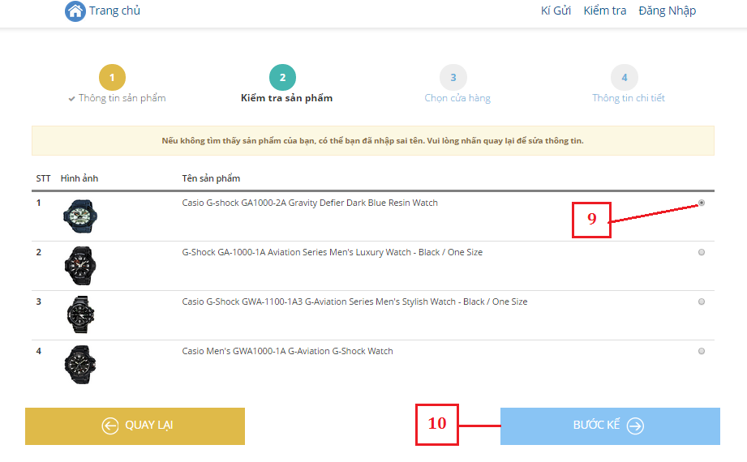

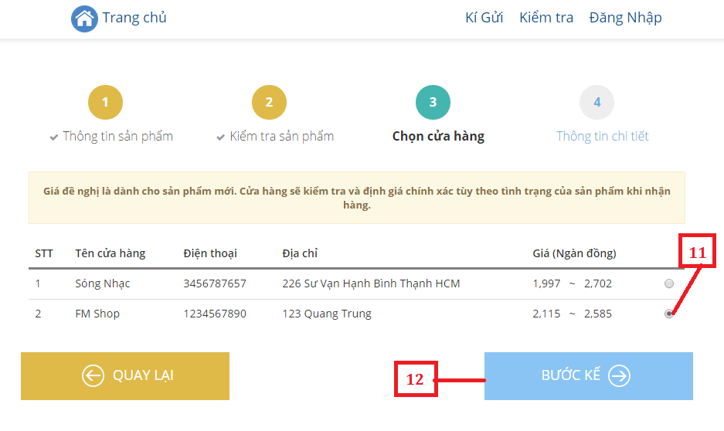

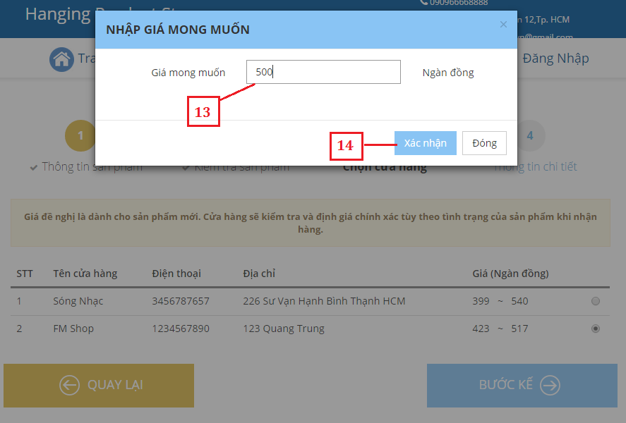

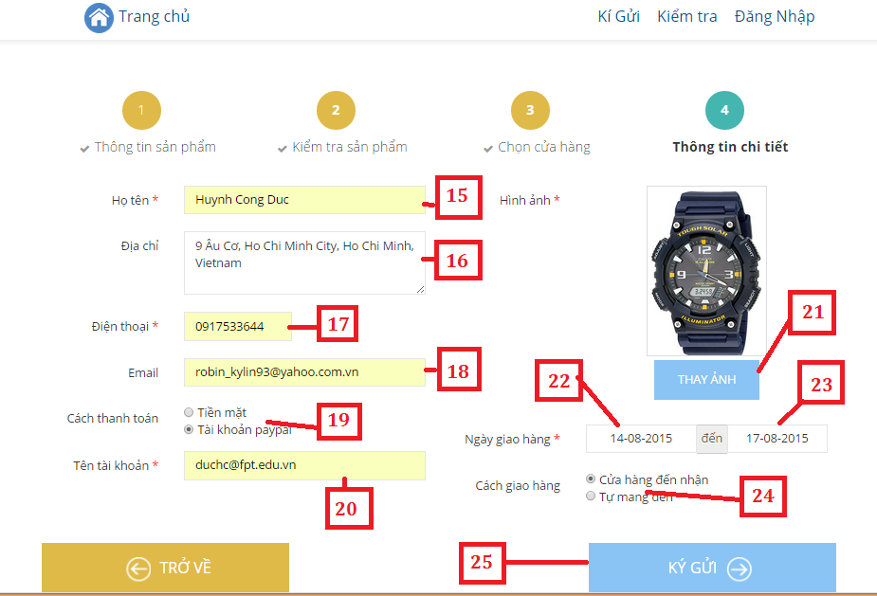

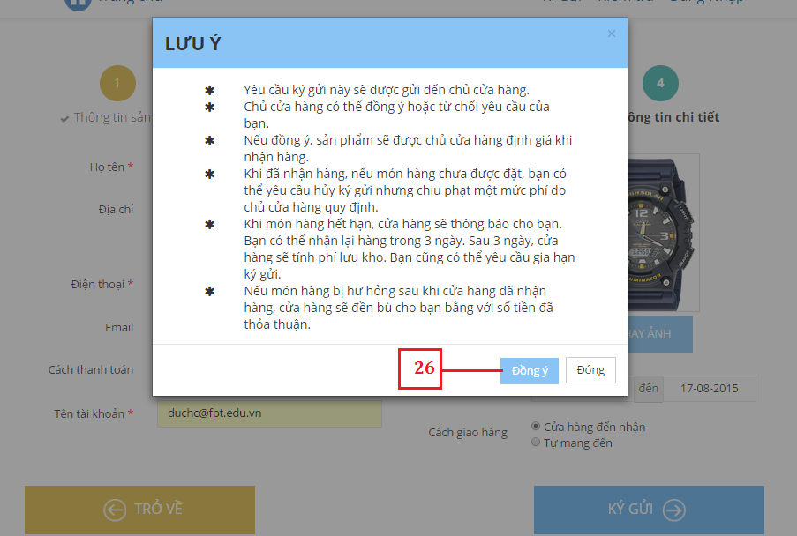



|  |  |
| --- | --- |
| **Step** | **Description** |
| 1 | Guest click on (1) |
| 2 | Fill product name in (3), choose category in (4), fill address in (5), fill new Status in (6) and fill description in (7) |
| 3 | Click (8) to go to step 2 |
| 4 | Click(9) to choose a product |
| 5 | Click (10) to go to step 3 |
| 6 | Click (11) to choose a store |
| 7 | Click (12) to fill desire price |
| 8 | Fill desire price in (13) |
| 9 | Click (14) to go to step 4 |
| 10 | Fill full name in (15), address in (16), phone in (17), email in (18). Choose an option in (19). If you choose “Tài khoản paypal”, fill (20). Click (21) to change image, choose date for (22) and (23). Choose an option in (24) |
| 11 | Click (25) to view rule of consignment |
| 12 | Click (26) to send request |

##### Order Product



Figure : Order Screen 1



Figure : Order Screen 2

|  |  |
| --- | --- |
| **Step** | **Description** |
| 1 | Guest click on (1) |
| 2 | Fill name in (2), email in (3), address in (4), phone in (5) |
| 3 | Click (6) to order |

##### Cancel Product

#### Store Owner Guide

##### Accept Request

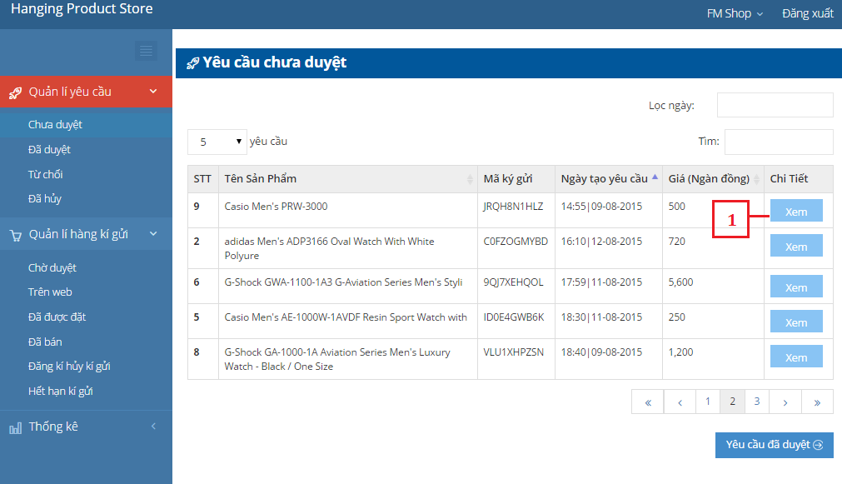

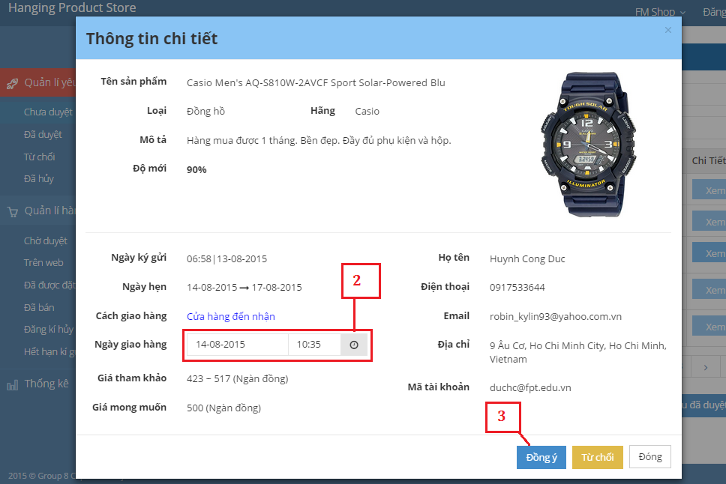

|  |  |
| --- | --- |
| **Step** | **Description** |
| 1 | Store Owner clicks on (1) to view details |
| 2 | Choose date in (2) |
| 3 | Click (3) to accept request |

##### Refuse Request



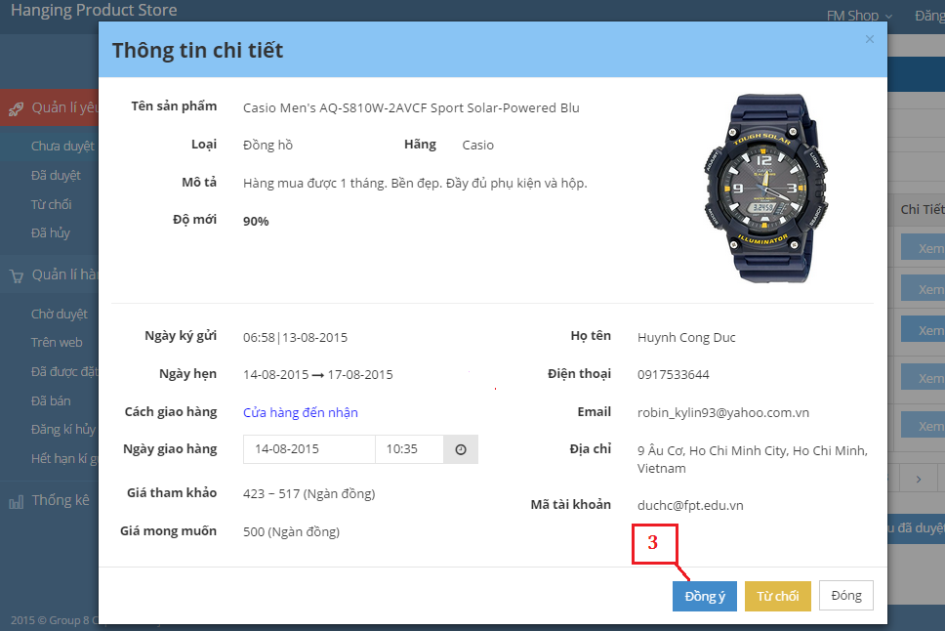

|  |  |
| --- | --- |
| **Step** | **Description** |
| 1 | Store Owner clicks on (1) to view details |
| 2 | Click (3) to refuse request |

##### Publish Product On Web

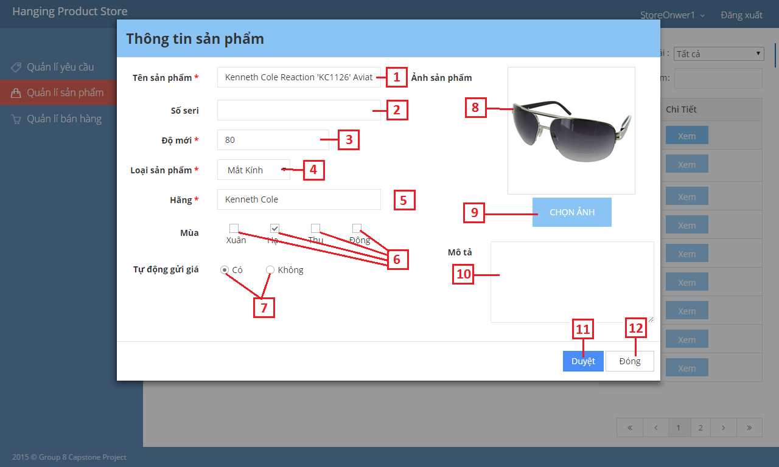

Figure : Publish Product On Web

|  |  |
| --- | --- |
| **Step** | **Description** |
| 1 | Store Owner clicks on (1) to view details |
| 2 | Fills product name in (2), product serial number in (3), product new status in (4), product brand in (6), product description in (10). |
| 3 | Choose product category in (5), which season to show product in (7), check send price automatically in (8) |
| 4 | Choose product image in (9) |
| 5 | Store Owner clicks on (11) to publish product |

##### Sell Product

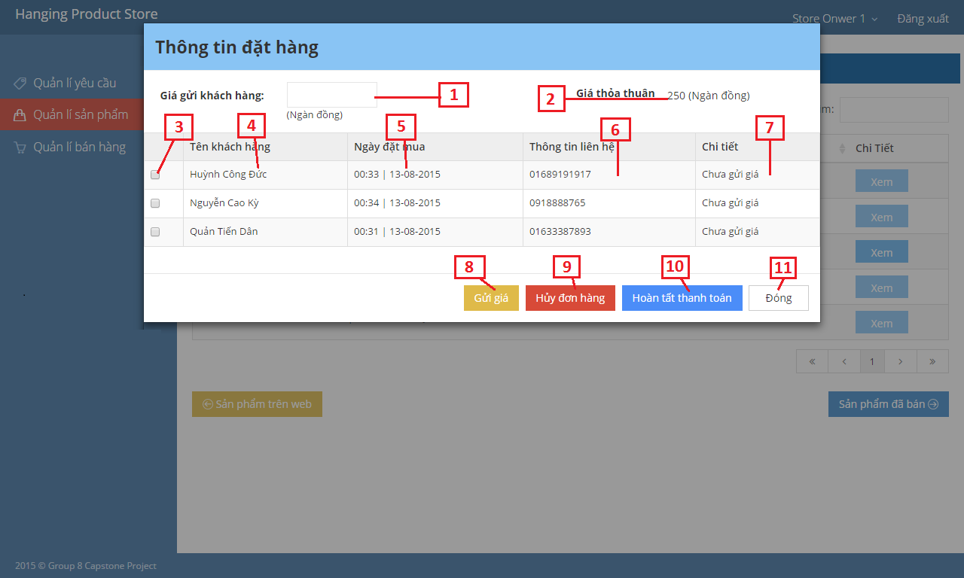

Figure : Sell Product

|  |  |
| --- | --- |
| **Step** | **Description** |
| 1 | Store Owner clicks on (1) to view details |
| 2 | Chooses 1 customer to sell product in (2) |
| 3 | Store Owner clicks on (3) to open sell product modal. |
| 4 | Fills selling price of the product in (4). |
| 5 | Store Owner clicks on (5) to complete sell product. |

##### Pay Consignor

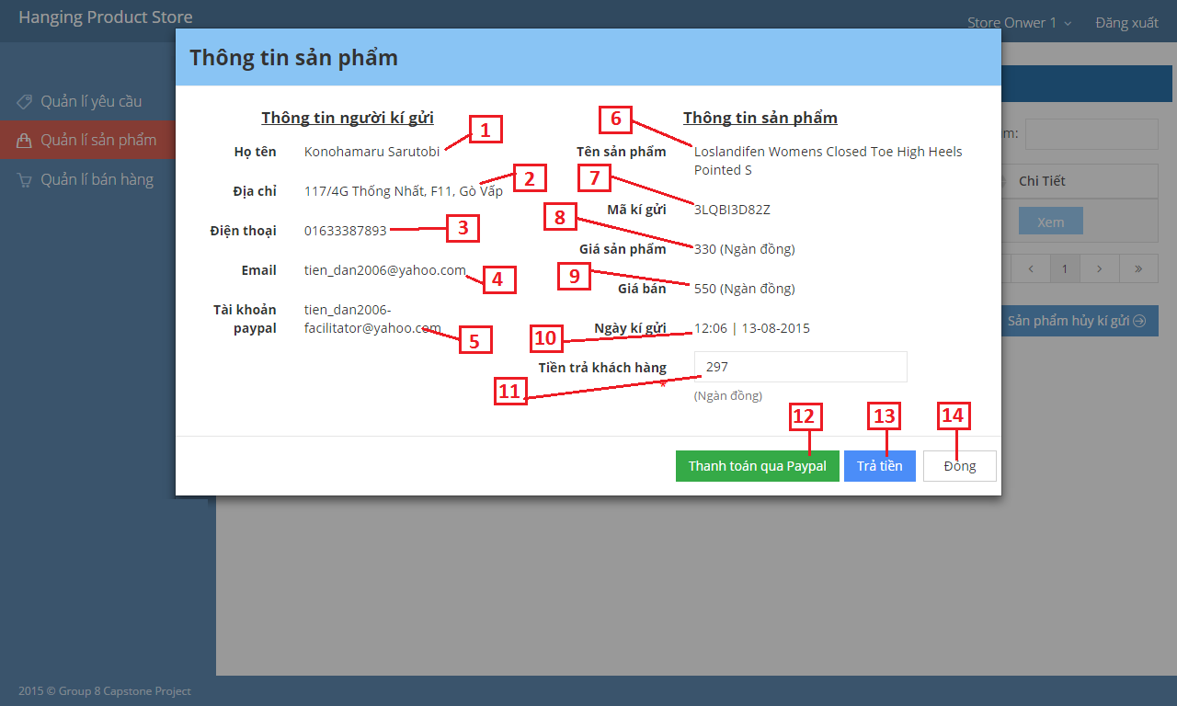

Figure : Pay Consignor

|  |  |
| --- | --- |
| **Step** | **Description** |
| 1 | Store Owner clicks on (1) to view details |
| 2 | Fills return price in (2) |
| 3 | Store Owner clicks on (3) to complete pay consignor. |

#### Admin Guide

##### Create User



Figure : Create User Screen

|  |  |
| --- | --- |
| **Step** | **Description** |
| 1 | Admin click on (1) |
| 2 | Fill user name in (2), password in (3), phone in (4), email in (5), name in (6), address in (7), paypal account in (8) and choose type of user in (9) |
| 3 | Click (10) to create user |

### Mobile Guide

#### Store Owner Guide

##### Login



Figure : Login Mobile Screen

|  |  |
| --- | --- |
| **Step** | **Description** |
| 1 | Employee fill their username in (1). |
| 2 | Employee fill their password in (2). |
| 3 | Touch (3) to login. |

##### Receive Product



Figure : Receive Product Mobile Screen

|  |  |
| --- | --- |
| **Step** | **Description** |
| 1 | StoreOwner fill negotiate price in (1). |
| 2 | Touch (2) |
| 3 | Touch (3) |

##### Cancel Product



Figure : Cancel Product Mobike Screen

|  |  |
| --- | --- |
| **Step** | **Description** |
| 1 | Touch (1) |
| 2 | Fill reason in (2) |
| 3 | Touch (3) |

# Appendix

* Amazon Advertising Product API

<http://docs.aws.amazon.com/AWSECommerceService/latest/DG/ItemSearch.html>

<http://docs.aws.amazon.com/AWSECommerceService/latest/DG/ItemLookup.html>

* Twilio API

<https://www.twilio.com/docs>

* Android Developer Guide

http://developer.android.com/reference/packages.html